  Maths and Social studies  Look up current weather conditions and the forecast for north east Scotland. Make a graph of temperature changes for this week and make some questions for a friend to interpret your graph. | 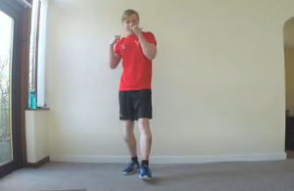  PE with Mr Voller  Mr Voller has put together PE videos for us to use during snow closure. You can find them on YouTube. | Technology  With friends or family, build a snow sculpture. Can you make a gallery with a sculptures in different categories – e.g. art, transport, food, wildlife family and so on.  The snow changes the way the world looks. Go out with a camera and photograph a scene or a detail that has changed with the snow.
Core Maths and Numeracy  Challenge a family member to a game of snow darts. Draw a dart board in the snow and throw 3 snowballs each before adding your scores. You can count down from 101 or set your own target number.  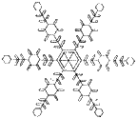  Symmetry – Make a snowflake with 6 lines of symmetry. Instructions can be found here. | 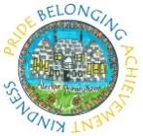  Snow Closures  Learning Grid |   Core Numeracy - Big Maths.  Complete your Learn-it for this week. Remember to time yourself and write down how long it takes to finish your questions.    Complete your CLIC and SAFE for this week.  These are not timed, so please work carefully and remember to check your work.  There is a weekly Sumdog challenge to help you stay sharp!
Core Literacy  Plan and write a short story (1 to 2 pages) with the title, “The Day the Snow Came”.  Watch one of your favourite films again, and write a review using the ideas on the template to help.  Help the adults at home by making food or a meal that everyone can share. | Core HWB  Invite some of our feather friends for tea by making them fat balls. The instructions show you how.  Cold conditions are dangerous. Think about what you need to do to stay safe outside. Then make a catchy acrostic poem to tell people about your rules. Words you could use for your poem are -COLD / SNOW / SNOW CODE/ WINTER.  Keep warm, busy, and help your neighbours by offering to clear the paths - make sure you ask permission before starting. | Core - Spelling Tasks  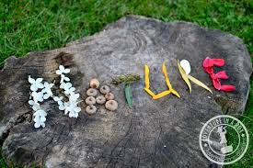  Task 1 – Nature words go outside and draw, make our display your words creatively in the snow. Take a photo of your scenic spelling.  Task 2 -Use each of your spelling words to create a sentence or question. Remember to underline your spelling word. Current weekly word list.  Task 3 – Choose three tasks from the  =spelling grid.

Resources
