Literacy  - Narrative- write a snow story e.g. “The Snow Storm” using the sequencing template (Page 4), try to write a sentence for each picture you draw.  - Snow spelling/phonics- write your spellings or phonics in the snow.  - Follow a recipe e.g. Hot chocolate, soup. Can you make up your own instructions? See writing instructions template (Page 5)  - Movie time! Pick your favourite movie –talk about the plot, setting and characters in the movie! Make your own cinema viewing with tickets and enjoy! | Numeracy  - Making footsteps in the snow. Can you count in 2’s, 10’s, 5’s or a different way?  - Snow ball target maths. Make a target that shows doubles, number bonds (9 and 1, 7 and 3 page 5 rainbow to 20). Aim your snow balls and shout your answers!  - Use the snowflake template (Page 6) to complete the symmetrical snowflake. What does symmetrical mean? Can you try to design your own?  - Can you try to make some 3D shapes out of the snow. Can you put your 3D shapes together? Try and name your shapes (page 7). | HWB  - Make fat balls (https://www.nhm.ac.uk/discover/how-to-make-fat-balls-for-birds.html) or feed the bird life- watch for bird life (https://www.rspb.org.uk/birds-and-wildlife/wildlife-guides/identify-a-bird/)  - How can you stay safe in the snow? Make a snow safe code poster. (Page 8)  - Be helpful-clear your paths offer to do a neighbours- make sure you ask permission. Are there any other jobs around the house you could offer to help with?
Science  - Look for signs of things freezing and melting outside.  - Snow Detectives – Look really closely at the snow, can you see crystals, can you see flakes, or patterns? Can you try to draw what you see? Has the snow made shapes in your garden or street? How has this happened?  - Bring a bit of snow inside. Can you predict how long it will take to melt? Can you time how long it takes to melt? | Snow day closures grid (P1 and P2/3)  Pick activities from the grid  When text is highlighted red, please find the worksheets on the page indicated. | Technology  - Take photos snow scenery  - Try to make an igloo. Don’t forget the door!  - Use some things you have around your house to try and make a sledge for your favourite toy.
Creative/PE  Mr Voller PE videos  https://youtu.be/UgrI8L7NGcc  https://youtu.be/IS8NhiXJHKc  https://youtu.be/x65WWmVIGL8  https://youtu.be/exGHiketmks  https://youtu.be/wTgxVcPbkx8  https://youtu.be/P-ZN_C1h5EE  https://youtu.be/i5b7N3wYSnY  https://youtu.be/miWZYY2wTA0  https://youtu.be/7u8dmOlBW1c  - Make a snow pet, snow sculpture  - Create a snow dance | Social Studies  Watch a weather forecast online. Make your own forecast using the weather map. (Page 9).  - Some animals change for snowy, cold weather – research one of the following:  - Arctic fox  - Snow leopard  - Mountain hare  - Ptarmigan  - Or one of your own. | RME  Winter Festivals  Find a winter festival from around the world. Make a fact file with at least 5 things you learnt.

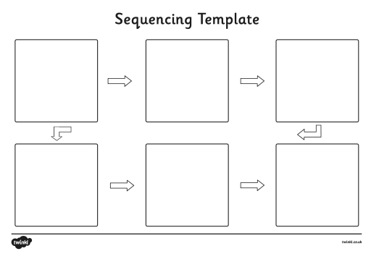

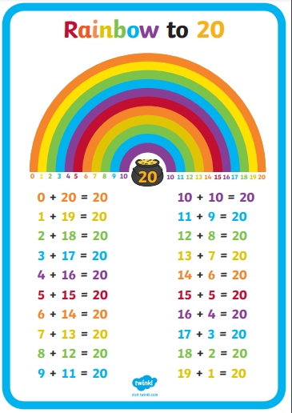
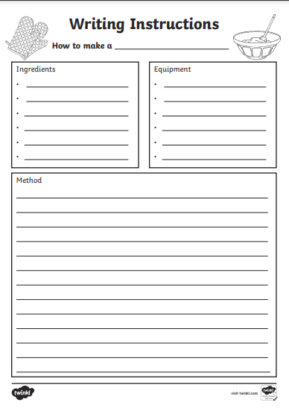
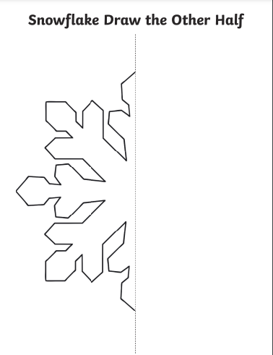
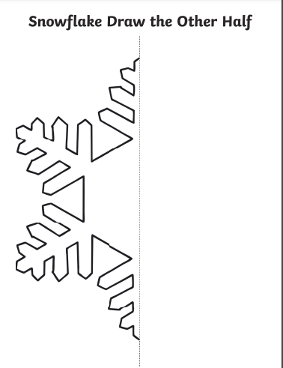
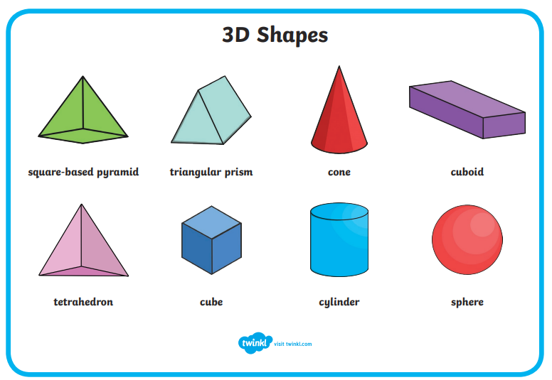

Snow Safety
