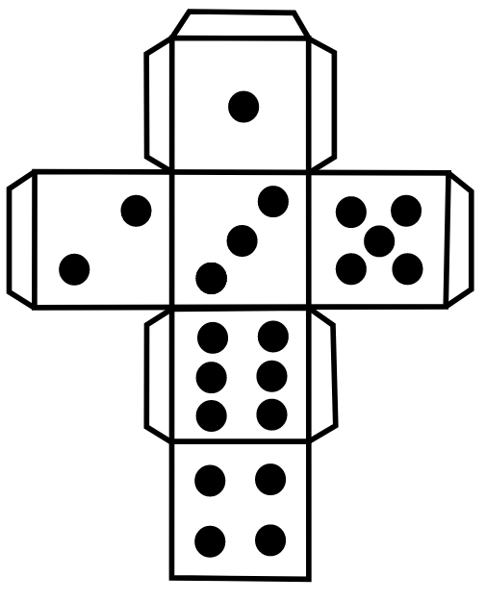
Lots of the activities refer to using a die or dice. If you do not have any dice you can print out this template and make your own. Happy rolling!

