Appendix 2
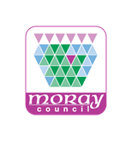

Aberlour Primary School
Child Protection Practitioner’s Handbook

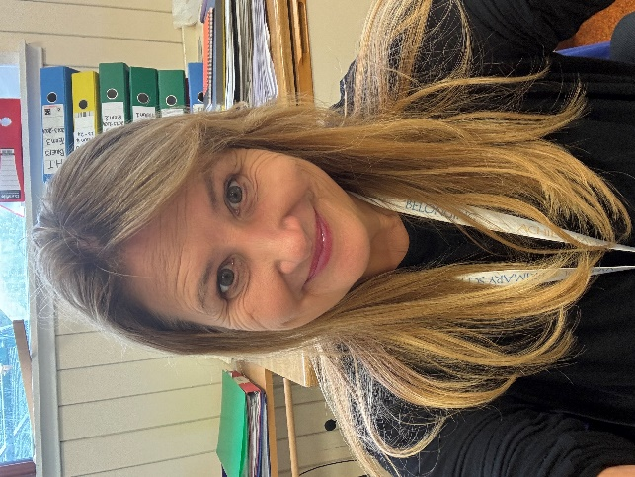

Mandy Inkson
Head Teacher
Child Protection Coordinator

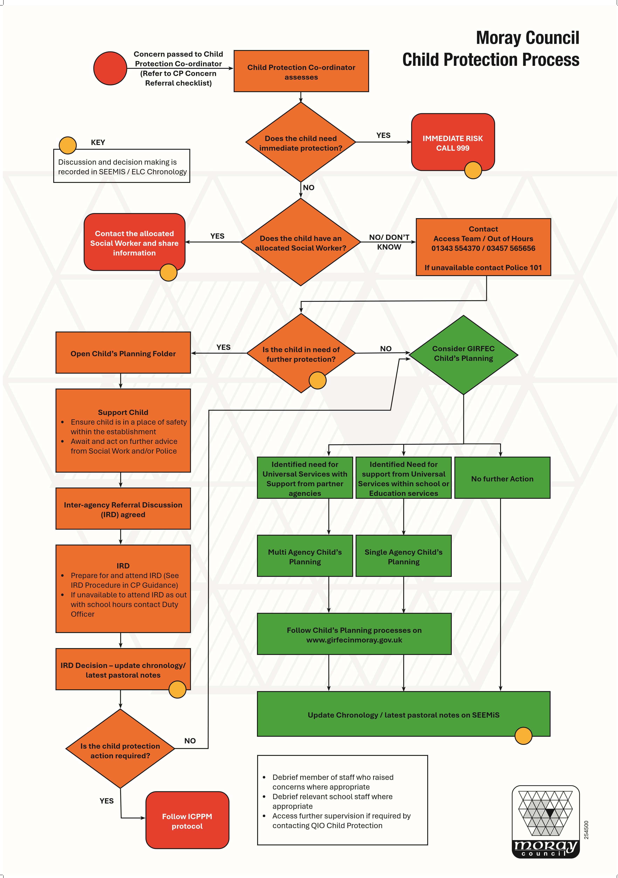
Introduction
"Child protection refers to the processes involved in consideration, assessment and planning of required action, together with the actions themselves, where there are concerns that a child may be at risk of harm….Child Protection Procedures are initiated when Police, Social Work or Health professionals determine that a child may have been abused or may be at risk of significant harm”.
(National Guidance for Child Protection in Scotland 2021 (Updated 2023)
The purpose of this induction handbook is to help ensure all staff are well placed to observe signs and symptoms in a child that may indicate child abuse. It will help you to know what your role and responsibilities are and what to do if you have any concerns about a child or young person.
This guide should be read in conjunction with the
National Guidance for Child Protection Scotland 2021 (updated 2023)
Support and Protection of Young People in Moray
Protecting People in Moray website
Moray Council’s Inter-Agency Initial Referral Discussion (IRD) Procedures.
Responsibility of All
All staff—whether in permanent, temporary, or voluntary roles—who work with or come into contact with children and young people have a vital responsibility in safeguarding and promoting their wellbeing. No single practitioner can fully understand a child’s situation in isolation. To ensure that children and families receive the appropriate support at the right time, it is essential that all adults working with them remain alert to signs of concern, share relevant information appropriately, and take timely, proportionate action in line with child protection procedures.
Staff working in a school/nursery are often viewed by children and young people as a trusted source of help and support, they are often the first to be aware that families may be experiencing difficulties and are also well placed to observe matters that may indicate a wellbeing or child protection concern. It is therefore essential that all staff understand the responsibilities they have for protecting children and promoting, supporting, and safeguarding their wellbeing.
All staff should recognise that they have a duty to:
- recognise, respond, record and report (the four ‘R’s).
- Be fully conversant with Moray’s Schools/Nursery’s School Child Protection Guidance
- Undertake Child Protection Awareness Raising Training every year which includes neglect, PREVENT, FGM etc.
- Contribute to the creation of a physically and emotionally safe school/nursery environment
- Know how to respond to any safeguarding, wellbeing and/or Child Protection concerns
- Know who the Child Protection Co-ordinator and Depute Child Protection Co-ordinator is within the school/nursery and report any safeguarding, wellbeing and/or child protection concerns to them without delay. The Child Protection Co-ordinator is also the Designated PREVENT Duty Lead
- In the absence of the Child Protection Co-ordinator, the staff member with concerns will not delay and will pass their concerns to the recognised depute for child protection within their school/nursery
- Where the Child Protection Co-ordinator or recognised depute is not available, staff must (without delay) refer their concern themselves to one of the core agencies (Social Work and/or Police – Contact numbers on posters displayed in every classroom).
- If concerns continue, despite the reassurances of the Child Protection Co-ordinator or another more senior member of staff, a direct referral to one of the core agencies should be made by the member of staff.
Responding to Concerns
Wellbeing / Child Protection concerns may arise in the following circumstances:
- a member of staff has concerns arising from observation of the child’s behaviour or appearance or comments the child has made
- a child tells a member of staff they have been abused or feel unsafe
- a third party expresses concerns to a member of staff: this could be another pupil, a parent or carer or member of the public
- an anonymous allegation is received
Procedure
- Where a disclosure has been made by a pupil to a member of staff, the role of school/nursery staff is to recognise, respond, report and record:
  - Recognise when the child’s behaviour and demeanour is a cause for concern and respond
  - Report their concerns immediately to the Child Protection Co-ordinator/Depute (Mandy Macleod)
  - Record in detail the exact details of the disclosure as soon as possible during/after the event. This record should include details of the date, time, location, events prior to the disclosure, others in attendance at the time and what the pupil said. You should use the child’s own words where possible, and include any other relevant information such as the child’s body language, emotional state, observation of any physical marks on the body etc. A distinction should always be made between facts, hearsay, and opinion.
- Where the Child Protection Co-ordinator assesses that there is direct or suspected abuse or potential danger/risk to a child, contact will be made with the Access Team or Police to determine what, if any, action needs to be taken. If the child already has an allocated social worker, the Child Protection Co-ordinator will contact the allocated social worker directly. If contact cannot be made, the police should be contacted immediately.
- The Child Protection Coordinator will ensure appropriate measures for the secure storage of Child Protection information, logging all communications.
- The child should be reassured and informed (as appropriate) of what is happening/going to happen.
Managing Allegations or Concerning Information About Staff/Whistleblowing
All staff and volunteers should understand what to do if they receive an allegation against them or an allegation is made to them concerning the behaviour of another member of staff, volunteer, or visitor. If a child protection concern involves a member of staff/volunteer, it must be treated with the same level of seriousness and urgency as any other disclosure made by a child or young person. The Child Protection Co-ordinator must immediately contact the Access Team and notify the Quality Improvement Officer (QIO) with responsibility for Child Protection.
A dynamic risk assessment must be conducted without delay to assess any immediate risks to children and young people. To ensure the safety of all parties and uphold the integrity of any investigation, the staff member against whom the allegation has been made may be assigned to alternative duties or placed on restricted duties until a full investigation is completed (Appendix 6)
What if a member of staff/volunteer has a concern about a colleague or trusted adult?
When staff have concerns about another adult’s behaviour, whistleblowing is the mechanism by which adults can voice their concerns, made in good faith, without fear of repercussion. It is important you understand Moray ‘s Whistleblowing (Confidential Reporting) Policy and who you talk to you if you have a concern about another adult.
Don’t think “What if I’m wrong?” think “What if I’m right?”
Some Do’s and Don’ts
DO Be alert to signs of abuse and neglect. It can happen anywhere | DO NOT Promise a child that you will not tell anyone else. Instead explain that to help them you will need to talk to other people
DO Be prepared to respond calmly. If a child confides in you, listen and take seriously what they are saying | DO NOT Try to ‘go it alone’. Children are best protected when all agencies work together
DO Keep a clear record of their disclosure, your concerns and what action you take | DO NOT ask leading questions. Rather only ask questions to clarify what the concern actually is. Once you have that information don’t ask any more questions, report your concerns accordingly
DO tell the child what you will do next | DO NOT stop or interrupt a chid who is recalling significant events
DO seek support for yourself if required | DO NOT express an opinion about the events or the alleged perpetrator
 | DO NOT tell the child everything will be “Ok”
Contact the named Child Protection Coordinator IMMEDIATELY with any concerns
Recognition: What is child abuse and neglect?
The identification and diagnosis of child abuse is rarely simple. The features are made up of a complex mix of medical symptoms and signs, social and emotional presentation, behavioural characteristics and background factors. What follows is a brief guide to help professionals look out for and pick out those factors that can lead to or indicate abuse.
Abuse and neglect are forms of maltreatment of a child. Abuse or neglect may involve inflicting harm or failing to act to prevent harm. Children may be maltreated at home, within a family or peer network, in care placements, institutions or community settings. Those responsible may be previously unknown, or familiar, or in positions of trust. They may be family members.
Children and young people may disclose abuse in a variety of ways, including:
- Directly – making specific verbal statements about what’s happened to them
- Indirectly – making ambiguous verbal statements which suggest something is wrong
- Behaviourally – displaying behaviour that signals something is wrong (this may or may not be deliberate)
- Non-verbally – writing letters, drawing pictures, by email or via a chat function as well as trying to communicate in other ways.
Children and young people may not always be aware that they are disclosing abuse through their actions and behaviour.
The following definitions show some of the ways in which abuse may be experienced by a child but are not exhaustive, as the individual circumstances of abuse will vary from child to child.
When services find it hard to engage
Evidence shows that some adults will deliberately evade practitioner interventions aimed at protecting a child. In many cases of child abuse and neglect, it is a clear and deliberate strategy adopted by one or more of the adults with responsibility for the care of a child. It is also the case that the nature of child protection work can result in parents/carers behaving in a negative and hostile way towards practitioners.
The terms ‘non-engagement’, ‘non-compliance’ and ‘resistance’ are used to describe a range of deliberate behaviour and attitudes such as:-
- Failure to enable necessary contact (for example missing appointments) or refusing to allow access to the child or to the home;
- Active non-compliance with the actions set out in the Child's Plan (or Child Protection Plan);
- Disguised non-compliance, where the parent/carer appears to co-operate without carrying out actions or enabling them to be effective; and
- Threats of violence or other intimidation towards practitioners.
Physical abuse
Physical abuse is the causing of physical harm to a child or young person. Physical abuse may involve hitting, shaking, throwing, poisoning, burning or scalding, drowning or suffocating. Physical harm may also be caused when a parent or carer feigns the symptoms of, or deliberately causes, ill health to a child they are looking after.
Equal Protection
On 7 November 2020 the Children (Equal Protection from Assault) (Scotland) Act 2019 came into force. The common law defence of “reasonable chastisement” was removed. The Act is consistent with the growing body of international evidence showing that physical punishment of children can lead to long-term negative outcomes.

Emotional abuse
Emotional abuse is persistent emotional neglect or ill treatment that has severe and persistent adverse effects on a child’s emotional development. It may involve:
- Conveying to a child that they are worthless or unloved, inadequate or valued only in so far as they meet the needs of another person
- Exploitation or corruption of a child, or imposition of demands inappropriate for their age or stage of development
- Repeated silencing, ridiculing or intimidation
- Demands that exceed a child’s capability that they may be harmful
- Extreme overprotection, such that a child is harmed by prevention of learning, exploration and social development
- Seeing or hearing the abuse of another (in accordance with the Domestic Abuse (Scotland) Act 2018)
Sexual abuse
Child Sexual Abuse (CSA) is an act that involves a child under the age of 16 years of age in any activity for the sexual gratification of another person, whether or not it is claimed that the child either consented or assented. Sexual abuse involves forcing or enticing a child to take part in sexual activities, whether or not the child is aware of what is happening. The activities may involve physical contact, including penetrative or non-penetrative acts. They may include non-contact activities, such as involving children in looking at, or in the production of indecent images or in watching sexual activities, using sexual language towards a child or encouraging children to behave in sexually inappropriate ways.
Child Sexual Exploitation (CSE) is a form of child sexual abuse. It occurs where an individual or group takes advantage of an imbalance of power to coerce, manipulate or deceive a person under 18 into sexual activity in exchange for something the victim needs or wants, and/or for the financial advantage or increased status of the perpetrator or facilitator.
Criminal Exploitation
Criminal exploitation refers to the action of an individual or group using an imbalance of power to coerce, control, manipulate or deceive a child or young person under the age of 18 into any criminal activity in exchange for something the victim needs or wants, or for the financial or other advantage of the perpetrator or facilitator. Violence or the threat of violence may feature. The victim may have been criminally exploited, even if the activity appears consensual.
- Child criminal exploitation takes a variety of different forms and affects both male and female children. It can include:
  - Being forced to work illegally
  - Being coerced into moving drugs or money across the country
  - Forced to shoplift or pickpocket
  - Forced to threaten/assault other young people
- County Lines: In Moray there is growing concern with ‘county lines’, which refers to the criminal exploitation by gangs which export illegal drugs into one or more areas e.g. Moray to Highland. There is currently police intelligence the gangs are exploiting children and vulnerable adults in Moray to move (and store) drugs and money and often use coercion, intimidation, violence (including sexual violence and weapons).
- Cuckooing: Another area of concerns is “CUCKOOING”. Cuckooing may indicate someone’s home has been taken over by intimidation or other means for the purpose of criminal activities. These gangs/individuals target vulnerable adults. Staff in Early years and the primary sector are in a good position to identify if this is happening due to the daily contact they can have with families. These gangs often come from the central belt and the north of England.
Neglect
Neglect is the persistent failure to meet a child’s basic physical and/or psychological needs, likely to result in the serious impairment of the child’s health or development. It may involve a parent or carer failing to provide adequate food, clothing and shelter (including exclusion from home or abandonment), to protect a child from physical harm or danger, to ensure adequate supervision (including the use of inadequate caregivers) or to seek consistent access to appropriate medical care or treatment.
It may also include neglect unresponsiveness to a child’s essential emotional needs. “Non-organic failure to thrive” refers to an inability to reach normal weight and growth or developmental milestones in the absence of medically discernible physical and genetic reasons. In its extreme form children can be at serious risk from the effects of malnutrition, lack of nurturing and stimulation. This can lead to serious long-term effects such as greater susceptibility to serious childhood illnesses and reduction in potential stature. With young children in particular, the consequences may be life-threatening within a relatively short period of time. Chronic physical and emotional neglect may also have a significant impact on teenagers.
Female Genital Mutilation (FGM)
This extreme form of physical, sexual and emotional assault upon girls and women involves partial or total removal of the external female genitalia, or other injury to the female genital organs for non-medical reason. Such procedures are usually conducted on children and are a criminal offence in Scotland. FGM can be fatal and is associated with long-term physical and emotional harm. The Prohibition of Female Genital Mutilation (Scotland) Act 2005 makes it illegal to perform or arrange to have female genital mutilation carried out in Scotland or abroad. A sentence of 14 years’ imprisonment can be imposed. There are also several options that should be considered to protect children and prevent female genital mutilation occurring including Child Protection Orders.
Forced Marriage
A forced marriage is a marriage conducted without the full and free consent of both parties and where duress is a factor. Duress can include physical, psychological, financial, sexual, and emotional abuse. Forced marriage may be a risk alongside other forms of so called ‘honour-based’ abuse (HBA). HBA includes practices used to control behaviour within families, communities, or other social groups, to protect perceived cultural and religious beliefs and/or ‘honour.’
Disability
“Children with disabilities” is a broad term which may be applied to children with a broad range of physical, emotional, developmental, learning, communication and health care needs. Disabled children are defined as a child in need under section 93(4) of the Children (Scotland) Act 1995.
Children with disabilities are vulnerable to the same types of abuse as their able-bodied peers. Children with behavioural disorders, learning disabilities and/or sensory impairments are particularly at risk. Neglect is the most frequently reported form of abuse, followed by emotional abuse. Incidence of abuse of disabled children is likely to be under reported.
Impact of Mental Health Problems on Children
It is not inevitable that living with a parent/carer with mental health issues will have a detrimental impact on a child's development and many adults who experience mental health problems can parent effectively. However, there is evidence to suggest that many families in this situation are more vulnerable.
A number of features can contribute to the risk experiences by a child or young person living with a parent or carer who has mental health problems. These include:-
- The parent/carer being unable to anticipate the needs of the child or prioritise the needs of the child before their own;
- The child becoming involved in the parent/carer's distress, disturbance, delusions and lack of insight
- The child becoming the focus for parental aggression or rejection;
- The child witnessing disturbing behaviour arising from the mental illness (often with little or no explanation);
- The child being separated from a mentally ill parent for example because the latter is hospitalised; and
- The child taking on caring responsibilities which are inappropriate for his/her age.
Child protection in this context requires compassionate recognition of the child’s experience in this dynamic, while remaining focused on the child’s needs.

Children and Young People Experiencing Mental Health Problems
Children can experience a range of mental health problems, from depression and anxiety through to psychosis. Child protection is a crucial component of the service response to children and
young people experiencing mental health problems.
A small number of children with mental health problems may pose risks to themselves and others. For some their vulnerability and risk levels may be heightened as a result of the mental ill health. For others, a need to control, coupled with lack of insight into or regard for the feelings and needs of others may lead them to preying on the vulnerabilities of other children.
Suicide and Self-harm Affecting Children
Suicide is an act of deliberate self-harm which results in death. Self-harm refers to self-poisoning or self-injury, irrespective of the apparent purpose of the act. Self-harming is generally a way of coping with overwhelming emotional distress. Many people self-harm where there is no suicidal intent. However, those that self-harm can be at a higher risk of suicide.
Parents, carers and peers may be the first to become aware of risk or distress. Education staff also often have daily contact with children and therefore need to be alert to circumstances where individuals may be at heightened risk.

Domestic Abuse
Domestic abuse describes any behaviour that involves exerting control over a partner or ex-partner's life choices and that undermines their personal autonomy. It is any form of physical, verbal, sexual, psychological or financial abuse which might amount to criminal conduct and which takes place in the context of a relationship. It is an assault on their human rights. Although most victims are women, men can also suffer domestic abuse, and it can also occur in same-sex relationships. Children and young people living with domestic abuse are at increased risk of significant harm, both as a result of witnessing the abuse and being abused themselves. Children can also be affected by abuse even when they are not witnessing it or being subjected to abuse themselves. Domestic abuse can profoundly disrupt a child's environment, undermining their stability and damaging their physical, mental and emotional health.
Young people may experience abuse and coercive control in their own relationships outside of the family home. As within adult domestic abuse, this can include physical, sexual and emotional abuse. This is often unrecognised, and victims may choose not to disclose. Social media and digital technology may be used to perpetrate abuse.
Children and Families Affected by Alcohol and Drug Misuse
Problematic parental substance use can involve alcohol and/or drug use (including prescription as well as illegal drugs). The risks to, and impacts, on children of parents and carers who use alcohol and drugs are known and well-researched. Children affected by parental alcohol and drug use may experience neglect, feelings of fear, blame, abandonment, anger and shame. Children who may not be recognised as Young Carers may have to care for children, or adults. Secrecy and denial are recurrent features within families affected by alcohol and drug use. Children’s potential to develop trusting, secure relationships are compromised. Stigma accompanying parental alcohol and drug use affects children, locks in secrecy and remains a barrier to connection with universal services, treatment and support.
Obesity as a Cause for Escalating Concerns about Risk of Harm
Severe obesity is not an automatic flag for child protection concerns as the complexity of the condition has to be considered while some neglectful situations may result in significant harm or death. If efforts by health services to provide information, guidance and support have been unsuccessful due to avoidance, hostility, denial, inability or unwillingness to follow essential clinical advice to prevent harm, these would be strong indications of the need to escalate concern.
Indecent images and internet-enabled sexual offending by adults
Internet-enabled sexual offending includes possession, exchange and distribution of indecent images of and/or with children; production of indecent images of and/or with children; sexual solicitation (online interaction with minors for sexual purposes); non-consensual sharing of sexual images; and conspiracy crimes such as working with others to distribute indecent images of and/or with children or to solicit children.
Children and young people who display harmful or problematic sexual behaviour
Harmful sexual behaviour is defined as ‘sexual behaviour(s) expressed by children and young people under the age of 18 years that are developmentally inappropriate, may be harmful towards self or others and/or may be abusive towards another child or young person or adult.’ (Hackett, 2014) Harmful or problematic sexual behaviour in children and young people can be difficult to identify. It is not always easy to distinguish between what is abusive and/or inappropriate and what constitutes normal adolescent experimentation. Practitioners' ability to determine if a child's sexual behaviour is developmentally typical, inappropriate or abusive will be based on an understanding of what constitutes healthy sexual behaviour in childhood as well as issues of informed consent, power imbalance and exploitation.
Digital Environment/Online safety
New technologies, digital media and the internet are an integral part of children's lives. Whether on a computer at school or at home, a tablet, a games console or mobile/smart phone, children and young people are increasingly accessing the internet whenever they can and wherever they are. This has enabled entirely new forms of social interaction to emerge, for example, through social networking websites and online gaming. Protecting children from online harm is a challenging outcome in a fast-changing media environment in which a sense of anonymity and disinhibition can escalate risks.
Online child abuse is any type of abuse that occurs in the digital environment and the internet, facilitate through technology and devices such as computers, tablets, mobile phones, gaming devices and other online enabled devices. If abusive content is recorded, uploaded or shared by others online, there is a risk of on-going experience of abuse. Online abuse can included online bullying; emotional abuse and blackmail; sharing of intimate images; grooming behaviour, coer4cion and preparatory behaviour for abuse including radicalisation; child sexual abuse and child sexual exploitation.
Under-age sexual activity
Increasing numbers of young people are engaging in a range of sexual activity before the age of 16. The reasons behind this behaviour vary considerably. In some cases, the activity will be wholly consensual; in others it will happen in response to peer pressure or as the result of abuse or exploitation. Young people who are sexually active will, therefore, have differing needs, so services and practitioners must provide a range of responses. National guidance provided by the Scottish Government covers the legal issues and advises practitioners how they can strike a balance between assuring the freedom of young people to make decisions and protecting them from activity which could give rise to immediate harm and/or longer-term adverse consequences.
The law is clear that society does not encourage sexual intercourse in young people under 16. However, it does not follow that every case presents child protection concerns, and it is important that a proportionate response is made. If there are no child protection concerns, there may still be needs to be addressed either on a single agency or multi-agency basis. However, child protection measures must be instigated:
- If the young child is, or is believed to be, sexually active and is 12 or under;
- If the older child is currently 13 or over but sexual activity took place when they were 12 or under; and
- If information suggests that any older child has been forced or enticed to take part in sexual activities (sexual abuse including child sexual exploitation), is or has been involved in pornography or prostitution, or the other person is in a position of trust in relation to an older child.
Child trafficking
Child trafficking typically exposes children to continuous and severe risk of significant harm. It involves the recruitment, transportation, transfer, harbouring and/or receipt of a child for purposes of exploitation. This definition holds whether or not there has been any coercion or deception, as children are not considered capable of informed consent to such activity. It applies to activity within a country as well as between countries.
Fabricated or induced illness
Fabricated or induced illness in children is not a common form of child abuse, but practitioners should nevertheless be able to understand its significance. Although it can affect children of any age, fabricated and induced illness is most commonly identified in younger children. Where concerns do exist about the fabrication or induction of illness in a child, practitioners must work together, considering all the available evidence, in order to reach an understanding of the reasons for the child’s signs and symptoms of illnesses. A careful medical evaluation is always required to consider a range of possible diagnoses and a range of practitioners and disciplines will be required to assess and evaluate the child’s needs and family history.
Sudden unexpected death in infants and children
Only a small number of children die during infancy in Scotland. While the majority of such deaths are as a result of natural causes, physical defects or accidents, a small proportion are caused by neglect, violence, malicious administration of substances or by the careless use of drugs.
Children Missing From Education (see also SS/011/03, Strategy for Supporting Pupil Attendance & Absence (including Children Missing from Education & EMA Procedures))
Children ‘missing from education’ are children and young people of compulsory school age who are:
- not on a school roll,
- not being educated otherwise (at home, privately or in an alternative provision),
- have significant unexplained absences from school for a continuous period,
- identified as vulnerable or at risk, and who have unexplained absences or unverified absences for any period of time.
Pupils who are ‘vulnerable or at risk’ will include pupils who:
- Are Looked After – either at home or away from home.
- Are on the Child Protection Register.
- Have been the subject of Child Protection investigations.
- Have a history of changing schools.
- The school has otherwise identified.
Children and young people may disappear from view of schools and education authorities for many reasons. However, children have a right to education and local authorities have a duty to provide education for all children in their area, and to plan and provide support for vulnerable children. Action must be taken at school and education authority level to locate families and to try to re-engage them with services.
Children who are missing from education can be vulnerable as a consequence. They will not enjoy the benefit of regular contact with adults outside the home and early signs of possible abuse may be overlooked. Missing education can impact on a child’s social and emotional wellbeing, as well as their educational attainment and should, therefore, be taken seriously.
Children and young people can be missing from education for a variety of reasons. For example:
- families who simply move and do not tell anyone
- children whose families have become homeless
- cultural reasons e.g. Gypsy/Traveller children
- families may deliberately disappear from view to, for example, escape debt or police attention.
- asylum seekers may well have changed their names to protect anonymity. This might also apply to those under witness protection or fleeing domestic abuse. Care must be taken to protect legitimate cases and, at the same time, ensure that the rights of individuals (such as estranged parents) are maintained.
If you have concerns that a child or young person is missing from education then you must refer to SS/011/03, Strategy for Supporting Pupil Attendance & Absence (including Children Missing from Education & EMA Procedures) for further advice and guidance.
PREVENT
The Prevent strategy is part of the UK government’s counter-terrorism strategy. It is focused on safeguarding individuals from being drawn into terrorism or extremist ideologies and ensuring they receive appropriate support.
Educational establishments have a statutory duty under the Prevent strategy to take steps to prevent learners from being radicalised or drawn into extremism; be alert to signs that a learner may be vulnerable to extremist narratives; respond swiftly and appropriately, in line with child protection and safeguarding procedures, and work in partnership with agencies such as Police Scotland, Social Work, and the Prevent Multi-Agency Panel (PMAP) to assess risk and provide support.
If you identify a child or young person who is at risk of being drawn into terrorism or extremist ideologies, follow our standard child protection procedures. In nurseries and all educational establishments the Child Protection Co-ordinator is the Designated Prevent Duty Lead.

Additional Training Opportunities
This school will undertake training for child protection for all staff on a yearly basis.
All new members of staff will be given the opportunity to access appropriate child protection training as soon as possible after appointment. The school Child Protection Co-ordinator will advise them of the school policy and procedure during their induction.
Other training opportunities will be advertised on the Moray Council website and the Child Protection Partnership website. This information will also be regularly circulated to Child Protection Co-ordinators and Head Teachers.
Other additional online training includes:
Child Protection Partnership Training:
  - Adolescent Substance Use
  - National Risk Framework to support the assessment of CYP
  - Contextual Safeguarding
  - Child hood Trauma and adversity
The Care and Learning Alliance: E-Learning Modules
The following no-cost E-Learning modules are available for all staff to access (click on the course title to find out more):
  - Children Affected by Parental Substance Use
  - Introduction to Child Sexual Exploitation
  - Think you know neglect?
  - What Makes a Good Chronology?
Useful references
Further Information can be found at the following websites:
- National Guidance for Child Protection in Scotland 2021 - updated 2023
- Moray's Interagency Child Protection Procedures 2023
- The Promise
- Secure Care: Pathway and Standards
- Getting it right for every child
- Children (Scotland) Act 1995;
- Protection of Children (Scotland) Act 2003;
- Children’s Hearing (Scotland) Act 2011;
- Children and Young People (Scotland) Act 2014 and its most recent, 2020 statutory guidance;
- Children (Equal Protection from Assault) (Scotland) Act 2019;
- Children (Scotland) Act 2020;
- and the UN Convention on the Rights of the Child and its forthcoming enshrinement into Scottish law via the United Nations Convention on the Rights of the Child (Incorporation) (Scotland) Bill.
- Trauma-informed practice
- Children in Scotland
- Children 1st
- CEOP
- Parentline
- Childline

Contacts

Access Team
01343 554370
Emergency Out of Hours
03457 565656
Police
101
If you require further information or advice on guidance and procedures:

Quality Improvement Officer (Child Protection Lead)
01343 563374
education@moray.gov.uk

Emma Johnston, Lead Officer (Public Protection)
07855 270356
emma.johnston@moray.gov.uk

