Reading  Read a page from a book and draw a picture to show what is happening in the text. Put in as much detail as you can. Use the book to help you. | Numeracy and Maths – Counting Out Loud  Choose a starting number between 1 and 20. Count backwards from that number.  Challenge: Can you count backwards from a number larger than 20? Can you count backwards with someone, each taking a turn to say a number? | Health and Wellbeing  Do something kind for someone. Can you pay them a compliment, make them something or help them with a task?
Tools for Writing - Vocabulary and Spelling  Look at the 100 most commonly used word list.  Choose 6 words to learn (ones you don’t already know). Get someone to quiz you on them. | Numeracy and Maths – What Comes Before?  Choose a number between 1 and 20. What is the number before your number? e.g. “What is the number before 17?”.  Challenge: Try to say the number before for larger numbers e.g. “What is the number before 30?”. Try to say the number 2 less than your number e.g. “What is 2 less than 9?”. | STEM  Junk modelling! Collect and recycle materials such as yogurt pots, cereal boxes and see what you can create with them.
Grammar  Investigate nouns. The sheet provided gives you a grid of nouns (naming words). If you don’t have a dice to play the game then you can rip up bits of paper and put numbers on them and choose 2 at random or just pick the words you like. | Numeracy and Maths – Cars in the Garage  Put up to 10 cars in the garage (in a box or anything where you can’t see the cars). Ask an adult to take some of the cars away and tell you how many they’ve taken away. How many cars are left in the garage? Look in the garage to check. How did you work it out?  Challenge: This time the adult takes some cars away but doesn’t tell you how many they’ve removed. Look at how many cars are left in the garage. Can you work out how many cars have been taken away? | Expressive Arts  Practise singing some nursery rhymes. Can you make up your own using a familiar tune but include people and characters that you know?
Writing – Creating Texts  Write or draw instructions for brushing your teeth.  Think of the order you would do things in.  Use words like First, Next, Then, Finally | Numeracy and Mathematics - Shopping Fun  Make a shop. Choose some items to sell in your shop and put some prices on them (nothing more than 10p). Give people some 1p coins and let them buy an item in your shop. Can you check that they have handed over the right number of coins for the item they choose?  Challenge: If someone wants to buy more than one item can you tell them how much their items cost altogether? Can you check they hand the right number of 1p coins for their items? | Social Studies  Create a time-capsule. What would your great-great-great-grandchildren need to know about the world right now? Add in a favourite toy, a newspaper clipping or anything else that would help them understand our world in 2021.
Listening and Talking  Watch this video https://www.youtube.com/watch?v=S9VjeIWLnEg  Why has it been made? What did you learn from it? | Puzzle - Card Games  If you've got a pack of cards play Snap, or a Memory Game (where you turn cards face down and try to find a pair). If you don’t have cards you could make your own by writing numbers of pieces of paper or card (packaging?). | Religious and Moral Education  Did you follow the above Health and Wellbeing task? See how you behaved like The Good Samaritan by watching the clip below:KS1 Religious Studies: The Christian Story of the Good Samaritan and the Lost Sheep - BBC Teach

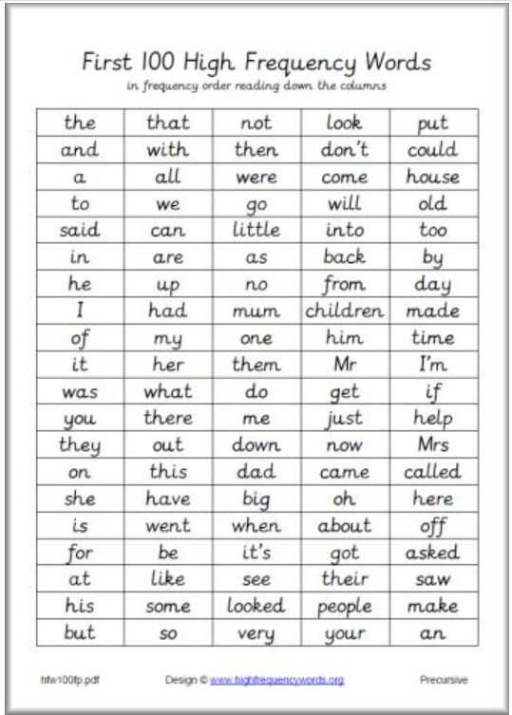
6 | cake | vegetables | orange | breakfast | dessert | sandwich
5 | jacket | trousers | shorts | skirt | shoes | hat
4 | car | speedboat | chariot | UFO | bicycle | submarine
3 | village | playground | castle | forest | circus | house
2 | mother | baby | crowd | astronaut | clown | firefighter
1 | lamp | clock | picture | clothes | football | light
 | 1 | 2 | 3 | 4 | 5 | 6

Nouns Game
Roll the dice to get a column and then again to get a row. The word you have is a noun. A noun is a person, a place or a thing. Use it in a sentence.
Eg If you rolled a 2 then a 4 your word would be speedboat.

