Literacy and English  Across and Down  Choose a spelling pattern to work on. (e.g. words ending in -ious) Find the correct spelling of 6 words with that pattern. Now, write each of your spelling words across and then down. (Starting with the first letter) Example:  when four  h o  e u  n r | Numeracy and Mathematics  · Count forwards & backwards by 7s from 7  · Count forwards & backwards by 8s from 8  · Count forwards & backwards by 9s from 9 | Health and Wellbeing  Let’s Dance – choose your favourite song to dance to. Think of 4 or 5 different moves to create a simple dance routine. Practice it over and over again until you are ready to perform! Have fun with this! You could perform your dance to your family. Why not teach them the moves too?
Literacy and English  Reading for pleasure – choose a book and find a comfy spot to read.  What makes this a good place for you? Is it quiet, bright, a den? | Numeracy and Mathematics  Fractions – colour and label correctly. (worksheet)  Can you spot any similar fractions?  Extra challenge – Can you draw some shapes of your own and split them into fractions? | STEM  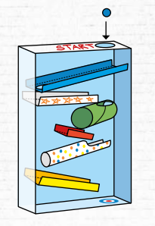  Marble Run – Create a marble run to experiment with gravity. You might use a cereal box, toilet roll tube, sellotape, scissors, egg carton, carboard. Can you get a marble to follow the path?  For more ideas visit https://www.smallpeicetrust.org.uk/wp-content/uploads/2025/08/EaS-04-The-Marble-Run-Challenge.pdf
Literacy and English  Celebrity Newspaper report – A celebrity has come to your school to open a new library. Write a newspaper report about the event. Remember to include a catchy headline, pictures with captions, the reporter’s name, written in the past tense and detailed sentences. | Numeracy and Mathematics  Add and subtract multiples of 10 - Find the total crowd at each concert and then the difference between the numbers of children and adults. Make up some of your own when finished.  - 340 adults, 60 children  - 470 adults, 80 children  - 530 adults, 70 children  - 890 adults, 30 children | 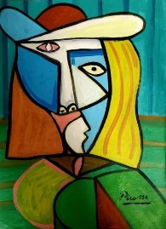  Expressive Arts  Famous Artist - Pablo Picasso had a unique style! Research some of his paintings. Draw and colour or paint a face in his style.  You can watch a video about Picasso here https://www.bbc.co.uk/bitesize/clips/ztgcjxs

Literacy and English  Adding My words – Choose 8 or 10 spelling words from a reading book. Each letter has a value. Consonants are worth 10. Vowels are worth 5. Write your spelling words and then add up the value of each spelling word.  Example  Said – 10 + 5 + 5 + 10 = 30 | Numeracy and Mathematics  Sports day – Make up five or more games or activities for a fun sports day. Decide what time each activity will start and how long it will go for. Now write a timetable or plan for the day. | Social Studies  Research - research your favourite animal, country or topic of your choice and write a fact file.
Literacy and English  Reading Task – Read a chapter or two of a book you are reading. Write an interview between you and the main character of your book. What questions would you like to ask them? Think about how the main character might respond. Be sure to write detailed responses for your characters. | Problem Solving  TV time - Choose a favourite TV programme.  - How many minutes long is it?  - If you watch it every time it comes on, how many minutes will you spend watching TV in a week?  - How many hours/days would you spend watching it in a year? | Health and Wellbeing  Mindfulness - Listen carefully with your eyes closed to any sounds you can hear. After one minute, open your eyes and write down everything you heard. You could try doing this in different rooms of your home or areas in your garden.

