Reading  Read daily for 20 mins.  Write about your favourite author. Explain what it is that you like about them. Is it the genre they choose, their style or choice of language? Fill out the attached sheet. | Numeracy and Mathematics  Pick 2 times tables that you find difficult. Count through the stations out loud to someone at home. For example: The 9 times table –  9,18,27,36,45,54,63,72,81,90,99,108 | Health and Wellbeing  Think about your home learning during lockdown and since then. What have been the challenges? What have you learned about yourself? Write out three things that help you focus and three that don’t. How can you reduce the three that don’t help?
Writing Instructions  Write instructions to teach someone how to do something. It could be bake a cake, sort a puncture or wash their hands properly. Make sure you include a list of what they will need and use bossy verbs in instructions. Check you haven’t missed anything out. You can see the sheet attached. | Numeracy and Mathematics  Partitioning  Using partitioning, complete the addition sums in the  Worksheet attached. There are 3 different levels, choose the one that suits you. | STEM  Explore planets beyond our solar system in the Galaxy of Horrors on NASA’s website here.  Try a bit of star gazing from your window or garden using these helpful hints.  https://www.nationaltrust.org.uk/visit/50-things/no.-27-go-stargazing
Spelling  Make a list of words you often struggle to spell. Think of all the different things you have done in the past to help you learn words. Use the one you think works the best to learn these. You might use a few different strategies to make sure. See how many you know by Friday. | Numeracy and Mathematics  Choosing the correct task for you (there are 4 different levels), complete the column subtraction sums. Remember to always start from the units. If you do not have enough - Units for example, you can borrow from the Tens column.  4 16  2356  -1237  1119  I borrowed from the tens column so that I now have 16 units takeaway 7 units. Then I was left with 4 tens takeaway 1 ten. | Expressive Arts  Follow the stages of the moon over the week by taking a photo (if possible!) Recreate the stages using the below activity: https://www.adabofgluewilldo.com/foil-printed-moon-craft/  Try sticking to a background to see the moon’s progression.
Similes  Similes – What are similes? Why do we use them in speech and writing? How do you compose your own? Complete the similes worksheet to practise and apply this skill. | Numeracy and Mathematics  Choose 4 of your favourite tv shows. Can you work out how many minutes each one is on for? If you watched them one after another, how long would you be watching tv in total? | Social Studies  Time travel backwards (or forwards) to a time in history. Write your present-day self a postcard and explain how life is different. If you have gone back in time, research a particular event or place to give you extra detail to include in your postcard.
Talking and Listening  Think about how you got on in the spelling task above. Tell someone about it. What helped you learn? Explain to them how you will remember these words in the future. Ask them to test you regularly and see how long you remember them. | Puzzle – Crazy Calculator  Look for the puzzle later in the pack. Can you use the broken calculator to make all the numbers from 1 to 20? | Health and Wellbeing  Make breakfast for your family one day at the weekend as a way of saying thank you. Challenge yourself to include at least one piece of fruit as well as a glass of fruit juice.

My Favourite Author
Author’s name

Favourite book written by this author

Reason for liking this particular author
Any facts you know about the author

Instructions for _________________________
You will need:

Instructions

Similes
A simile is a figure of speech that directly compares two different things. The simile is usually in a phrase with the words "as" or "like." Using similes in our writing helps to create greater description and imagery, both of which help to engage the reader.

Here are some examples of similes…
As flat as a pancake  As free as a bird  As clear as mud  As quiet as a mouse  As cold as ice | The place was like a ghost town  Life is like a box of chocolates  The sun was like a burning light bulb  Soaring like an eagle

Look at the phrases below. Have a go at completing the phrases to make them interesting similes.

The moon glowed like . . . . . .

Raindrops dripped down the window pane like . . . . . .

The air smells as fresh as . . . . . .

The rose petals are as delicate as . . . . . .

The surface of the water is as smooth as . . . . . .

The icicles pointed downwards like . . . . . .

Dewdrops glistened on the flowers like . . . . . .

The clouds are as fluffy as . . . . . .

The girl sang as sweetly as . . . . . .

The traffic moved as slowly as . . . . . .

Have a go at making up your own similes, using ‘like’ or ‘as’

Numeracy and Mathematics -Partitioning
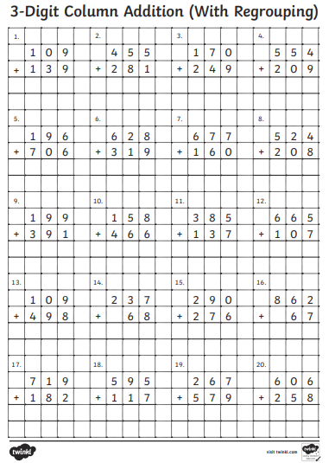

Numeracy and Mathematics -Partitioning
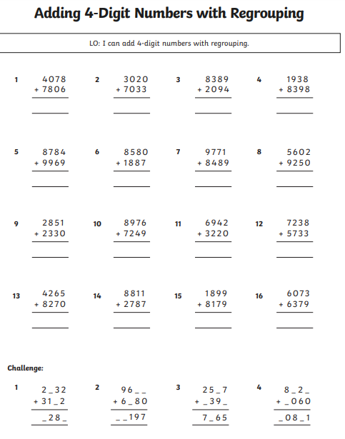
Numeracy and Mathematics -Partitioning
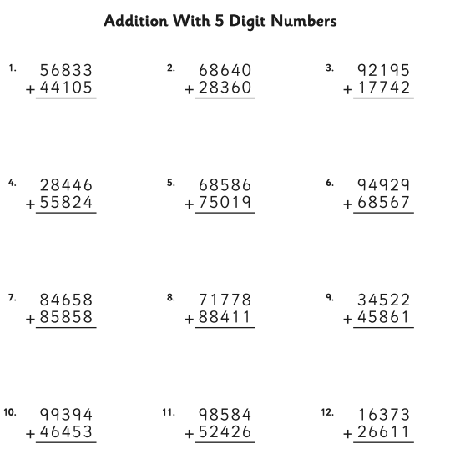

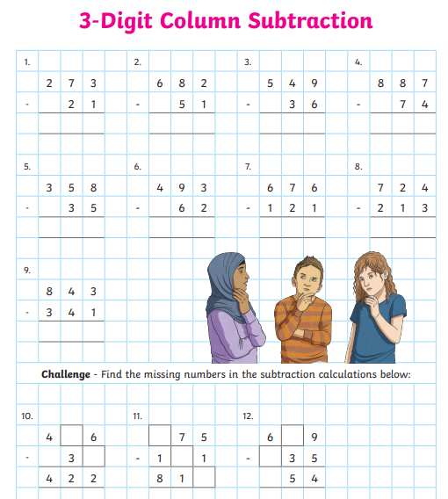

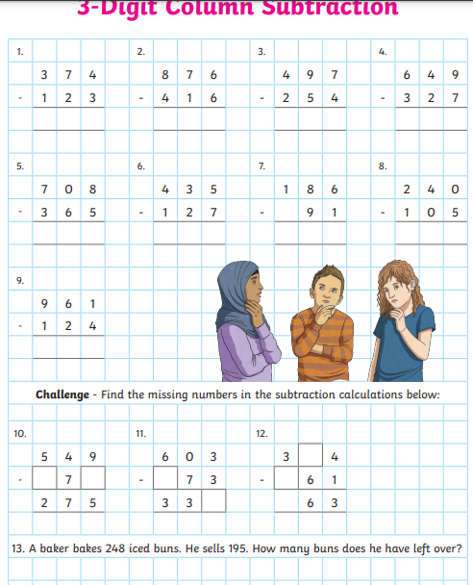
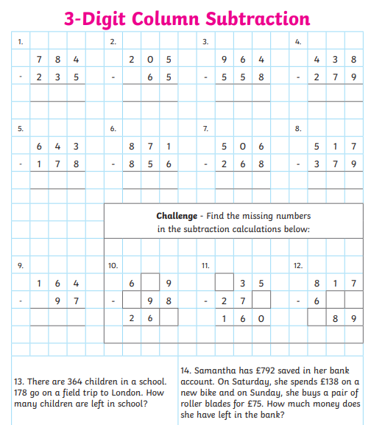

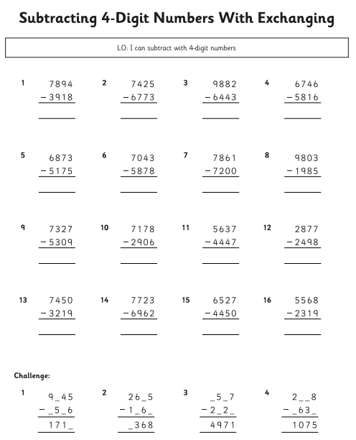

Numeracy and Mathematics – Crazy Calculator
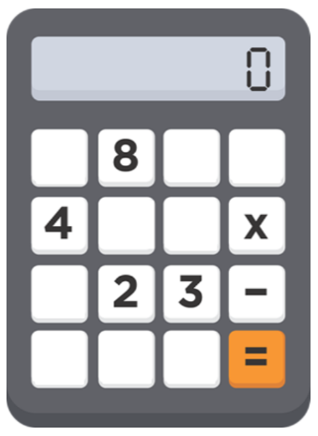
This activity will develop your skills in solving a mathematical puzzle. You will use the image below of a broken calculator to play a game for two players.
- Write down the numbers 1 – 20.
- Take it in turns to select one of the numbers and see if you can make the number using only the number and symbol keys that are left on the broken calculator. For example, 8 – 4 - 2 = 2 or 8 – 3 x 2 = 2.
- You score a point for each number that you can make.
- You could play this game again by changing the numbers and symbols left on the broken calculator, and then try to make the numbers 1-20 again.
- To make this activity more challenging, choose only two numbers and two symbols for the calculator, what numbers can you make now?

