Literacy and English  Draw and label 10 of the spelling words from the page attached. Choose words which give you a challenge. Try to include colour and add lots of detail. For more of a challenge find some unfamiliar ew words in a dictionary. | Numeracy and Mathematics - How many numbers can you make?  Deal out three number cards from a deck of playing cards. Using +, -, x and ÷, make as many numbers as you can using just these three numbers. You get one point for each different number you can make. Play 5 times and see who wins. | Health and Wellbeing  Create a pandemic study guide to help yourself and younger learners. What skills do you need? What equipment is useful? What advice or pointers could you offer with your recent experience?
Literacy and English  Choose a fiction or non-fiction book to read for 25 minutes each day. Look for ‘ew’ spelling words in the text? Write each one down and beside each word that you find, write a word which has a similar meaning that could be used instead. | Numeracy and Mathematics - Jelly Bean Fractions    In a packet of jellybeans, one eighth are green, one quarter are red, half are yellow. The rest are blue. There are 6 green beans. How many are there of each other colour?  Challenge: Can you create your own question? | STEM  Explore planets beyond our solar system in the Galaxy of Horrors on NASA’s website here.  Try a bit of star gazing from your window or garden using these helpful hints.  https://www.nationaltrust.org.uk/visit/50-things/no.-27-go-stargazing
Literacy and English  VIP Task – Think of a person of significance that you know of (e.g. Famous author or actor) or someone you know personally. Write a Very Important Person Profile about them. Use the guide sheet to help. | Numeracy and Mathematics – Giving Directions  In this activity, you will use compass points and directions to describe routes on a map. Find the activity instructions later in the pack. | Expressive Arts  Fold a piece of paper into quarters and fill each section with a different pattern. Look to include elements of shading, intersecting and/or parallel lines, a variety of shapes etc. Could you aim to have parts that are symmetrical or opposites of one another?
Literacy and English  Writers’ Craft – Tom's Terror. How does a writer hook us into a story? What can they do to keep us interested? Read Tom’s Terror excerpt. Use the ideas in the start of this story to write what happens next. You don’t need to finish the story, write the next 150 words. Can you keep the reader on the edge of their seat? | Numeracy and Mathematics – Times Table Chain  Draw a long rectangle with 10 boxes. Pick a number card (between 1-10) from a deck of cards. If you pick a 4, multiply 4 by 7 and write the answer in the fourth box. Continue to complete the rectangle.  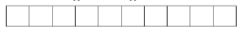  Challenge: How long did it take you to do it? Can you beat your time? Can you race a member of your family to see who can complete the chain quicker? | Social Studies  Research face-masks through history. How have masks changed since times of bubonic plague? Why have they changed? What have we learned that informs these changes? Design your own mask to protect you in the future.
Literacy and English  Punctuation is important for helping us to read fluently and get the correct understanding. Complete the punctuation activity attached. | Puzzle - Magic Square  Write down the numbers 1 to 9. You can only use each number once, and you have to use them all. Put one number in each box. Where do you put the numbers so that each row, column and diagonal all add up to the same total? Is there only one solution.  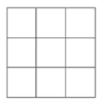 | Health and Wellbeing – P.E.  Be the next Joe Wicks! Create a fun and engaging workout routine, film yourself completing it and send it to a family member. Now can you set a weekly time to meet online with your family to get them fit?

Spelling words with ‘ew’ pattern
Column 1 | Column 2 | Column 3
blew | renew | renewable
chew | screw | reviewer
crew | threw | interviewer
dew | interview | interviewee
drew | overview | withdrew
few | outgrew | jewellery
flew | screwdriver | shrewd
grew | renew | newsagents
new |  | newspaper

Punctuation activity
1. Add an apostrophe in the sentences below where it is needed.
a. My hat is in the lions cage!
b. We borrowed books from the schools library.
c. Its a shame we cant go out.

2. The following dialogue is from the novel The Secret Garden. It is a conversation between Mary and her cousin Colin who are meeting each other for the first time. Add speech marks where they are needed throughout the passage.
How old are you?
I am ten, answered Mary, forgetting herself for the moment, and so are you.
How do you know that? He demanded in a surprised voice.
Because when you were born the garden door was locked and the key was buried. And it has been locked for ten years.

3. Add commas where they are needed to the sentences below.
a. Jenna what do you know about coin collecting?
b. Collecting things such as buttons pins and stamps can be fun.
c. Well we might start a new collection of classical music.

4. Re-write the following sentences marking whatever changes are necessary to make them correct.
a. I seen a ghost once in the basement.
b. Are you flying back to america.
c. Be careful. That house is haunted.
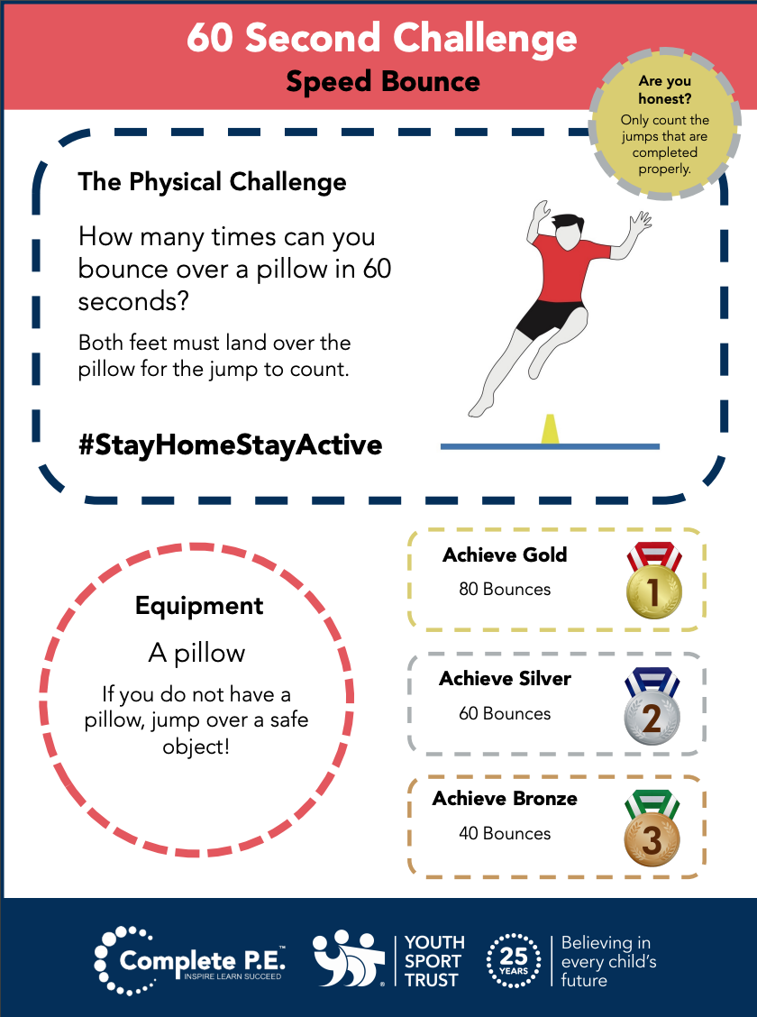
Significant Person/VIP Profile

Design a layout for your profile using a mix of areas to include; bullet point information, boxes for pictures/illustrations and paragraph spaces for sentences.
Include a title and a range of sub headings, inlcuding things like …
- Name of Person:
- Date of Birth:
- Born in:
- Family:
- Why is this person important?
- What have they done to become famous/be significant in my life?
- What did they do before they were famous? What was their early life like?
- Interesting facts about this person
- What skills and qualities make this person likeable?
- You can add your own sub headings too!

Numeracy and Mathematics – Giving Directions
Part 1  In this activity, you will use compass points and directions to describe routes on a map. The picture below shows a compass, which is used to give or follow directions. You can see the points North (N), North East (NE), East (E), South East (SE), South (S), South West (SW), West (W) and North West (NW) labelled around the compass. The angles on the compass are listed on the outside of the compass. This tells you how many degrees you have turned from North.  This video clip shows how to use a compass to read a map (https://www.bbc.co.uk/teach/class-clips-video/using-a-compass-and-reading-maps/z77tf4j)  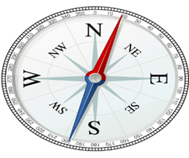  Part 2  The next picture shows a map of Ali’s local area. There are different points shown on the map and these are listed in the key. Find Ali’s house on the map. Use the compass to work out where the other places on the map are located from Ali’s house. For example, the takeaway café is North of Ali’s house. Share your answers with an adult to see if they agree. | 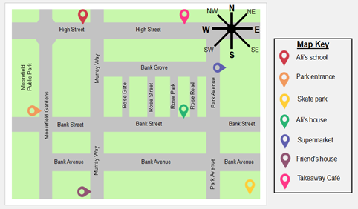  You are now going to give directions to reach different places on the map. Think about the different directional words you can use. For example, to get to school from his house, Ali could go West along Bank Street, and then turn 90° right into Moorefield Gardens. Then he would head North until he turns right into the High Street. He should then head East until he reaches the school. Make up directions for going to different places on the map. Ask someone at home to follow your directions on the map to see if you are correct.  Now think about your own local area and your route to school. What directions would you give to get from your house to your school? You might try using an online map to help you think about the directions. The next time you are outside, you could test your directions by travelling the route you have described. Some electronic devices such as a mobile phone or a tablet have a compass function, which you could use as an extra check.
Tom’s Terror!
It was a cold, damp night as Tom walked past the old school. The moon was full and shining in the inky blue sky. The stars twinkled and the piercing wind blew Tom’s hair over his eyes.

“Ouch!” yelped Tom, as he crashed onto the soggy ground. Tom had just tripped over a large, jagged rock, or at least that is what it looked like. Rubbing his knee he got to his feet. He looked around to see if anybody had seen him fall. As he turned around he saw something move in the shadows over at the old school. He was a little scared but that wouldn’t stop Tom.

Tom’s heart was beating fast as he got closer to the school. He opened the gate slowly and tiptoed towards the door. Gingerly, he pushed the door open and stepped inside...

