Literacy  Narrative- write a snow story e.g. “The Snow Storm” (See Image 1)  Snow spelling- write your spellings in the snow. Can you add suffixes – take, taken, taking.  Follow a recipe to make a Hot chocolate/drink/soup/cake  https://www.scholastic.com/parents/klutz/hot-chocolate-recipe-kids.html  Movie Analysis – Watch your favourite movie, then write a summary about the main points, draw and label your favourite setting and draw and label your favourite character.  For an extra challenge, create your own character that could appear in the film.  Use your VCOP (Image 2) pyramids to help label your setting and character tasks. | Numeracy  Negative numbers: Watch BBC Bitesize clip and complete activities  https://www.bbc.co.uk/bitesize/articles/zxthnbk#z4xnwsg  Do you have a thermometer at home? Can you read the temperature outside – Record your readings and answer the questions on the worksheet.  Make your own symmetry snowflakes.  Practise chanting your times tables.  Learn Its  Sumdog | HWB  Make peanut butter treats for the birds. Follow the recipe link below.  https://www.naturalbeachliving.com/easy-peanut-butter-bird-treats/  Don’t worry about making ornaments, you can make them into balls!  Weather conditions-stay safe  Can you create a snow safe code to keep yourself and others safe during the winter months? Think about the clothing you should wear, about travelling, things you should take with you.  Be helpful-clear your paths offer to do a neighbours- make sure you ask permission
Science  Make snow – Follow the instructions on the link attached.  https://www.makelifelovely.com/diy-snow-tutorial/  Melting freezing – Collect some snow from outsides and put it into 3 different containers.  - Add 1 teaspoon of salt to one of the containers  - Add 1 teaspoon of sugar to one of the other containers  - Do not add anything to the last container  What one melts the fastest? Why?  What one melted the slowest? Why? | Snow day closures grid  Pick activities from the grid  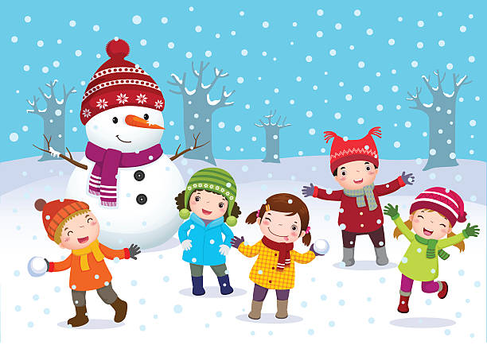 | Technology  Take photos of some beautiful snow scenery.  Build an igloo or some kind of winter shelter.
Creative/PE  Mr Voller PE videos  https://youtu.be/UgrI8L7NGcc  https://youtu.be/IS8NhiXJHKc  https://youtu.be/x65WWmVIGL8  https://youtu.be/exGHiketmks  https://youtu.be/wTgxVcPbkx8  https://youtu.be/P-ZN_C1h5EE  https://youtu.be/i5b7N3wYSnY  https://youtu.be/miWZYY2wTA0  https://youtu.be/7u8dmOlBW1c  Make a snow pet, snow sculpture  Create a snow dance | Social Studies  Weather forecasting – Watch the weather forecast on the T.V and pay attention to the symbols used. Make your own weather symbols and use them to record your own weather forecast. Remember to mention where you are, the temperature and what will happen over the next few days.  Challenge: Compare the weather at this time of year to a hot country like Australia.  Animal adaptations – How do animals change to  Survive the cold weather. Research a local wild animal. Make a poster using the headings below to help you  - Habitat  - Diet  - Predators  - Any other interesting facts | RME  Winter Festivals – Research the winter festivals celebrated over winter. What one would you like to take part in most and why?

Image 1
