Reading  Read a story and think about:  - who was in it?  - what was the problem?  - how was the problem sorted out?  Can you think of a different ending? | Numeracy and Mathematics - Two Groups  Find up to 10 items (e.g. 6) and put them together on the floor, table or piece of paper. Re-arrange the items so they are in two groups. How many are in each group? Can you write it down? Now put the items back together. Put them into two different groups. How many are in each group this time? Keep going to find as many different combinations as possible. Once you’ve found all combinations, try again for a different number of items (e.g. 7).  Challenge: Can you find a pattern or rule for organising your items into 2 groups so that you find all the combinations quickly and don’t miss any out? | Health and Wellbeing  Tell somebody why you love them and what it is that they do for you that makes you feel this way.
Tools for Writing - Vocabulary and Spelling  Using some words chosen at random from a book you are reading. Can you think up a sentence that has as many of your the words in as possible. Tell your sentence to someone or write it down. (Check your words are spelt correctly). | Numeracy and Mathematics - Twos  Find some toys or teddies. Give each of them 2 items e.g. coins, pencils. Now work out how many items the toys have altogether. How did you work it out? Can you tell someone your strategy? Try again with a different number of toys/teddies. Give each of them 2 items again.  Challenge: What would happen if each toy was given 3 items? Can you work out how many they would have altogether? | STEM  Can you make an indoor den? Is it big enough to fit you inside or is it made for a toy? Can you measure how long, tall and wide it is? You could use measuring tape or even just your hands!
Tools for Writing - Speech bubbles  Have a look at the sheet provided and decide what each animal might be saying. Fill in the speech bubbles with your ideas. Remember to use capital letters and full stops. You could draw your own characters and put in speech bubbles. | Numeracy and Mathematics - Action!  Choose a movement e.g. star jump, twirl. Roll a dice. Repeat the movement the correct number of times (the number of dots on the dice).  Challenge: Can you choose 2 movements and combine them to total the number of dots e.g. “I roll a 5, so do 3 twirls and 2 star jumps.” | Expressive Arts  Take a photo of the same view from your window every day at the same time. At the end of the week what do you notice has changed? Think about light, colours and the nature that you can see.
Writing – Creating Texts  Diary entry- look at the example of a diary entry from Red Riding Hood and use the sheet provided to write your own. You can write about a real day or make a day up. You could even pretend to be a different story book character. | Numeracy and Mathematics - Shopkeeper  Make a shop like you did for the last grid. Make all your prices be 10p or less. This time give your shoppers 2p, 5p or 10p coins. When they pay for an item work out how much change your shopper needs.  Challenge: Can you work out the change if they buy 2 items? Can you explain how you work out the change they get for 1 or 2 items? | Social Studies  Create a postcard to advertise your local area. What would the key features be? Try to include at least one natural and one man-made feature.
Listening and Talking  Watch the news or Newsround (from their website) https://www.bbc.co.uk/newsround  and come up with questions about what you hear. What would you like to discuss after listening to the information? | Puzzle - Maze Explorer  Look at the maze on one of the next pages. Can you find your way through the maze from one face to the other? Did you use any strategies to help you? | Religious and Moral Education  Diwali is a festival all about new beginnings. Watch the clip below:  What is Diwali? - BBC Bitesize  Try to think of ways that people can celebrate together when it is difficult to meet up.


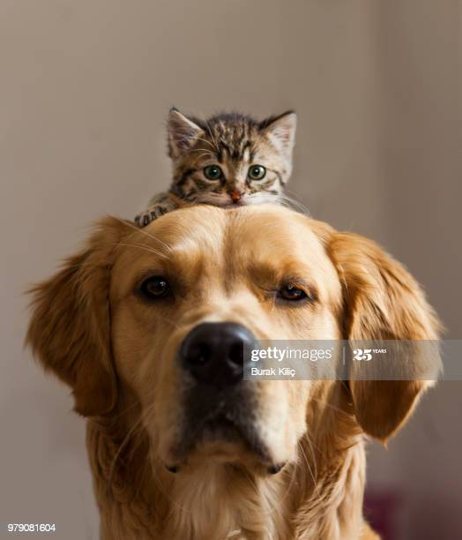
Fill in the Speech Bubbles with what you think the animals might be saying to each other.

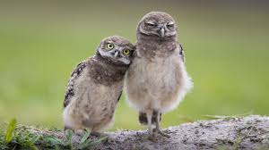

Here is an example of a diary entry from Little Red Riding Hood.
Can you use the sheet provided to write your own diary entry? It can be real or you can make it up.
Remember to
- include the date
- get it in the right order
- include words like then, next, after that
- include how you were feeling
Diary of Little Red Riding Hood
Saturday 12th September
Dear diary
What a day! I woke up this morning bright and early and mum told me that Granny wasn’t feeling too well. I had planned to nip round to Snow White’s but mum asked if I would take some yummy food to Granny instead. It was a beautiful day so I was happy to make the journey through the woods.
On the way I stopped to pick some flowers and a wolf appeared and told me that he knew a shortcut. He seemed very kind and wise so foolishly I believed him!
Finally, I arrived at Granny’s house but I knew straight away that something was wrong. She didn’t look herself at all! I asked a lot of questions and eventually realised it wasn’t her, it was the wolf!
Just then a kind woodcutter ran in and rescued us.
In the end the woodcutter brought me home. Mum couldn’t believe what had happened and I’m not sure I can either. I won’t be talking to strangers in the woods again.
Red
