Literacy and English  Reading for Pleasure  Pick a favourite book and read it with an adult. Can you help them sound out some of the shorter words? When you finish, draw a picture of your favourite part of the book. | Numeracy and Mathematics  Number formation  Practice writing the numbers 1-10 in shaving foam, paint, rice, salt, or use coloured pencils to make rainbow numbers | Health and Wellbeing  Emotions  Talk to an adult about things that make them worry and what they do to feel better. Together, come up with some strategies you can use when you feel worried and make a poster.
Literacy and English  Writing  Use the template below to make a story map for one of your favourite stories. Talk to an adult about what would happen if you changed part of the story. | Numeracy and Mathematics  Number Sequences  Play a game of hopscotch using the numbers 1 to 20. Go up and down the board, missing out a number (or maybe 2 or 3) each time. | STEM  Magnets  Test items around your house to see if they are magnetic or not. Can you work out what all the magnetic objects have in common?
Literacy and English  Comprehension  Listen to the story Silly Billy by Anthony Browne  (SILLY BILLY | Anthony Browne | Read aloud #storyoftheweek #storywithamoral ) and discuss these questions with an adult:  - What did Billy worry about?  - What did Grandma give Billy to help him?  - Do you think it’s good to share your worries? Why?  - Did you like the story? Why? | Numeracy and Mathematics  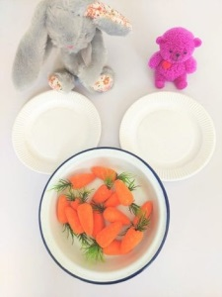  Equal Groups  Have a teddy bears picnic and share out the snacks. Make sure every teddy gets the same number of treats!  What happens when a teddy bear leave? What about when more arrive? | Expressive Arts  Art  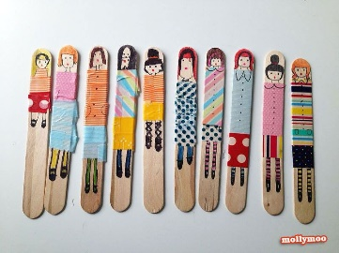  Using materials from around your house, make your very own Worry Doll.
Literacy and English  Word Building  Play a game of boggle using the template below. Ask an adult to fill it with the sounds you know and see how many words you can make! | Numeracy and Mathematics  Money  Make a coin rubbing picture and label the different coins. Talk to an adult about the different coins: what shape are they? What size? Are they all the same colour? | Social Studies  Make a Treasure Map  Hide some treasure somewhere in your house and make a map to help find it! You could even test your map by giving it to an adult and seeming if they can find the hidden treasure!
Literacy and English  Phonics  Practise your sounds with a game of sound snap using the letter cards below! For an extra challenge, you could practise your handwriting and make the cards yourself. | Problem Solving    How many different ways can you make the number 6 using things from around your house? | Health and Wellbeing  P.E.  Make an obstacle course in your house or garden. How quickly can you complete it? Can you beat your fastest time?

