Primary 2: Learning activities
(Remember: Primary 2 in Scotland is equivalent to Year 1 in England.)
Parents will need to register for a free account on Studyladder if they wish to use these resources. Click the link here to find the registration page.
Literacy | Numeracy | Health and Wellbeing
Reading  Read your own book or go to the Oxford Owl website where you can read an ebook and find activities.  Share a book with someone at home and then work on remembering questions.  Eg.  Remembering  Can you recall a fact from the story?  What is the setting in the story? – How do you know?  Name the main characters in the story? What are they like?  What was the first thing that happened in the story?  Can you list three main events in the story?  Who solved the problem in the story? – What did they do?  Grammar  Use the link below and try the activities in the grammar section eg. full stops and question marks and simple sentences.  https://www.studyladder.co.uk/games/literacy/gb-year-one  Writing  Write a description of yourself, someone you know or a character from a book or film.  You can use the writing template in the writing section – Writing Descriptions: Describe Yourself at https://www.studyladder.co.uk/games/literacy/gb-year-one as a guide.  Write a letter to a friend or a family member about something you have done.  Choose a favourite character from a book or film and write about the next adventure.  Find a picture of a place and write about what happens there eg. beach, playpark or write as many adjectives you can to describe the picture.  Write about whatever you choose!  Remember to include; capital letters and full stops and think about the adjectives and verbs.  Spelling  Create a table to practise the following sounds.  sh/ch/th/wh/qu/ng/ck  How many words can you list?  Common words  Test yourself on common words, work your way through the first 25 or first 50, identifying any you are unsure of. Focus on learning to spell some of these words.  Spelling rules  Practise the following spelling rules:  Suffixing rules –  - nouns adding s to form the plural  - verbs adding ing to show the present tense  - verbs adding ed to show the past tense  - Select words from a book or poem you are reading, see if you can change them by adding the suffixes.  Use some of the active spelling strategies you would use in class. Eg, writing out in different colours, pyramid writing, write sentences using as many of your spelling words as possible.  Try out some of these online games to practice your spelling using phonics or tricky words:  River rapids tricky word race  https://www.ictgames.com/mobilePage/rapidRiver/index.html  Forest Phonics sound spelling  https://www.ictgames.com/mobilePage/forestPhonics/index.html  Little bird Tricky word spelling  https://www.ictgames.com/littleBirdSpelling/  Phonics word search  https://www.ictgames.com/mobilePage/phonicFinder/index.html  Coconut Vowel word making game  https://www.arcademics.com/games/coconuts  Puzzles, word finders and spot the difference  https://www.bbc.co.uk/cbbc/puzzles  Handwriting  Here are some different ways to practice your handwriting:  - Choose words to practice and write them out 3 times using your neatest cursive writing. Then try putting them in a sentence  Talking and Listening  Try out some of the ideas below to practice your listening and talking skills  - Play 20 questions  - Play a board game  - Watch news round to learn about the news: https://www.bbc.co.uk/newsround/news/watch_newsround  - Place out some items. Remember them. Get someone to hide some of them. Can you tell what is missing?  - Chose an object or word etc. Describe it to a partner using one word or phrase. Can they guess it? Try adding more detail until they get it. | Log into studyladder; year 1 and try the following:  https://www.studyladder.co.uk/games/mathematics/gb-year-one  Addition  Try some of the addition activities including;  - Adding 1, 2, 3, 4, 5  - Adding by counting to 10, to 20  - Adding by counting (problem solving)  Subtraction  Try some of the activities including:  - One less than (problem solving)  - Subtracting 2, 10  - How many left – problem solving  - Subtracting 2 (problem solving)  - Subtracting from 10 (problem solving)  Multiplication  Try - counting by 2 activity  Division  Try – Share between activity  Numbers and Place Value  Try:- Reading, writing and ordering numbers to 100 and Counting by 10.  Data, Graphs and Statistics  - Choose simple questions to gather data  - Interpret data presented using drawings and symbols  Maths – Measurement  Measure yourself and your family, who is the tallest and the shortest.  Extra challenge: Can you put your family in height order?  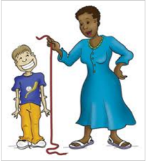  Maths – Data Handling  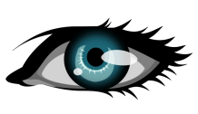  Ask your friends and family what their eye colour is. Can you make a simple tally chart?  Extra Challenge: What is the most common and what is the least common?  Also, you may wish to use the websites below for further activities.  Online Games  Play games at www.topmarks.co.uk  www.sumdog.com  https://home.oxfordowl.co.uk/kids-activities/fun-maths-games-and-activities/  Some others we recommend include:  Money  - https://www.doorwayonline.org.uk/time-and-money/  - https://www.topmarks.co.uk/money/toy-shop-money  Numbers  - https://www.ictgames.com/rangeArranger/index.html  - https://www.topmarks.co.uk/maths-games/mental-maths-train  Number bonds  - https://www.arcademics.com/games/alien  - https://www.arcademics.com/games/mission  Shape Puzzles  - https://www.starfall.com/h/geometry/puzzles-easy/?  Time (scroll down to the games)  - https://mathsframe.co.uk/en/resources/resource/116/telling-the-time  - https://mathsframe.co.uk/en/resources/resource/117/telling_the_time_in_words# | Art  Your fingerprint is completely unique, just like you!  Can you create some fingerprint art?  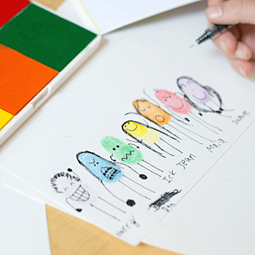  Draw a picture to illustrate your story writing.  STEM challenge  Can you make your own moving hand? Follow the link below!  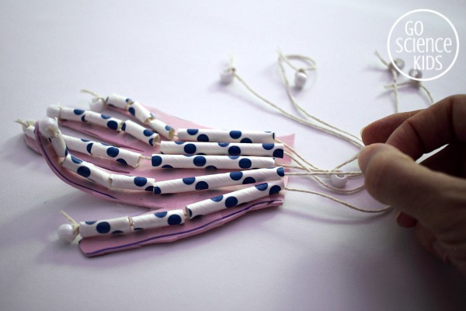  https://gosciencekids.com/articulated-hand-movable-fingers-joints-tendons/  STEM - Make your own 3D constellations.  1. Watch the video about stars.  https://www.bbc.co.uk/teach/class-clips-video/articles/zmfgkmn  A constellation is a group of stars forming a recognisable pattern.  The constellations that we know are patterns of stars in the sky, often shaped like animals or characters from legends. These patterns are extremely useful for learning your way around the sky.  2. Make your own 3D constellations by connecting the stars. You can also use marshmallows and toothpicks to make edible constellations.  * Challenge* - Why not have a go at making your own constellation and giving it a name!  Can you create your own constellation story, describing how it came to be in the sky?  For inspiration, watch the video - How Coyote Made the Stars.  https://www.youtube.com/watch?v=98vhIC8Eg1k  3. Get really creative and pretend to be astronomers, discovering new constellations.  Music - Constellation Song  Listen to the Constellation song below.  https://www.bbc.co.uk/cbeebies/watch/stargazing-constellation-song  French  Have a go at learning body parts in French using this song.  https://www.youtube.com/watch?v=bChrAwLzoSo  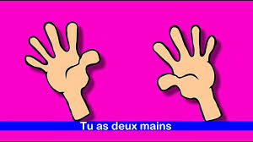  Memory  Try the apps below to develop your memory skills.  - Memorama  - Musical memory  Story telling  - Make a puppet of a character from your favourite story.  - 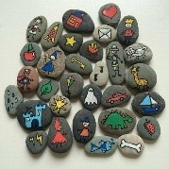Create your own story stones by drawing characters, props and parts of the setting on stones.  - Act out a story you like. Take on different characters. Think about what they act, look and sound like. Maybe even write a script.  - Use your toys to make your own movie by recording it on a tablet.  - Make up a silly story by taking turns to say a sentence. You should follow on from what the other person has said. E.g.  Person 1: once upon a time there was a little black dog.  Person 2: One cold day the little black dog was woken up with a crash…
  sh | ch | th | wh | qu | ng | ck

