Reading  If you wanted to find out some facts about something where would you look? Can you think of any information sources? Choose a topic you are interested in and find out 3 interesting facts about it. | Numeracy and Mathematics - Sharing  Put out two toys or teddies. Get a small pile of items e.g. coins, counters, cards. Share the items equally between your toys/teddies (e.g. share 6 between 2, 16 between 2). How many does each toy get?  Challenge: Are there any numbers of items which will leave a remainder when you share them between 2 toys? | Health and Wellbeing  Think about a scenario where someone is experiencing difficult/challenging feelings. Maybe something you have read in a book or seen on TV. Talk to someone at home about strategies that would help the person to feel better.
Tools for Writing - Vocabulary and Spelling  Use some words from a book you are reading. Can you think of a game you could play to help you learn your words?  Teach someone your game and explain the rules. | Numeracy and Mathematics - Number Fun  Choose a number (maybe start with a number up to 10). Make a book or poster about your number. Can you write it, draw it, show it in different ways? | STEM  Follow this method to make your own bubble mixture. What happens if you add more or less of one of the ingredients? Which bubbles last the longest? https://www.bbcgoodfood.com/howto/guide/how-make-bubble-mixture
Tools for Writing  Draw a character for a story. It can be human, animal, alien etc Then write words around your character to describe them. Remember the words will describe their personality, not just the way they look. | Numeracy and Mathematics - Days of the Week  Practise saying the days of the week in order. If today is Tuesday, what day is tomorrow? What day is it in 3 days time?  Challenge: Can you says the days of the week backwards? If today is Sunday, what day was it yesterday? | Expressive Arts  Can you recreate your school badge? You could draw, paint, model or collage using different materials. Be adventurous!
Writing – Creating Texts  Choose one of the poems in this pack.  Copy the way the author has written this one to write one of your own. You could use your own name. | Numeracy and Mathematics - Item Sort  Find some items in your home. Sort them using a rule e.g. sort into red and not red, sort into like and don’t like, sort into heavy and light.  Challenge: Can you sort using a rule you choose and see if someone can work out your rule? | Social Studies  Think about what you would like to be when you are older. If you wanted to be a shopkeeper you could make your own shop and ask someone at home if they would like to buy anything.
Listening and Talking  This listening activity needs a helper. Sheet 3 is to be read out to you and you complete the activity on sheet 4. Other activities can be found here.  https://www.teachingideas.co.uk/english/the-listening-skills-pack/ | Puzzle – Game Time  Play a board game e.g. Snakes and Ladders, dominoes or a card game. How many different times do you use maths during the game? | Religious and Moral Education  Watch this short story from Islam at the following link:  https://www.bbc.co.uk/bitesize/topics/zj3d7ty/articles/z4mvydm  What messages do the stories tell us about being kind? Are they similar to any other stories you have been told?

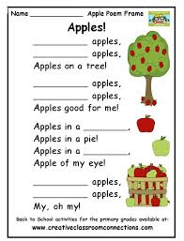

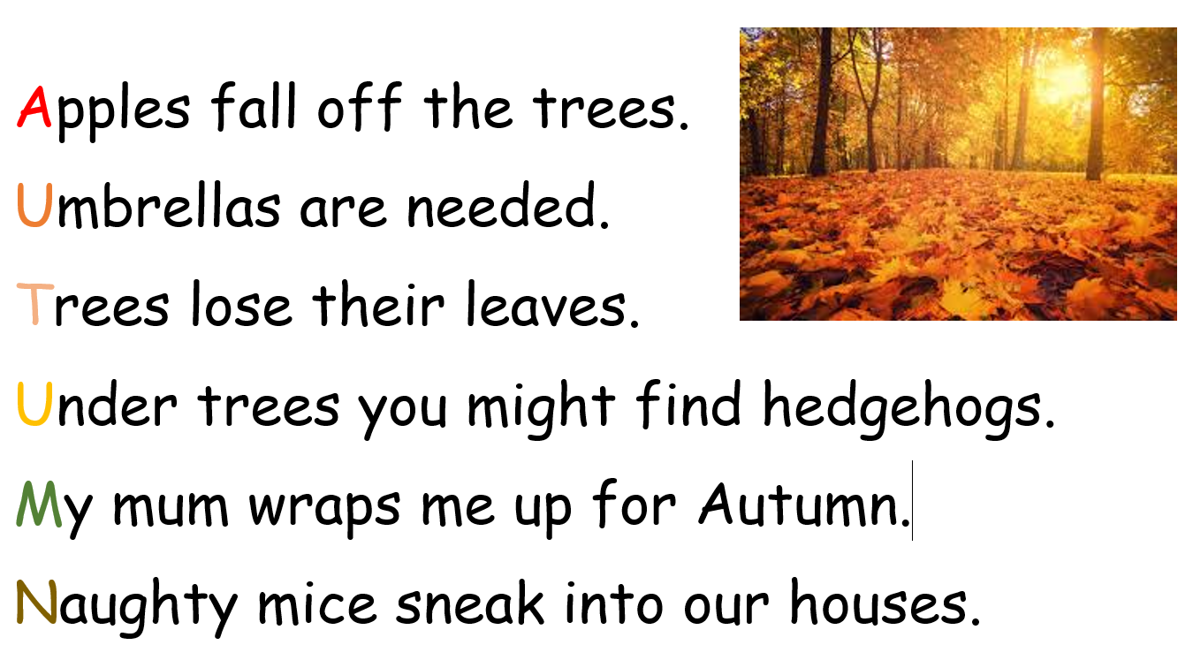

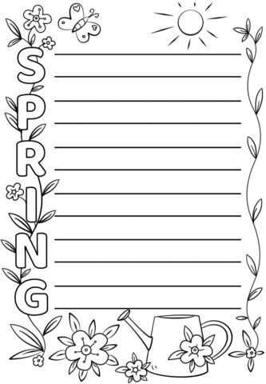

Sheet 3
Instructions for adult/peer Answers
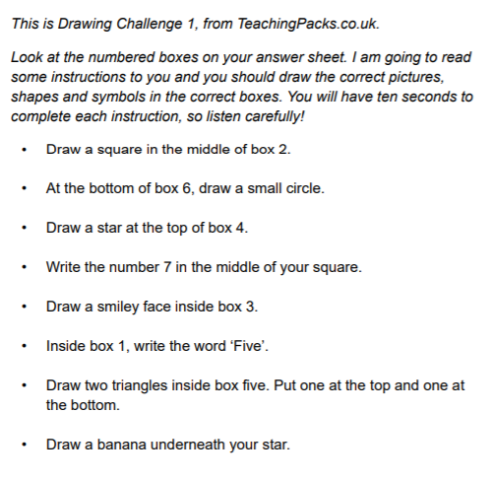

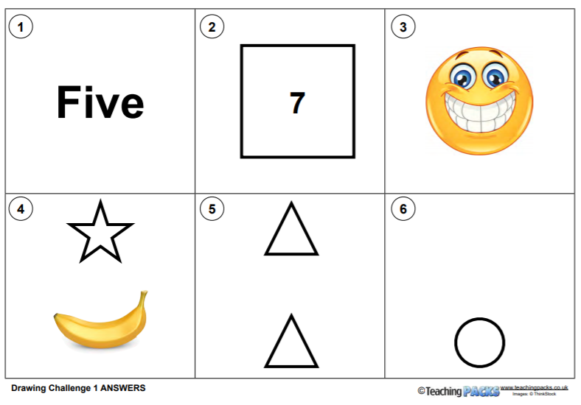

Sheet 4
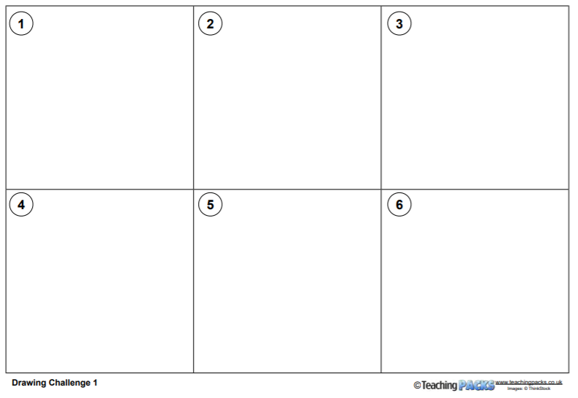
Pupil Sheet

