Literacy and English  Reading Task – Choose a book to read. Now write about the main character in the story. Choose 5 – 10 words to describe his or her behaviour. Give an example for each one. E.g. Sally is foolish when she goes to the mill by herself. | Numeracy and Mathematics  Top Marks - Visit www.topmarks.co.uk Go to maths games for age 7-11 and click on ‘Hit the Button’. Go to ‘Number Bonds’. Here you may choose ‘Make 100 (tens)’, or ‘Make 100’ which is slightly more challenging. Why not try some of the other games too? | Health and Wellbeing  Friendship bracelets – Make a paper friendship bracelet for somebody in your family or for a special friend. Follow the link below or input ‘DIY Easy Bracelet. Paper bracelet’ into the YouTube search box.  https://www.youtube.com/watch?v=Rh8w1cz6F8w&t=181s  You will need: coloured paper (you could use white paper and colour it in), scissors, cellotape and a pencil.
Literacy and English  Connect the dots spelling – Choose at least 10 spelling words from a story. First write your spelling words in dots. Then connect the dots by tracing over them with a coloured pencil. | Numeracy and Mathematics  Four operations - Roll a dice five times and record each number shown on the dice on a piece of paper. For example, 1, 4, 3, 5, 3. Then you need to find a way to reach an answer of 1 using any operations (addition, subtraction, multiplication, and/or division) on the numbers.  You can only use each number once and you have to use at least two numbers in each calculation. For example, we could get the answer of 1 by calculating 3 ÷ 3, 5 – 4, 4 – 3, and so on. Now try to find a calculation with the answer of 2 using any operation, then an answer of 3 and so on until you reach 21. | STEM  Invention: Invent and draw a robot to collect food from a local shop for someone who is staying at home. Think about how the robot travels and how it is going to pick up and carry food. Remember an invention must be something new or something better than we already have. You could build a model of your invention.
Literacy and English  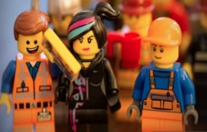  Story writing – You wake up to find that you are living in a Lego world. Write a short story about this event. How did you feel when you woke? What did you see/hear/feel around you? What did you do while you were there? How did you escape the Lego world, or did you decide to stay? If so why? Use punctuation and paragraphs so that your story makes sense! Read it aloud to your family at home. | Numeracy and Mathematics  Ordering numbers - Order these numbers from largest to smallest.  A. 53,241 66,467 68,987 85,329  B. 10,237 10,190 9,931 10,202  C. 35,421 42,019 8,983 54,874 | Expressive Arts  Fantastic Creature Design - Design and draw a fantasy creature which has all the features listed below.  - can burrow underground  - has armoured skin  - has good hearing  - can run fast  - has webbed feet for swimming  - has sharp claws  - has sharp teeth  - not easily seen in undergrowth  - has a long neck for seeing over high walls  - has very good eyesight  - has a long tongue for catching insects
Literacy and English  Spelling Dots Game – This is a two-player game. Make a square of 4 rows of dots with 4 dots in each row. Take turns to read a word for your partner and they spell it. If the word is spelled correctly, the player can connect two dots. When a square is formed, he can write his initials in the box. Good Luck!  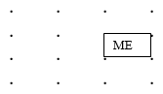 | Numeracy and Mathematics  Money - Look at a takeaway menu or a catalogue page. Now work out what you would buy with £10 or £12. How much money you would have left over? If you don’t have a menu at home you could use one from online. | Social Studies  Famous Scots – Choose a famous Scot to research. Some suggestions include Robert Burns, David Livingstone, James Watt or any Scottish Olympians.  Create a timeline of important events and achievements in their lives.
Literacy and English  Punctuation - These sentences are missing punctuation and capital letters. Rewrite them using the correct punctuation.  - our neighbour mr jones drives an aston martin just like james bond  - i have to go to asda today for a few things i need to get bread milk sugar and flour  Now write 5 more sentences of your own. Check your work for capital letters and punctuation. Try to include at least 3 different types of punctuation in each sentence. | Problem Solving  Number detective - Be a detective and think creatively. Follow the clues and use your reasoning skills to find the mystery number. Click on the link below to access the task or see attached worksheet  https://nrich.maths.org/204 | Health and Wellbeing  Your Strengths - Talk (or write) about a time when you had to do something difficult and you got through it. Explore how you felt beforehand and how you overcame the challenge. Think about which character strengths you used to help you.

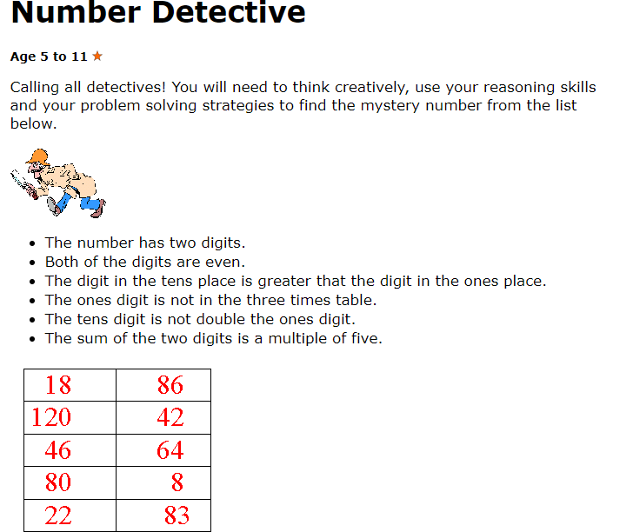
https://nrich.maths.org/204
