Literacy and English  Reading Task – Choose a book to read. Find 5 – 10 interesting words in this book. Write down what each one means. Then use each word in a sentence of your own. | Numeracy and Mathematics  Counting forwards and backwards in 6’s, 7’s, 8’s – throw or bounce a ball and practice counting forwards and backwards by 6’s, 7’s and 8’s | Health and Wellbeing  Obstacle course – Create your own indoor or outdoor obstacle course using anything you can find! You could take photos of it or make a video explaining how to set up your course and what you’ve to do! Have fun!
Literacy and English  https://www.pobble365.com/greedy/  Click on the link to see the picture.  Scroll down to choose two or more of the activities: Story Starter  Question Time  Sentence Challenge  Sick Sentences  Perfect Picture | Numeracy and Mathematics  Writing numbers – practice saying these numbers.  4,567 3,514 40,627 86,540 87,649 62,285  Now try to write them in words.  Challenge: Can you write in words the number that comes next after each one.? | STEM  Food Technology - Design a healthy breakfast, snack, lunch or dinner using ingredients in your house.  Help to make one of these meals if possible!  Can you put the foods you have used into the correct food groups? (Fruit and vegetables, diary, meat/fish, carbohydrates, fat/sugar group) Draw a picture to show your findings.
Literacy and English  Story writing – Using the attached sheet write a short story about a witch that lives here. What kind of witch is she? Why does she live in this dwelling? What does she do? Use the story guide to help. | Numeracy and Mathematics  Running Dice–You will need 2 dice. This is a two-player game. Roll both dice and add the amounts together to get a total. Take it in turns to add the number rolled to the running total. Try and answer before the dice are rolled again by your partner. Who gets past 100 first? Can you play in reverse –start at 100 and subtract! | Expressive Arts  Musical instruments – Listen to a piece of music of your choice. Can you identify and name the types of instruments you hear playing? Write them down.  Research these instruments and create a poster to show what you have learned.
Literacy and English  Upper and Lower – Choose at least 10 spelling words from your favourite book. First, write each word in UPPERCASE letters. Second, write each word in  lowercase letters.  *Example- SLIDE slide | Numeracy and Mathematics  Staycation 2020 - Your task this week is to plan a dream day out and work out how much it will cost. Let’s call it a staycation!  See the attached information. | Social Studies  Famous Scots – Choose a famous Scot to research. Some suggestions include Robert Burns, David Livingstone, James Watt or any Scottish Olympians.  How does their life compare with ours? Display this in writing or with drawings to show the differences.
Literacy and English  Punctuation Thief - Oh No! Someone has removed all the punctuation from ‘James and the Giant Peach’ and ‘Gangsta Granny’ (attached). Choose one to read. Read it aloud to help you insert the correct punctuation. | Problem Solving  Find the difference - Place the numbers 1 to 6 in the circles so that each number is the difference between the two numbers just below it.  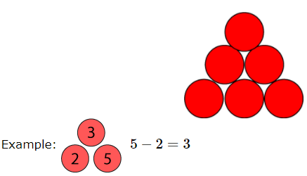  Or play interactively on https://nrich.maths.org/6227 | Health and Wellbeing  I admire you – Draw a picture of someone you admire. Why do you admire them? Why not create a card for that person and share how you feel.

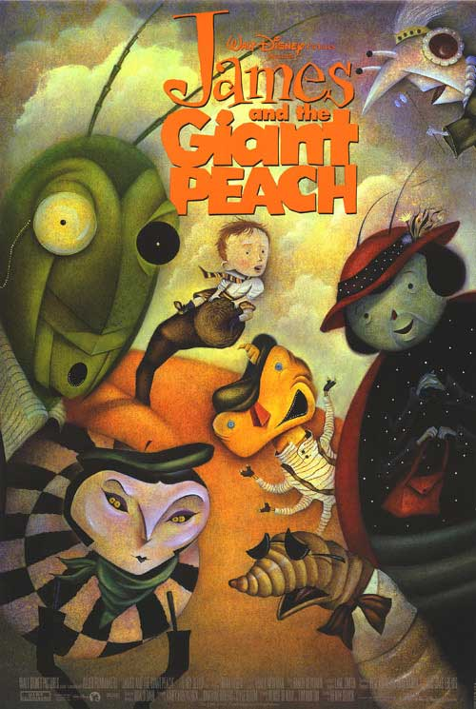
commas ,
exclamation marks !
speech marks “ ”
question marks ?
Punctuation Thief! Someone has removed all the punctuation from ‘James and the Giant Peach’. Read it aloud twice to help you insert the correct punctuation.

Hint: Look at the boxes below to choose the appropriate punctuation.

theres more magic and power in those things in that brown bag than in all the rest of the world put together the old man said softly but but what are they james murmured finding his voice at last. where do they come from. ah-ha the old man whispered youd never guess that. he was crouching a little now and pushing his face closer to james until the tip of his long nose was actually touching the skin on james’s forehead.

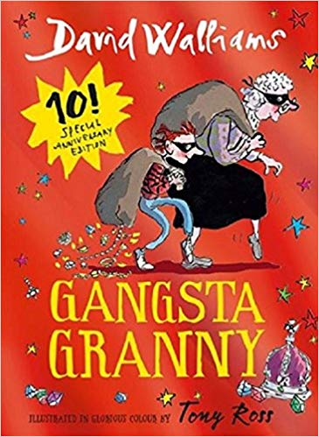

Punctuation Thief! Someone has removed all the punctuation from ‘Gangsta Granny.’ Read it aloud twice to help you insert the correct punctuation. (page 216)
Hint: Look at the boxes below to choose the appropriate punctuation.

The unlikely pair of gangstas stood at the riverbank Are you ready asked Granny her mask completely steamed up from sitting in the back of a police car for over an hour. Yes said Ben trembling with excitement Im ready
Granny reached out to hold ben’s hand and then she counted three two one and on one they leapt into the dark waters below
Staycation 2020

Your task this week is to plan a dream day out and work out how much it will cost. Let’s call it a staycation!
Here are some things to think about and research:
• Where would you like to visit? Maybe ask your family for ideas too.
• How will you get there?
• If you go by public transport (e.g. bus or train), work out your route and how much it will cost.
• If you go by car, work out the total number of miles and cost of fuel.
• What would you like to see and do? This website may help you https://www.visitscotland.com
• Look online and choose up to 5 activities for your day out. Write down your ideas and make a note of the websites (you may want to use them again later).
• Find them on a map and work out how to get from one to another and how long it will take.
• Where will you eat and drink while you are there? Look at menus online and choose your favourite lunch and dinner.
THE CHALLENGE - • Work out how much your dream day staycation will cost.
Extra challenges
• Ask your family to set a budget for the day out (how much it will cost). Will you need to change your plans at all? If so, plan out another version so that the total cost will be under the total budget.

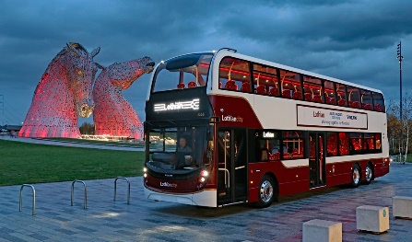
• Make a Powerpoint of your staycation and share it with your family.

• Design a poster for the place you want to visit.

Which Witch Lives here?

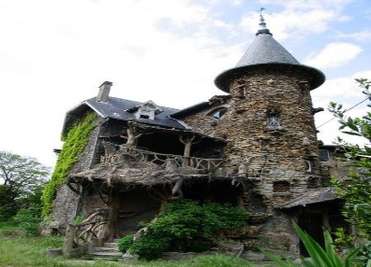
Look at this picture. Write a story about the witch who lives here? Think about what kind of witch she is, how did she end up living here? What does she do during the day and at night? Does she have any pets living with her? Do any friends live nearby?

