Literacy and English  Read every day for 25 mins. Choose 10 descriptive words (adjectives or adverbs) from your book. Write 3 synonyms (words with a similar or related meaning) for each descriptive word. | Numeracy and Mathematics - Target 100  Roll two dice to make a two-digit number (or make up your own number). What do you have to add to this number to make 100? Can you work it out a different way to check your answer? Roll and repeat…  Challenge: Can you roll 3 dice and make your target 1000? | Health and Wellbeing  Circle of Feelings. Think about different feelings and how you might recognise that someone was feeling like this. Write the words into a circle of feelings, with all the good, positive feelings inside the circle and the not so good/negative feelings on the outside.
Literacy and English  Journalism -choose a news event you are interested in, past or present, and compose a news article that shares the news with the public. For example - Messi Leaves Barcelona, Bake Off Winner Crowned, Lockdown for Britain. Use the News Article sheets to help you. | Numeracy and Mathematics – Addition Challenge  Roll a dice 3 times to make a 3-digit number (or make up your own number). Repeat so that you have 2 numbers. Add them together to find the total. Can you work it out a different way to check your answer?  Challenge: Can you make 3 numbers and find their total? Use a different strategy to check your answer. | STEM  Invent a machine to improve you and your family’s lives. What would it be able to do and how would it work? Think about the important features, how it would be powered and who it is designed to help. Who knows- you might end up on Dragon’s Den one day!
Literacy and English  Design a poster about your favourite hobby. The aim of the poster is to share information about the skills you can learn and the benefits of having this hobby. For example, baking, football, dancing, singing etc. Remember to include a heading, pictures and key words/statements. | Numeracy and Mathematics - Rugby Score  In rugby, you get 3 points for a penalty, 5 for a try and 7 for a converted try. A team scored 36 points. Find all the ways they could have scored these points, e.g. – 4 tries, 1 converted try and 3 penalties.  Challenge: Make some problems up for your family to solve. Can you make one which has more than one solution? | Expressive Arts  Doodle Drawing! Use a few coloured pens or pencils and doodle random shapes on paper. Your challenge is then to turn your doodles into animals or objects of your choice. Can you create a story or a song based on the relationship between your doodle drawings?
Literacy and English  If a news article is biased, it means that it takes sides and does not give a fair representation of both sides of an argument. Why do think balanced reporting is important? Complete the activity to help understand this more. | Numeracy and Mathematics – 3D Object Hunt  Look for 3D objects around the home e.g. a tin of baked beans. Name the objects you find (can you find a cylinder, sphere, cuboid?). Describe your object to someone e.g. how many faces, edges and vertices (corners) does your object have?  Challenge: Can you hide your object and describe its properties to someone (e.g. how many faces) so they can guess which object you have? | Social Studies  Research what lockdown in Edinburgh in 1645 was like. Were there similarities to today? How has technology helped us? Would you prefer to be living now or then? Write up a pros and cons table to support your view.
Literacy and English  How do we change indirect speech into accurately punctuated direct speech? Look at the examples and have a go yourself using the direct speech worksheet. | Puzzle  What is the number in the blue box?  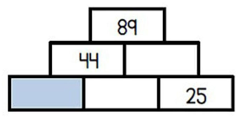 | Health and Wellbeing  Learning Intention: be able to identify the characteristics that make a good friend. Create a paper doll chain using plain paper, a pencil and scissors. On each doll write 3 qualities that make a good friend. Attached is a YouTube link on how to make paper dolls. https://www.youtube.com/watch?v=kZo68K6vWZ4EXT

CHECKLIST: Newspaper / Magazine Article

Features of a Newspaper / Magazine article My ideas for my first draft
What kind of article is it?
News (local, national or international) /Sport / Entertainment / Fashion / Weather etc.
Think of a bold and eye-catching headline.
Organise information in subheadings
Write each paragraph as a column, how many will you have?
Write in a ‘news style’ with short and informative sentences giving details about the 4 W’s
- Who is the story about?
- What has happened?
- Where did the story take place?
- When did it take place?
How did the event unfold, what are the details?
Use quotations from the main person and eye witnesses
Use interesting vocabulary that hook the reader in and holds their interest.
What other features of magazines/newspapers are there on the page?
e.g. competitions/advertisements/letters
Include a picture or photograph with a caption.

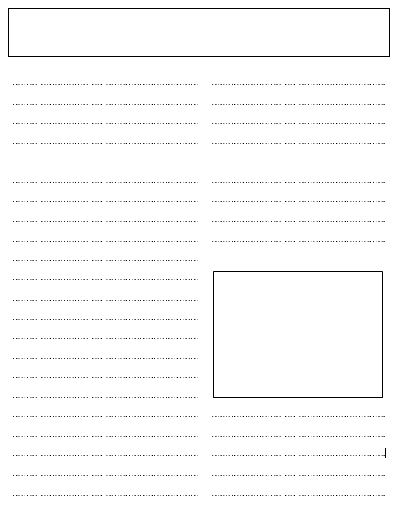

Biased or Balanced?

If a newspaper or magazine article is biased, it means that it takes sides and does not give a fair representation of both sides of an argument.

If a newspaper or magazine article is balanced, it means that it does not take sides and it considers both points of view in an argument or situation equally.

Here are two short articles about the same subject. Do you think they are balanced and fair articles, or do they take sides and present only one point of view?

Ain’t they got anything better to do?

Imagine the scene: you’re a 77-year old woman, fiercely independent and used to living alone. The house you have lived in all of your life becomes freezing as temperatures plummet in winter. You have no central heating and little money. In desperation you walk miles to a local park and cut down a tree for firewood. Whilst lugging the heavy wood home, you are stopped by the police and arrested for destroying public property! This is policing gone mad. Why arrest the innocent people when real criminals are roaming the land?
Woman arrested for chopping down tree

Brenda Haindrock, 77, was arrested yesterday for chopping down a tree in Pumley Country Park.
Police Constable J. Smith said the pensioner was apprehended at 5pm on High Street as she dragged a tree along the pavement.
Mrs. Haindrock, when interviewed, said: “I have no money for coal or firewood, so I chopped down a public tree. I’m a member of the public so why I can’t I do that.”
A police spokesman said: “Destroying public property is a crime.”

So, which article do you think is biased and which balanced? Why?

Why do you think it is important for the media to report an unbiased and balanced view?

Why do you think it is important for people to be able to recognise the difference between biased and unbiased views?

Have you ever encountered bias in the media? Discuss this with an adult in your family.
Indirect Speech to Direct Speech
In previous learning, we changed direct speech into indirect speech. We are now going to do the reverse by changing indirect speech into direct speech.
To do this correctly, we need to remember where the punctuation goes.
Look carefully at where the commas, speech marks and full stops go in each example.
Zia said that the work was fun.
becomes
“This work is fun,” said Zia.
Musa whispered to Alfie that he knew the answers.
becomes
Musa whispered to Alfie, “I know the answers.”
Now change the following sentences from indirect to direct speech.
1. Minael whispered that the work was easy.
2. Ishan complained that he wanted to go home.
3. Alisha said that Ben was a good cricketer.
4. Samantha whispered to Elena that she loved the new class project.
5. Mr Swan announced that he was retiring.
6. The news reader announced that the River Tweed had flooded.
7. The frightened child screamed for help.
8. Rosa pleaded with the referee not to send her off.
9. The anxious new child asked where her teacher was.
10. Ms Yates told her class to do their best work.
Mr Regent quietly asked the class to get on with their work.
Notice that the last example uses an adverb. Can you write a reported speech sentence similar to the one above (using an adverb) e.g. calmly, confidently, gently, encouragingly?

Self-reflection Plenary
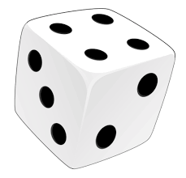
At the end of a day of learning you might like to choose a row (A, B or C) and roll a die to select some self-reflection questions. You can Look at them by yourself or, even better, discuss them with someone else.
 | 1 | 2 | 3 | 4 | 5 | 6
A | Were there any tasks today that I found too easy? Why? Could I have added my own challenge? | Were there any tasks today that I found too difficult? What made it difficult? Did I give up straight away or keep trying? | Did I estimate correctly how long each task would take? If not did I under estimate or over estimate? | Did I start with the easiest bits of the task or the hardest? Did I work through tasks in a specific order? | Did I try going back to a tricky task later and reading it again? Did it make a difference? | Did any of yesterday’s tasks make more sense today now that my brain has had time away from it?
B | Which parts of today’s tasks used knowledge I felt confident about remembering? | Which tasks had new learning in them? What did I learn? | Thinking of one of my tasks. Did I understand the concept that I was working on? | Did I find it easy to stay on task today? What helped/hindered this? Is it different depending on the task? | Can I think of ways to improve my motivation for tomorrow? | Do I need to practise anything to make tomorrow’s learning easier?
C | Did I have everything I needed to complete the tasks? Did I use anything to help me? | Did I get stuck? How did I get past that? Did I give up or try something else? What did I try? | What made my learning stick today? What did I do that helped me understand a particular task? | How can I make sure I remember what I learned? What have I done in the past that has worked? | How long do I think I will remember what I learned? How could I check next week, next month? | Am I worried about anything after today’s work? What can do if I am worried?

