Reading  Read daily for 25 mins.  Summarise the last chapter you read, or the book so far. Include the main characters, setting and the main events. It may help to note down key words as you read. There is a sheet provided. | Numeracy and Mathematics - Odd One Out  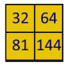  Look at the 4 numbers in the box. Can you find a rule which would work for 3 of them but not the 4th (therefore the 4th number would be the odd one out)? Here is an example: three numbers are even because they can be divided by 2 (32, 64 and 144). The 4th one is not even (81) so it’s the odd one out.  Challenge: Can you make a box of 4 numbers for someone in your family to try? | Health and Wellbeing  Think of someone in your community that keeps you safe and helps your community function. Can you write a letter or a certificate to them to say thank you?
Literacy and English  Story explorer – think about a story you have read that has an interesting setting. Make a list of all the places and features of this setting. Draw a map that shows all these features and how they are connected. Use the story explorer sheet to help you. | Numeracy and Mathematics - Times Table Chain  Draw a long rectangle with 10 boxes.  Pick a number card (between 1-10) from a deck of cards. If you pick a 4, multiply 4 by 9 and write the answer in the fourth box. Continue to complete the rectangle.  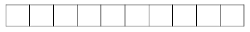 | STEM  Create a lockdown time capsule. Can you create a video and include a link to it that your future ancestors would be able to access? What 3 things could you put in that would tell the future what life was like in 2021?
Literacy and English  Visitor’s Guide – design a leaflet or web page about a story setting you know well that tells people all about the story setting, for example, Hogwarts School. What would you expect to see and do when you visit? Use the guide sheet to help you! | Numeracy and Mathematics - Estimation  This activity will help you to use estimation to solve a real-life problem. Find the activity later in this pack. | Expressive Arts  Choose a section of the book you are reading to act out like a play. You may need to rewrite some lines as though they were in a script. See if you can convince someone at home to play one of the parts too!
Spelling and Vocabulary  synonyms – use a dictionary or thesaurus to help you investigate words with a similar meaning. Complete the worksheet provided and have a go at the game. Cut out the words, you might want to stick them onto card first (an old cereal box works well) then turn them face down. Try to turn over 2 with the same meaning. | Numeracy and Mathematics - Measurements  In this activity, you will change metres (m) to centimetres (cm) to compare measured lengths. You will be challenged also to compare distances which are written in different ways. Find the activity later in this pack. | Social Studies  Make a cloud-wheel by drawing round a circular tub, splitting it into 4 quarters and labelling using the following link: https://sciencing.com/types-clouds-kids-8294039.html  Can you draw a picture for each to help you categorise the clouds seen from your window?
Listening and Talking  Prepare a talk on something where different points of view are discussed, ie school uniform, protestors, strike action etc | Problem Solving - Pocket Change  Use some small change – 1p, 2p, 5p, 10p, 20p pieces. Ask a homework buddy to work with you. One of you should put some coins in your pocket and say, for example, “I have three coins in my pocket worth 16p.” Your partner must work out what the coins might be. Swap over and play again.  Challenge: Try with 4 coins. | Health and Wellbeing  Create an exercise routine set to your favourite song. Choose a song with high tempo and plan your exercises accordingly. You could even teach the routine to a friend or family member over video-call.

Synonyms
Synonyms are words with a similar meaning e.g. friend and pal.
Link up the words below into synonym couples.
Now try to find other words that mean the same as these words. Write your suggestions in the think bubbles. You could use a thesaurus to help you (there are online versions).
speedy damp
hot quick
wet scalding
cold delighted
happy chilly

prquiet
prbusy

Complete these sentences using your synonyms for busy or quiet.

As the sun set the waves lapped onto the ____________________ beach.

The pickpocket scurried through the _______________________market place.

The _________________________ playground was alive with the sound of nursery children.
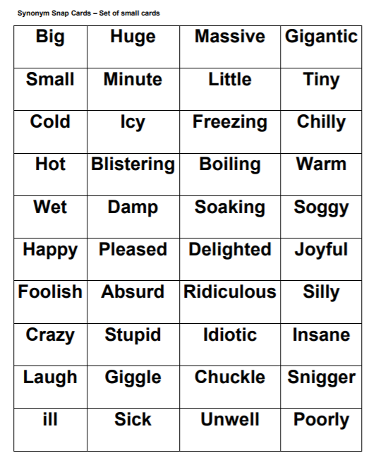

From Primary Resources

Planning My Talk
Opposing views
Information about the topic
My opinions are …. and reasons for these.
How I plan to invite others to have their say.
Chosen topic (and why)
Summary
Key words from reading
Setting
Characters

Story Explorer
Every story deserves a good map! Maps help us explore and when it comes to a good story we don’t want to miss anything. Think about the maps you remember from children’s books - The Hobbit, Lord of the Rings, Narnia, The Marauder’s Map in Harry Potter or The Isle of Berk in How to Train Your Dragon. Maps can be really creative and show more than just locations and geographical features - they can bring all the elements of the story to life and show us what it might be like to explore them! The map could be of a whole world or just a small cityscape, depending on the setting. Choose a book you have read and enjoyed to use a focus for your map. If you like sharing stories with younger children, try creating a map of a well-known fairy tale such as Jack and the Beanstalk or Little Red Riding Hood.
Your map should include….
- key landmarks and physical features in the setting e.g. the school, the swamp, the dark tower,
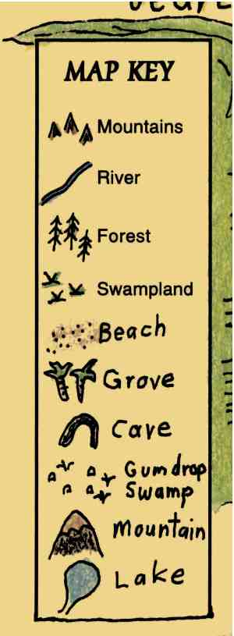
- a map key that helps the reader identify specific places e.g.
- locations of characters

Make a list of all the things you would like to include on your map below …..

Now sketch out and label your map on a blank sheet of paper or use the grid sheet provided.

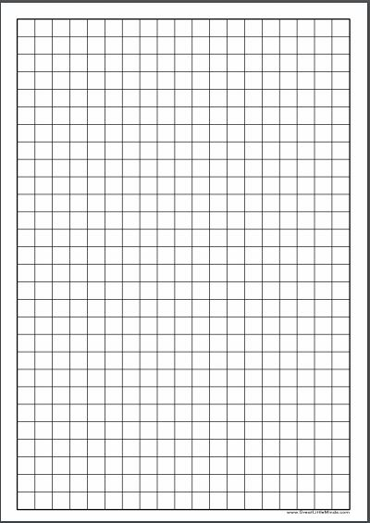
Numeracy and Mathematics – Estimating
This activity will help you to use estimation to solve a real-life problem. Imagine you have been asked to make a wooden frame for a picture you have painted.
The picture is a rectangle with sides that measure 27 cm and 59 cm. The wood you need comes in 1 metre (100 cm) lengths.
Round the measurements to the nearest 10 cm to estimate how many 1 metre lengths of wood you need to order. You could draw a sketch of the frame and the lengths of wood on paper to help you in this activity.
How much wood will you need and how much is left over?
How close was your estimate?
What size frame could you make with your leftover wood?
If you paint another picture with sides that measure 25.76 cm and 58.29 cm how much wood will you need?
Round the measurements to the nearest whole number to estimate how many 1-metre lengths of wood you need to order for this frame.
Estimate how much wood you will have left over to the nearest whole number.
Now calculate the exact amount of wood you would need to make the wooden frame and how much wood you now have left over.
Was your estimate reasonable?
Do you have enough wood left to frame another picture you painted which measures 6.5 cm by 4.7 cm?

Numeracy and Mathematics - Measurements
In this activity, you will change metres (m) to centimetres (cm) to compare measured lengths. You will be challenged also to compare distances which are written in different ways.
This table shows the distance six children jumped in a long-jump competition. Write all the distances in centimetres.
Use the distances in centimetres to work out
  - which child jumped the furthest?
  - what is the difference between the longest and shortest jump?
  - what is the total distance jumped by all 6 children in centimetres? Convert this amount into metres.
Child | Distance jumped
1 | 150 cm
2 | 2.30 m
3 | 203 cm
4 | 312 cm
5 | 1.75 m
6 | 3.21 m

Child 1 and 2 also took part in a 10 kilometre (km) race. After 20 minutes, child 1 had run 7 km 20 m and child 2 had run 7.2 km. Which child was in the lead? Explain to someone else how you worked out the answer.

Visitor Guide
Stories are full of exciting places to go, things to do and people to meet (or maybe magical creatures!) or see. Think of a story setting from a story/book you know well. What are the things that make the setting exciting to explore?
You are going to design and write a Visitors Guide to your chosen setting. It can be a hand written leaflet or a website page (completed on SWAY, Powerpoint or Word).
When composing your Visitor Guide, include information on the following, using these subheadings. You can also add you own sub headings if you wish!
• Location - What kind of atmosphere does the place have? Scary, funny, exciting? Is the setting a ‘real’ place or fantasy, or a combination of both? Or is the setting historical?
• Climate - Is it a hot or cold place? Do visitors need to wear special clothes? They might need a costume! What will the weather be like? Maybe the story is set in space!
• Transport - How will visitors get there? If it’s a different place in time, they might need a time machine. If the story is set in space, they might need a rocket. Or maybe they’ll travel by horse and cart! Is there a special way to explore the world they’re visiting? Maybe they’ll have to travel by umbrella!
• Attractions - Are there different attractions that could be visited? For example, if you went to Hogwarts you might like to visit Hogsmeade and the Shrieking Shack. Or if you went to Dream Country you might want to see the dream jars. Is there anywhere that should be avoided if it’s dangerous?
• Things to do - What can they do while they’re there? Ride a dragon with Horrendous Hiccup or go on a motorbike with Gangsta Granny? Or maybe race through the jungle with Mowgli and Baloo the Bear?
• Food - What food can they expect to eat when they get there? Are there places to eat? Will they be able to eat the food or is it dangerous? Maybe they could try Willy Wonka’s everlasting gobstoppers or have a picnic with The Famous Five?
• People - Who might they see when they are there? Maybe they’ll meet some hobbits, or Tom Gates or Mabel Jones! Think about the characters in the book and think about what kinds of people or creatures live in the story world you are focusing on.

Once you have completed your Visitors Guide, share it with a family member and ask them for their feedback. Does your leaflet make your story setting sound exciting to visit? Would they like to go? Which part do they think sounds the most interesting?

© National Literacy Trust 2018 Story Explorers © National Literacy Trust 2018 Story Explorers

