Reading  Read daily for 30 mins  Write about your favourite author. Explain what it is that you like about them. Is it the genre they choose, their style or choice of language? | Numeracy and Mathematics - Make 48  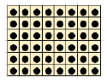  This is an array showing 48 dots. All rows have the same number of dots (8), and all columns have the same number of dots (6). How many other arrays can you show that contain 48 dots? Can you draw all the options you can find? | Health and Wellbeing  Set yourself 3 SMART targets for the rest of the school year. The targets you set yourself should be:  Specific  Measurable  Achievable  Relevant  Time bound
Literacy and English  The Diary of a £5 note – this was the title of the winning GOLD story from BBC’s 500 words competition. Read the story and look for the ways Vishal S (author) brought this inanimate (not alive) object to life. Create your own The Diary of... using an everyday object of your choice... e.g. the lunch box, the pencil case, the gym shoe..... | Numeracy and Mathematics - Packed Lunches  Put yourself in charge of choosing and ordering 5 packed lunches. Find the activity and information later in this pack. | STEM  Design an item of clothing that contains a super-power to help you back at school. Glasses that read at double-speed? Gloves that help you to write? Draw a detailed diagram and explain how your invention would be useful.
Literacy and English  Author Profile – What inspires an author to write? Where do their ideas come from? What is the writing process like for them? Follow this link to find out about well know authors and their work. https://www.scottishbooktrust.com/authors-live-on-demand Complete the Author Audio task sheet. | Numeracy and Mathematics - Ice Cream Sums  Tubs of ice cream are delivered to shops in boxes. If a box contains 30 tubs, how might they be packed? For example, they could be packed in 2 rows of 5 tubs stacked three layers high. How many other ways can you find to pack 30 tubs of ice cream in a box? Write down or draw the different ways. How might the tubs be packed if there are 48 inside a box?  The boxes of ice-cream tubs come to the shops in a refrigerated lorry. If a lorry holds 600 bumper boxes of tubs which each hold 48 tubs, how many tubs is this altogether? | Expressive Arts  Watch a film and closely study your favourite character. Look at how they use facial expression and their body to show how they feel. After watching, choose a short section of the film to act out. Try to use the techniques that you observed the actors using.
Spelling and Vocabulary  Suffixes are letters added to the end of a root word. Use the columns on the accompanying sheet to note as many words as you can find which have the relevant suffix. A dictionary might help you if you get stuck. | Numeracy and Mathematics - TV Guide  Use a TV guide from a newspaper, magazine or online. Choose your favourite programme on three days of the week. For each programme, work out how long your programme lasts for. Work out how long you will have watched TV in total if you watch these three programmes. | Social Studies  Do you agree with the restrictions that have been brought about during the COVID-19 pandemic? If you were in charge of the government, what would you do differently? List three things that you agree with and three that you don’t- try to explain your answers.
Talking and Listening  Be a critic. Watch a TV show - evaluate different aspects of the performance, including how believable the characters are, the dramatic effects and suitability for different audiences. Discuss your thoughts with a family member or friend. | Puzzle - Ball Throw  Find someone to play this game with and find a ball or something else you can throw e.g. a rolled-up sock. Choose a target number. A good one to start with is 10. Say a number less than 10 and throw the ball. The other person has to catch the ball and say that number partner to make 10 e.g. if you say 7 then they must say 3.  Challenge: Can you do this for a bigger or harder target number? Can you say your answer before you catch the ball? | Health and Wellbeing  Look after a baby for a week! Boil an egg, let it cool, give it a face and a name. You now have your very own egg-baby to care for this week. You must keep your egg-baby close to you at all times!

Numeracy and Mathematics – Packed Lunches
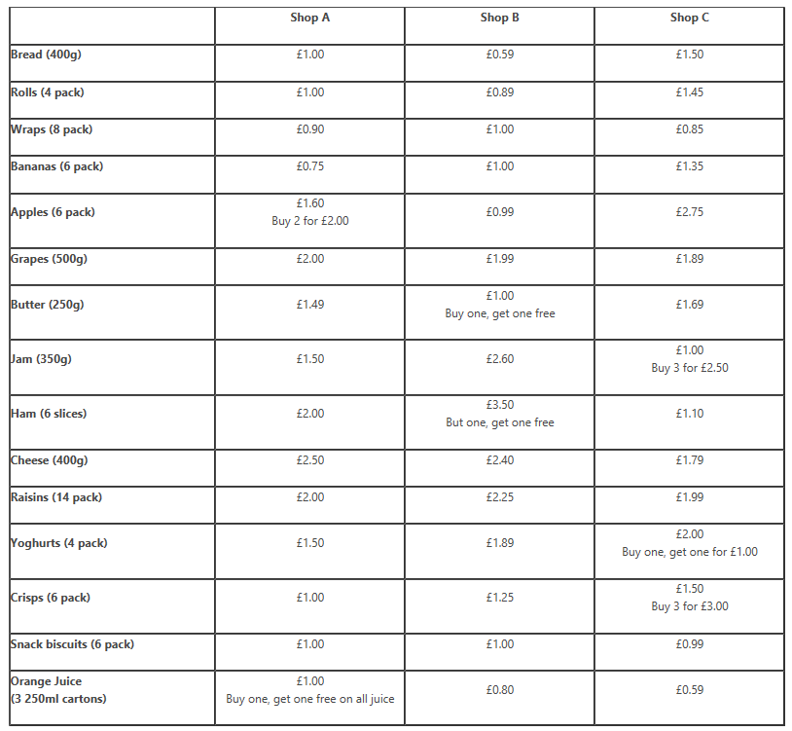
In this activity, you are going to plan ‘back-to-school’ packed lunches. There needs to be enough food to have 5 lunches. Each lunch should include a filled sandwich/roll or wrap, a drink, a piece of fruit and at least 2 other snacks.

Use the table to compare costs and work out what you would like to buy for each of the 5 lunches using a £12 budget. Remember that some of the items are ‘on offer’. Write down what you will buy, how much it will cost and if you have any change/money left. Write out a menu for the 5 lunches.
If you only have time to visit one shop, which of the shops will give you the best value for your money? Use this table to price the items in each of the shops which you have chosen to buy above. Remember to think about the amount of portions that each item will provide. Remember to make sure you stay within the £12 budget.
Discuss with an adult which shop you would choose to buy your items from. Share your shopping list with the adult and talk about how much of your budget you spent. Explain why you chose to buy things in certain shops

My Favourite Author
Author’s name

Favourite book written by this author

Reason for liking this particular author
Any facts you know about the author

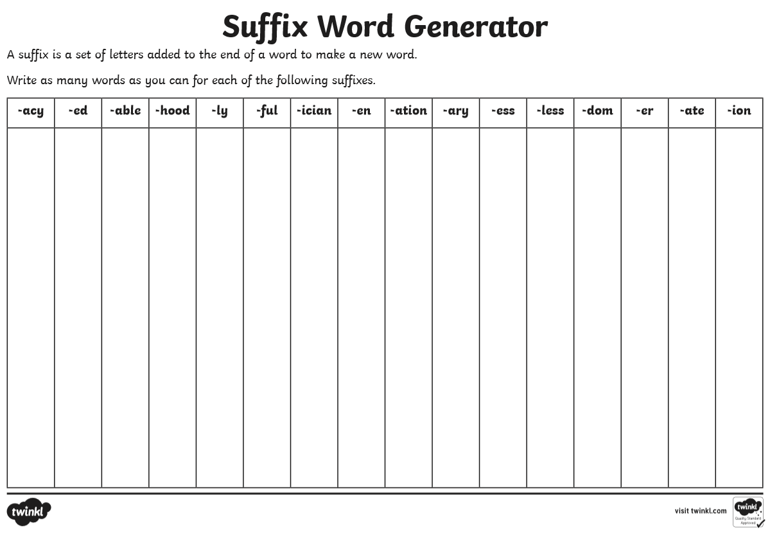

The Diary of a £5 Note
By Vishal S (Winner of GOLD award Age 10-13 category)
DAY 1
Born today! But why am I here?
All I know: I emerged from this machine, which printed two UGLY images on me. On one side, a rather fancy-looking woman and on the other a stern, grumpy, balding man.
NOT the look I would have chosen...
DAY 3
Today, I was inside another machine. Met loads of other notes just like me. Discovered they call us fivers! Loved it. Cosy, warm and friendly!
But next second, I get shoved out of a tiny slot into the cold.
Some grubby hands stuff me in a pouch... Now it's just me and a £50 note - thinks he's 10 times better than me... Hope I'm out of here soon...
DAY 63
Still here.
Bored... Been in this same wallet for weeks now. Nothing ever happens except the £50 bragging. Then some coins dropped on my head. Ouch.
I'm getting really claustrophobic now.
Also, I started wondering about the meaning of my life...
DAY 102
Been put in an old, rusty tray. But I have my own compartment with some other £5s. That's great. Made some new friends. We've got lots in common!
However, there's a weird scent of expired Kit Kats and Rolos...
DAY 103
Rude awakening today. There was a massive CRRRCHIIINGG and the tray was jerked out. A few of my buddies got swiped away.
Then CRRRCHIIINGG, again, the tray was slammed back in. Got a headache now...
DAY 167
My latest wallet 'home' was snatched by a small, podgy child. She pulled me out, then twisted me, drooled on me and put me in her mouth and chewed me. Worst pain ever...EXCRUCIATING...
Fortunately, I'm made from the finest of thermoplastic polymers - my ego was more damaged than my edges.
DAY 248
Shocking day. This lady was rushing down the road and dropped me onto the horrible, grimy street floor. Lay there for hours... I got trodden on, rained on, and finally driven over by a 50 TONNE TRUCK. Cheers...

DAY 439 (AM)
Today, I got shoved into a suitcase with loads of my other friends. Saw a hooded man. He looked mean. Heard gunshots, screams and a very loud alarm.
Don't get what all the fuss and noise was for...
DAY 439 (PM)
Heard sirens. Then more gunshots. Suitcase was opened... looked up to see a friendly man with a shiny badge and stripes on his shoulder. Got transferred back into a machine like the one I started in.
Still don't get my life - why am I here?
DAY 3784
I've seen quite a lot over these years. But something different happened today.
My latest owner was strolling through a park, and stopped in front of an old man. His clothes were ragged. He was sat on a crumpled sleeping bag on the floor.
With desperation, he begged, "Any change mate?"
I was handed over.
The man started sobbing gently.
He wept, "You just saved my life, mate."
My owner smiled.
Finally, I think I know why I'm here

Create your own Diary Of A……
Think about the places your object is placed, what it is used for and how it might feel if it was a real living being!
You can use the diary structure of “Day 248” like Vishal S, or you can use the real date and time if you prefer ….
Vishal S wrote his story in 500 words… which is a good length for a short story. Try and aim for a similar length, between 300-500 words! Have fun!

Author Profile
Using the link to the Scottish Book Trust, choose one of the featured authors that you are interested in learning more about. Listen to their talk and make notes below.
What I learned from what I heard…

What I want to know now…
My questions!

After you have done this, use your notes to start writing an Author Profile. Think about including the following headings:
Name of Author:
How long have they been writing for?
What books/texts have they written?
Who is the audience for their writing? e.g. young children, teenagers, etc…
What inspired them to write?
What things help them write/what is their writing process?
What is the author best known for?
Other Interesting Author facts?
Why are their books popular?
You can add other headings if you wish. You can also use your “what I want to know now” questions to do further research on your chosen author. Many authors have their own dedicated websites which host lots of interesting information. Ask an adult to help you find a suitable site to use. You can also illustrate your work with pictures and ideas taken from your chosen author’s stories. You may even want to draw a profile picture of your chosen author.
