Literacy and English - Reading  Choose a book or a selection of short stories and read for 30 mins each day. Look at the way the author begins each chapter or section. Can you up level it? Re-write an opening paragraph in your own words. Ask a family member to guess which one is yours and which one belongs to the original author. | Numeracy and Mathematics – Fruit Bowl  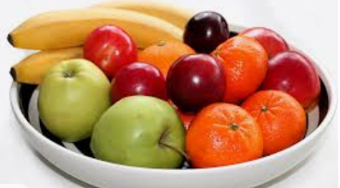  One quarter of the pieces of fruit in a bowl are apples and one quarter are oranges. There are also 4 bananas, 3 pears and 3 plums. How many apples are there?  Challenge: Can you create your own question and try it out on a friend or family member? | Health and Wellbeing  Risky behaviour. Crossing the road without looking, drinking from an unknown bottle and not wearing a mask on public transport are all deemed to be ‘risky’. Write down ten ‘risky’ behaviours and one way for each that they could be avoided e.g. waiting for green man.
Literacy and English - Spelling and Vocabulary  Look at the grid of vocabulary. Practise spelling them by saying them out loud and speaking each letter. Write a sentence for each one to show you understand the meaning. See how many of the words you can use in a conversation in one day! | Numeracy and Mathematics - Fraction Garden  Your challenge is to use the clues (information later in the pack) to make a scale drawing of our fraction garden, with the correct amount of garden given to each part e.g. flowers.  Challenge: Can you make one of these challenges for a family member or friend? | STEM  Program a robot to follow your instructions at https://vr.vex.com/ . Click on the lightbulb icons to watch tutorials and learn how to get started.  This link https://education.vex.com/vr/ sets challenges for those who want extra difficulty.
Literacy and English - Tools for Writing  Poetic Devices - look at the attached list. Revise the different terms and then come up with an example for each one. | Numeracy and Mathematics - Pizza Party  You are planning a party and you want to serve pizza. You buy six pizzas for your guests to share. You might find it helpful to draw pictures to help you complete this activity.  Problem 1 - Guests will eat ½ of a pizza each. How many guests can you feed? Problem 2 – If each guest eats ¾ of a pizza, how many can you feed now?  Problem 3 - If you wanted to buy enough pizza to feed four guests, how many would you need if they eat ¾ of a pizza each?  Challenge - What if you wanted to feed six guests? Or ten guests? Or 20? Is there any pizza left over depending on how many guests you have? | Expressive Arts  Photography challenge. Focus on parts of your bedroom or home that are normally ignored. Take close-up photos of different textures/materials or use Lego figures to create a world of tiny people surrounded by huge objects. Search in images for ‘miniature people’ if you need inspiration.
Literacy and English - Writing  Have a go Poetry – using the poetic devices you know about, have a go at writing a poem. There are no rules, you can write freely and/or you can use the guide sheet for ideas! | Numeracy and Mathematics – Everyday Fractions  Fractions appear in everyday problems. Look for the everyday fraction questions later in the pack. How many can you solve? Talk to a family member about the strategies you used.  Challenge: Can you make up some problems for your family to solve? | Social Studies  “Climate change is the greatest threat facing humanity today”  How far do you agree with this? Write a short piece to try and persuade people that your viewpoint is the correct one. Include research where possible.
Literacy and English  Watch an episode of Newsround either on TV or online. Note down the 3 main story headlines and 3 pieces of information about each story. Share this with a member of your household by telling them the news stories in summary. | Puzzle – Crazy Calculator  Look for the calculator puzzle later in the pack. Can you use the broken calculator to make all the numbers from 1 to 20? | Health and Wellbeing  Learn how to administer First Aid with these useful and easy-to-follow activities: https://firstaidchampions.redcross.org.uk/primary/first-aid-skills/  Try to practise your technique on a family member.

Vocabulary

Plethora | noun | a large or excessive amount of something
Sporadic | adjective | occurring at irregular intervals or only in a few places; scattered or isolated
Constellate | verb | form or cause to form into a cluster or group; gather together
Anomalous | adjective | deviating from what is standard, normal, or expected
Discombobulate | verb | to disconcert or confuse (someone)
Edacious | adjective | having to do with eating or fond of eating

Garden Design- Fractions, Decimal Fractions and Percentages
You have been asked to design a garden for your school. The area is 20 metres long and 5 metres wide.
The area allocated for each feature has been written in the table below as a mixture of decimals, percentages and fractions:

Feature | Area
Flowers | 20%
Vegetables | 1/10
Paving | 0.05
Grass | 60%
Seating | 1/20

Use this information to design and draw a scale plan of the garden. This link will help you to compare fractions, decimals and percentages.
Draw your garden on the squared paper on the next page.
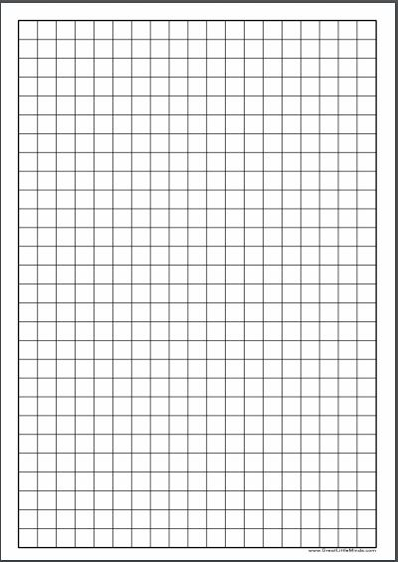

Poetic Devices

Read the following definitions of vocabulary associated with poetry. Choose some of these to help develop your emotions poem.

Alliteration: two or more words starting with the same sound

Assonance: repetition of vowel sounds e.g. She seems to beam rays of sunshine with her eyes of green.

Imagery: use of language to create a vivid image

Internal rhyme: placement of rhyming words within a line of poetry

Metaphor: where the writer writes about something as if it were really something else

Onomatopoeia: when a word sounds like the noise it is describing e.g. pop, crash, crunch, bang

Personification: language describing human action, motivation and emotion is used but is referring to non-human things e.g. My alarm clock yells at me to get out of bed every morning.

Rhyme: words with similar sounds

Simile: describes something by comparing it to something else using like or as
Have a Go Poetry
Choose a topic … here are some common poetry themes...
- An emotion, such as love or fear
- A person, real or fictional My Little Sister,
- A place, real or fictional e.g. The Factory, The Coal Mine
- A feeling, like acceptance or rejection
- An object – A Drawing Pin, The Dolls House
- An animal – The Penguin..
- A time – Winter, A summer’s night
Now, brainstorm what you know about the subject. Note down your ideas.
Think how you will structure your poem... here are some ideas..
- Acrostic: The first letter of the first word on each line spells out a word.
- Free verse: There are no rules. Just write what comes to mind.
- Haiku: This short poem uses a specific number of syllables per line.
- I Am: Write a poem all about you that doesn’t have to follow any other rules.
- Narrative: A narrative poem tells a story and includes ballads and epics.
- Rhyming couplets: The last word in each of two consecutive lines rhyme
Start writing! And see what you come up with!

Numeracy and Mathematics – Everyday Fractions
Fractions appear in everyday problems. How many of the following problems can you solve? Talk to a family member about the strategies you used.

- Tom had two bars of chocolate, he gave ⁵ ⁄ ₁₂ to his friend Sue, how much did he have left?
- A group of three friends are sharing apples between them. How much does each friend get if there are:
  - six apples to share?
  - one apple to share?
  - two apples to share?
  - 12 apples to share?
- A relay race is 4km long. Each runner completes of a ² ⁄ ₃ kilometre how many runners are needed to complete the race?
- ³ ⁄ ₅ of a group of children were girls. If there were 24 girls, how many children were there in the whole group?
- Bob had 120 toy cars in his toy shop. He sold ² ⁄ ₃ of them at £15 each. How much money did he get?
- Sarah thought that her train journey would take ⁷ ⁄ ₁₀of an hour but the actual journey took ¹ ⁄ ₅ of an hour. How long did the actual journey take?
- Harry took ² ⁄ ₃ of an hour to run to the gym. This was ¹ ⁄ ₃ of an hour shorter than the time it took him to walk there. How long did he take to walk there?
- At the zoo, ⁴ ⁄ ₆ of the animals are kept outdoors. Of the animals ¹ ⁄ ₂ kept outdoors are in cages. What fraction of the animals at the zoo are kept outdoors in cages?
- A strawberry milkshake recipe asked for ² ⁄ ₃ cup of chopped strawberries per milkshake. If Anna wanted to make three milkshakes, how many cups of strawberries would she need?
- Lauren is icing 30 cupcakes. She spreads chocolate icing on ¹ ⁄ ₅ of the cupcakes and toffee on ¹ ⁄ ₂ of the remaining cupcakes. The remaining cupcakes will get lemon icing. How many cupcakes have lemon icing?

Numeracy and Mathematics – Crazy Calculator
This activity will develop your skills in solving a mathematical puzzle. You will use the image below of a broken calculator to play a game for two players.

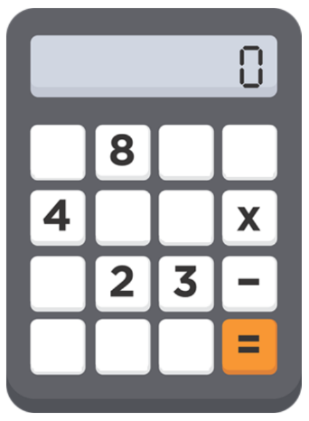
- Write down the numbers 1 – 20.
- Take it in turns to select one of the numbers and see if you can make the number using only the number and symbol keys that are left on the broken calculator. For example, 8 – 4 - 2 = 2 or 8 – 3 x 2 = 2.
- You score a point for each number that you can make.
- You could play this game again by changing the numbers and symbols left on the broken calculator, and then try to make the numbers 1-20 again.
- To make this activity more challenging, choose only two numbers and two symbols for the calculator, what numbers can you make now?

