Reading  Choose a fiction or non-fiction book to read today. Try to read for at least 30 minutes. Can you find any of your spelling words (from the page attached, choose a column which you think is a good challenge for you) in the text? Think about the types of things the writer does to keep the reader engaged. Can you make a Top 5 list? | Numeracy and Mathematics - How Many Can You Make?  Deal out four number cards from a deck of playing cards. Using +, -, x and ÷, make as many numbers as you can using just these four numbers. | Health and Wellbeing  Making positive changes. Search for ‘dealing with change BBC Scotland’ to learn about a strategy that can help you cope with changes around you. Try to implement these strategies the next time that you are feeling anxious or overexcited.
Spelling and Vocabulary  Using the spelling words on the page attached, choose a column which you think is a good challenge for you. Write 10 silly sentences. Try to use at least one spelling word in each sentence.  Example: Today I tied a knot in my shoelaces, but I accidently tied my shoes together, so I fell over! | Numeracy and Mathematics - Odd One Out  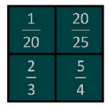  Look at the 4 numbers in the box. Can you find a rule which would work for 3 of them but not the 4th (therefore the 4th number would be the odd one out)? Here is an example: three numbers are bigger than ½ because the number on the top is more than half of the number on the bottom (20/25, 2/3 and 5/4). The 4th one is less than ½ (1/20) so it’s the odd one out.  Challenge: Can you make a box of 4 numbers for someone in your family to try? | STEM  Explore planets beyond our solar system in the Galaxy of Horrors on NASA’s website here.  Try a bit of star gazing from your window or garden using these helpful hints.
Tools for Writing  Sort your spelling words according to the number of syllables, from fewest syllables to most syllables. Clap out the rhythms of the words, one clap per syllable. You could try to write a short poem or rap using these words and sentences. | Numeracy and Mathematics - Division Questions  72 ÷ 12 = 6  Write 3 short word problems to match this  number fact. Next, draw a picture to represent  each of the problems.  Challenge: Can you write some related sums that you also know the answer to e.g. 6 x 12 = 72? | Expressive Arts  Search for ‘Pointilism Art’ or follow this link: https://artfulparent.com/pointillism-art-for-kids/ . Follow the above instructions or challenge yourself to make a pointillism portrait: 1. Take a portrait photo 2. Sketch a version of the photo 3. Add pointillism detail. Search on the internet for pointillism portraits to see how realistic they are.
Story Writing  Using one of the sentences you created in the previous activity, write an imaginative story around it. Try to use lots of descriptive language using creative adjectives. Can you include figurative language such as similes or metaphors? | Numeracy and Mathematics - On The Buses  In this activity you will explore the cheapest way for a family to travel on the bus. Find the activity later in the pack: | Social Studies  Your favourite sports players began life with dreams just like yours. Pick someone who inspires you, find out where they grew up and learn a little about their life story. Create a fact sheet with as many interesting details on as you can find.
Literacy and English  Complete the Willy Wonka fill in the blanks activity on the page attached. Can you think of any of your own words to fill in the blanks that will also make sense? | Numeracy and Mathematics – Strategy Game  Nim 7 is a strategy game for 2 players. You will need 7 objects, e.g. counters, sticks or pebbles.  Place the chosen objects in a pile and decide who will go first. Players then take turns at removing either 1 or 2 objects. The player who takes the last object wins. Play again with the other player going first this time. Can you find a winning strategy? Does it matter who goes first? When you have found the strategy, invite another player to play against you. Can they spot your strategy?  Investigate what happens when you start with a different number of objects or when you take away 1, 2 or 3 objects on each turn. Can you spot any patterns that will help you find a winning strategy whatever number you start with, and however many you are allowed to take each time? | Health and Wellbeing – P.E.  Take part in the 60 second catch and clap challenge every day this week. There are instructions on one of the pages attached. You don’t have to use a ball; you could use balled up socks. What is the best score for the week?

Silent letter spelling words
Column 1 | Column 2 | Column 3
knock | knuckle | knives
knot | doubt | wrestle
know | plumber | subtle
bomb | whistle | rhubarb
lamb | knife | exhaust
numb | knight | honour
thumb | climb | rhyme
debt | choir | rhythm
rhyme | honest | mortgage
castle | beret

Numeracy and Mathematics – On The Buses

In this activity you will calculate the cheapest way for a family to travel by bus. The table on the left shows the bus ticket prices.
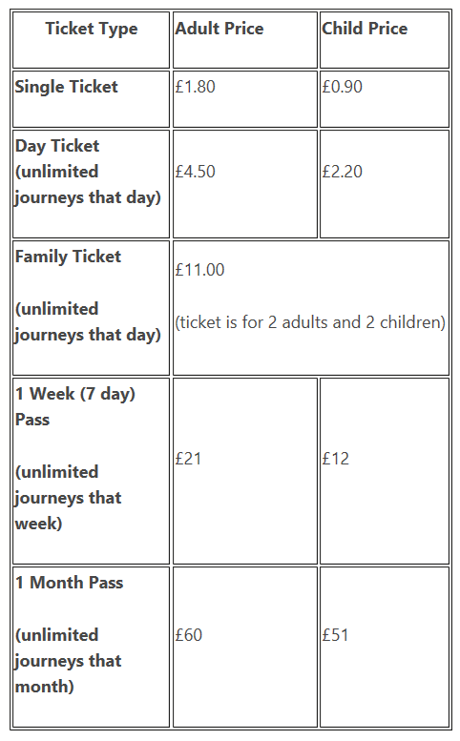

The Smith family has 2 adults and 2 children. They take two bus journeys per day Monday to Friday, and four bus journeys on Saturday. The family do not travel on Sunday. Work out the cheapest way for the Smith family to travel each day and the total amount that they would spend on tickets. Share your answers with someone at home to see if they agree.

Mrs Smith finds an offer online to save money on weekly passes. This is a saving of 10% on one adult weekly pass and 5% on one child weekly pass. Work out if this would be a cheaper way for the family to travel.

Now think about different families or groups who might travel by bus. For example, one adult with three children, or two adults with one child. Decide on the journeys they make. Work out the cheapest ways for them to travel and then share your answers.

Willy Wonka – Fill in the Blanks
Below is a copy of a letter Willy Wonka sent to all the lucky winners of a Golden Ticket. Somehow, some of the words have gone missing. Can you fill in the blanks so that the letter makes sense? There is a suggested word bank or you can use your own words if they are appropriate.
Word bank: mischief, instructions, gates, sharp, warmly, wildest, wonderful, fantastic, invite, visit, exciting, guest, lucky, tasty, cupboard, afterwards, factory, large, loaded, years, finder.

Greetings to you, the lucky ____________ of this Golden Ticket, from Mr Willy Wonka! I shake you __________ by the hand! Tremendous things are instore for you! Many _____________ surprises await you! For now, I do __________ you to come to my factory and be my __________ for one whole day – you and all others who are __________ enough to find my Golden Tickets. I, Willy Wonka, will conduct you around the factory myself, showing you everything that there is to see, and ____________, when it is time to leave, you will be escorted home by a procession of _________ trucks. These trucks, I can promise you, will be ___________ with enough delicious eatables to last you and your entire household for many _________. If, at any time thereafter, you should run out of supplies, you have only to come back to the __________ and show this Golden Ticket, and I shall be happy to refill your ___________ with whatever you want. In this way, you will be able to keep yourself supplied with ___________ morsels for the rest of your life. But this is by no means the most _________ thing that will happen on the day of your _________. I am preparing other surprises that are even more marvellous and more ____________ for you and for all my beloved Golden Ticket holders – mystic and marvellous surprises that will entrance, delight, intrigue, astonish, and perplex you beyond measure. In your ____________ dreams you could not imagine that such things could happen to you! Just wait and see! And now, here are your _____________: the day I have chosen for the visit is the first day in the month of February. On this day, and on no other, you must come to the factory _________ at ten o’clock ___________ in the morning. Don’t be late! And you are allowed to bring with you either one or two members of your own family to look after you and to ensure that you don’t get into ____________. One more thing – be certain to have this ticket with you, otherwise you will not be admitted. From Willy Wonka.

