Reading  Read daily for 25 mins  Skim the opening chapter of a book in order to generate questions and make appropriate predictions about what is going to happen. Use the sheet provided to note them down. | Numeracy and Mathematics – Times Table Chain  Draw a long rectangle with 10 boxes. Pick a number card (between 1-10) from a deck of cards. If you pick a 4, multiply 4 by 8 and write the answer in the fourth box. Continue to complete the rectangle.  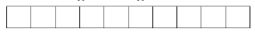  Challenge: How long did it take you to do it? Can you beat your time? Can you race a member of your family to see who can complete the chain quicker? | Health and Wellbeing  Ask three people to tell you things that they love about you. Draw a self-portrait and take your time to carefully write down the amazing features that you have around your portrait.
Literacy and English  There are lots of reasons why people choose to write poetry, including expressing emotion and feeling. Think of a strong emotion for you e.g. joy, pride, sympathy. Use the poetry sheets to help you compose your own poem using poetic devices. | Numeracy and Mathematics - Multiply Maths  7 x 11 = 77  Write three word problems which this sum could represent e.g. 11 people went to a fast food restaurant. The meal deal was £7 per person. What was the total bill? | STEM  Learn to code: https://studio.code.org/s/express-2020  There are lots of courses that will save your progress if you have signed in using an email address.
Literacy and English  Kennings- here you will learn about another type of figurative language which can help us develop our own writing techniques. Read the examples and have a go at creating your own Kennings, use the Kennings sheet to help, then share with you family! | Numeracy and Mathematics – Fridge Filling  A small fridge in a café has a storage capacity of 120 litres. Work out how many of each of these bottles you could squeeze into the fridge.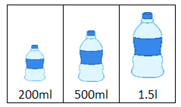  Remember: There are 1000ml in 1 litre (l). | Expressive Arts  Link to the HWB task below by taking photos of each step of your cooking journey. Use these photos to help you create a step-by-step recipe card to share or swap with a friend. Keep instructions simple so that they can follow along by themselves.

Prefixes  Prefixes go at the beginning of words and change the meaning. Have a go at the worksheet then try using some of the words to come up with your own sentences. | Numeracy and Mathematics - Times and Routines  In this activity, you will create a schedule to help Michael plan his day. A schedule is a plan of events with details of when each task will take place. Find the activity later in the pack to plan Michael’s day. | Social Studies  How can food be cheaper if it has travelled around the globe? Look carefully at the labels of food- could you avoid air miles by buying from a local shop? Choose a country from your food labels and calculate just how far your food has travelled.
Listening and Talking  Create an Advert – Look at the adverts around you and on the TV. Note words and phrases which are used to persuade or influence you. Rehearse your own advert for an object of your choosing. You could even record your advert. | Puzzle – Magic Square  Can you fill in the missing number? (Clue: All rows, columns and diagonals must have the same total). | Health and Wellbeing  Help prepare a meal for your family. Your job is to plan what ingredients are needed (and how much of each ingredient!), to help cook and then to present your meal. Extra points if you clean up afterwards too!
  40 |  | 30
   | 25
   |  | 10

Notes from Reading
What I think the book is about.

What I think will happen in the book.

Questions I have about the book.

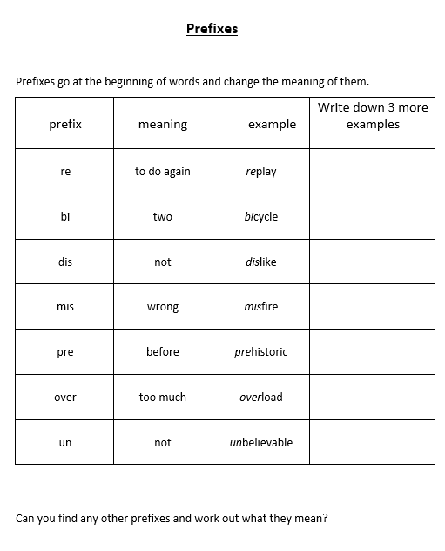

Emotions Poetry
There are lots of reasons why people choose to write poetry. These can include expressing emotion and feeling, to share a funny idea or story, to entertain others and to put thoughts into words so that they are not forgotten.
When writing poetry, you can make your poems interesting by using “Poetic Devices”. These can include things like similes, metaphors, alliteration, idioms and many more.
Today we are going to use our senses to structure a poem that helps us express an emotion. Read the examples below.

Fear
Fear is a black stormy cloud
It tastes like cold rice pudding
It smells musty and damp
It is a dark lonely street
It sounds like echoing footsteps
It feels as if I am alone

Joy
Joy is a rainbow bursting in the sky
It tastes so sweet, like sherbet fizzing on my tongue
It has the scent of the newly cut grass
I see it, whirling like a fairground
The sound of children laughing
Joy makes me feel on top of the world.
Can you spot any similes and metaphors?
How does each of the poems make you feel?
How does the structure of each poem add to the feeling it gives you? e.g. how each line begins? Use of punctuation…

Now have a go yourself. Choose an emotion and use poetic devices to express how the emotion touches each of your senses.
Use the following to help you structure your ideas.
What colour is the emotion?
What does it taste like?
What does it smell like?
What does it look like?
What does it sound like?
What does it feel like?

You can use the Poetic devices sheet to help with some interesting techniques.
Poetic Devices

Read the following definitions of vocabulary associated with poetry. Choose some of these to help develop your emotions poem.

Alliteration: two or more words starting with the same sound

Assonance: repetition of vowel sounds e.g. She seems to beam rays of sunshine with her eyes of green.

Imagery: use of language to create a vivid image

Internal rhyme: placement of rhyming words within a line of poetry

Metaphor: where the writer writes about something as if it were really something else

Onomatopoeia: when a word sounds like the noise it is describing e.g. pop, crash, crunch, bang

Personification: language describing human action, motivation and emotion is used but is referring to non-human things e.g. My alarm clock yells at me to get out of bed every morning.

Rhyme: words with similar sounds

Simile: describes something by comparing it to something else using like or as

Kennings
What is a Kenning?
Kenning is an Old Norse term. It is use in writing to describe something without giving the name away. It looks at the characteristics of a subject and then describes the qualities of what the thing is or what it does. It is a poetic phrase that is used instead of the name for something.
These are some short modern day examples of kennings
Ankle biter = a very young child
Bean counter = a bookkeeper or accountant
Head twister = an owl
Mind reader = a person who knows what you are thinking
Postman chaser = a dog
Show stopper = a performance receiving long applause
Tree swinger = a monkey
Tummy slider = a penguin

Read the examples below. Can you guess the objects the writer is describing?
Sun stealing  Night stretcher  Cold maker  Snow faller  Face freezer  Christmas bringing | Animal worrier  Night mover  Meat eater  Paw licker  Prey hunter  Woods dweller  Night howler | A ball chaser  A crowd pleaser  A fast runner  A sneaky diver  A corner taker  A goal scorer  A mate hugger

Kenning Rules
A kenning describes what a specific noun (e.g. person, animal, object) is or does
Each line is a simple phrase with a noun + noun OR a noun + verb
If you are creating a noun + noun phrase, try adding ‘er’ like “cheese eater”
If you are creating a noun+ verb phrase, try adding ‘ing’ like milkshake drinking

Have a go writing your own kennings… think of something common in every day life… e.g. a park, a radio, supermarket, pet, a sport…. have a go a creating several of your own kennings. Test them out on your families at home. Can they guess the person/animal/object/idea?

Numeracy and Mathematics – Times and Routines
In this activity, you will create a schedule to help Michael plan his day. A schedule is a plan of events with details of when each task will take place. The table below shows the things that Michael needs to do during a day. He plans to get up at 7 am and needs to be in bed by 8.30 pm.
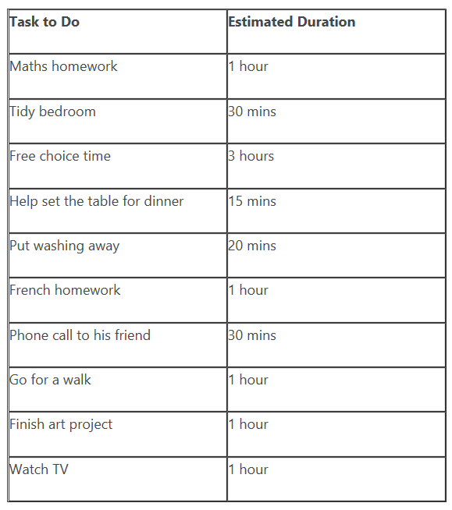
Use the information in the table above to help Michael plan his day. The tasks can be split up across the day. For example, he could have ‘free choice’ three times a day for 1 hour. Think about if there are tasks which are better planned for certain times of the day.
Write out a schedule to show what Michael will be doing throughout the day. Remember you will need to include time for him to get dressed, eat his meals and get ready for bed. Try to record the times using 12 hour or 24 hour notation.
Now try to plan your own schedule for each day next week. Discuss with an adult the things you plan to do each day. Over the week see how accurate your schedule is and update it with any changes you need to make. At the end of the week, discuss your schedule with an adult. What did you spend most time doing? Were there things that you forgot to include in your planning? What things stayed the same each day? Are there times or activity lengths that changed
