Literacy and English  Read for 25 mins every day  Character Analyser - Think about the main character.  Using the information that you have read from your book so far, answer the questions on the attached worksheet. | Numeracy and Mathematics  Pick 2 times tables that you find difficult. Count through the stations out loud to someone at home. For example: The 9 times table –  9,18,27,36,45,54,63,72,81,90,99,108 | Health and Wellbeing  Think about your best friend. List 6 qualities they have that makes them a good friend.  Make a bright, colourful thank you card for your friend. Remember to include some of the reasons you like having them as a friend inside.
Literacy and English  Discussion – Persuasion  When we persuade someone, we give them reasons why they should or should not do something.  Have a discussion with someone at home about how you feel about the statement below.  A forest should be cut down and the land should be used to build a new theme park.  There is a worksheet to help you below. | Numeracy and Mathematics  Partitioning  Using partitioning, complete the addition sums in the  Worksheet attached. There are 3 different levels, choose the one that suits you. There is an example to show you how to lay out your work. | STEM  Use recycling materials like old plastic bottles and toilet rolls, build a fort that could withstand an invasion.  Challenge: Don’t use any tape or glue to hold it together, try to balance things on top of each other.
Literacy and English  Writing  Design a new cereal. Think about what the box will look like, what flavour is it? What can you include to try and get people to buy your cereal over a different one? What are 3 ingredients in your cereal? Look at the example included to give some ideas. | Numeracy and Mathematics  Choosing the correct task for you, complete the column subtraction sums. Remember to always start from the units. If you do not have enough - Units for example, you can borrow from the Tens column.  4 16  2356  -1237  1119  I borrowed from the tens column so that I now have 16 units takeaway 7 units. Then I was left with 4 tens takeaway 1 ten. | Social Studies  There are 8 planets in our Solar System. Can you find out their names and 3 interesting facts for each one.  For example:  Mercury  - Mercury is the closest planet to the sun.  - It takes only 88 days for Mercury to travel around the sun compared to the 365 days it takes Earth.  - Mercury does not have any moons or rings.
Literacy and English  Comprehension - Creature from the deep.  Using the picture on the attached worksheet, try to come up with answers to the questions below. | Numeracy and Mathematics  Choose 4 of your favourite tv shows. Can you work out how many minutes each one is on for? If you watched them one after another, how long would you be watching tv in total? | Music  Create your very own rap. All you need is your voice.  You can tap against something with your hands for a beat if you want as well. Try creating simple instruments with spoons- how do different surfaces change the noise you make?
Literacy and English  Writing  The Great British Bake – Off is running a competition. They are collecting recipes and the winners will have their recipe published in a new book. Write out a recipe to one of your favourite foods. Use the template and example below to help. | Problem Solving  Money matters  You have been given a small amount of money to organise a party. You must decide how much of each item you would like to buy. Remember whichever items you choose, there must be enough for everyone at the party.  Work out the total cost for each item you buy.  For example: 3 packets of crisps at £1 each = £3 total.  Take £3 away from the total amount of money to find out how much you have left.  There are 3 different levels, choose one that suits you. | Health and Wellbeing  Stamina is the ability exercise for a long period of time. See if you can make it to the end of this stamina test without stopping.  10 jumping jacks  10 sit-ups  Run on the spot for 10 secs  10 burpees  10 second plank  REPEAT ALL THESE EXERCISES TWICE

Character Analyser

Analyse means to examine something in detail to explain it.
Using the information that you have read from your book so far, write what you know about the main character.
You can use the questions below about the main character to help.
- Describe the main character’s physical appearance (what they look like).
- List 3 qualities or traits that the main character has. (Their personality, what are they like? Funny, kind, helpful).
- What event in the story has been most important to the main character so far?

Creature from the deep

Using the picture below, try to come up with some answers to the following questions.
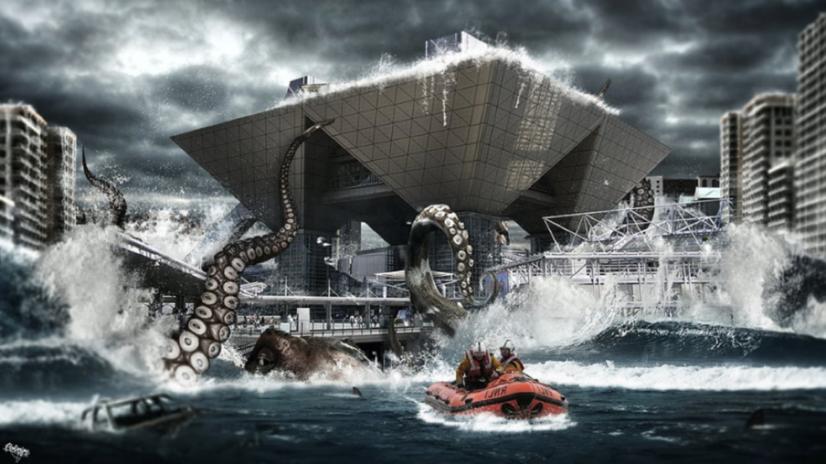
- Who are the people in the boat?
- What do you think the people in the boat are doing?
- Who would you call to help in an emergency like this and
why?
- If you were one of the people in this city, what would
You do?
- From what we can see the creature looks very large. How
do you think it got this size?

- Where do you think the creature is from?
- If you had this creature as your pet, what would you call it?
- What do you think is going to happen in this story?
- What do you think the building in the middle of the picture is?

Cereal Design Examples

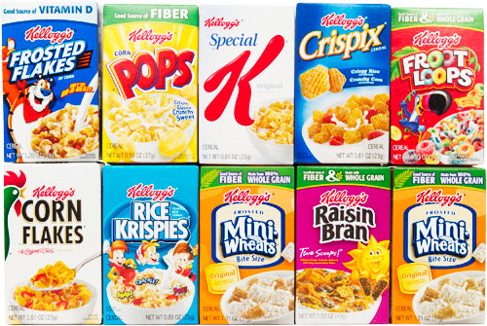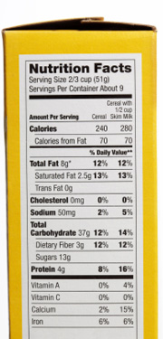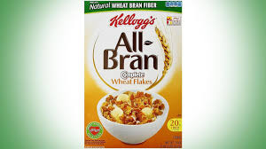

Persuasive Discussion

This forest should be cut down and the land should be used to build a new theme park.
How many of these words and phrases can you use in your discussion?  - Is it really worth... ?  - This needs to be dealt with...  - A friend of mine says...  - No-one but a complete idiot would believe that...  - We can do without this...  - Of course...  - It is disgraceful that...  - How unfair! Another thing...  - I believe that... | - More importantly...  - If this goes ahead...  - Surely...  - Local people feel that...  - Do you really think... ?  - How could we possibly... ?  - I hope that you agree...  - Do you want to be part of... ?  - An intelligent person like yourself...  - As a result...  - This will cause...  - It goes without saying... | - Evidently...  - The real truth is...  - Another reason...  - I strongly believe...  - I am sorry that...  - It will ruin...  - In my opinion...  - It would be a good idea if you could...  - This will mean that...  - We can solve this by...
First of all, decide whether you think they should cut down the forest or not. Now using some of the phrases below give reasons why you think this way.

Example Cupcake Recipe  Ingredients:  - 110g softened butter  - 110g golden caster sugar  - 2 large eggs  - ½ tsp vanilla extract  - 110g self-raising flour  For the buttercream  - 150g softened butter  - 300g icing sugar  - 1 tsp vanilla extract  - 3 tbsp milk  - food colouring paste of your choice (optional)  Method:  - STEP 1  Heat oven to 180C/160C fan/gas 4 and fill a 12 cupcake tray with cases.  - STEP 2  Using an electric whisk beat 110g softened butter and 110g golden caster sugar together until pale and fluffy then whisk in 2 large eggs, one at a time, scraping down the sides of the bowl after each addition. | - STEP 3  Add ½ tsp vanilla extract, 110g self-raising flour and a pinch of salt, whisk until just combined then spoon the mixture into the cupcake cases.  - STEP 4  Bake for 15 mins until golden brown and a skewer inserted into the middle of each cake comes out clean. Leave to cool completely on a wire rack.  - STEP 5  To make the buttercream, whisk 150g softened butter until super soft then add 300g icing sugar, 1 tsp vanilla extract and a pinch of salt.  - STEP 6  Whisk together until smooth (start off slowly to avoid an icing sugar cloud) then beat in 3 tbsp milk.  - STEP 7  If wanting to colour, stir in the food colouring now. Spoon or pipe onto the cooled cupcakes.

Maths – Addition using partitioning
EXAMPLE:
TU TU
48 + 25 = 73
Step 1: Add the tens - 40 + 20 = 60
Step 2: Add the units – 8 + 5 = 13
Step 3: Add the two answers together 60 + 13 = 73

If your number starts with hundreds or thousands, add them first.
1* 2* 3*
  - 23 + 15 125 + 252 1245 + 3254
  - 75 + 26 254 + 361 2547 + 7859
  - 89 + 74 458 + 258 2365 + 5423
  - 42 + 13 347 + 654 3654 + 5421
  - 22 + 65 124 + 325 7521 + 2389
  - 78 + 28 258 + 578 2987 + 9864
  - 46 + 18 654 + 742 3698 + 3356
  - 32 + 32 245 + 456 2458 + 8564
  - 56 + 39 785 + 125 1152 + 2365
  - 67 + 42 456 + 753 4578 + 3895

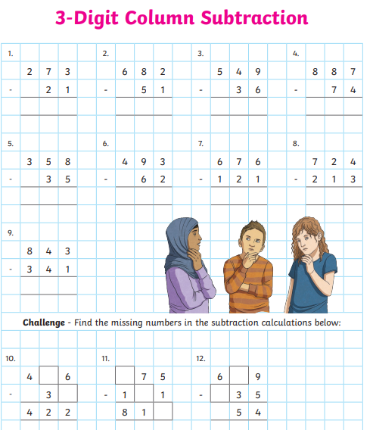
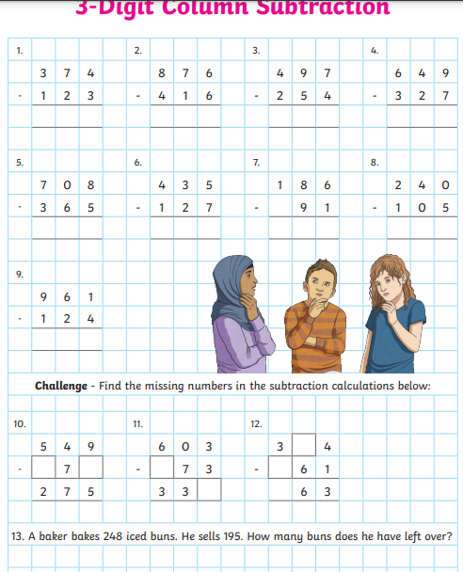
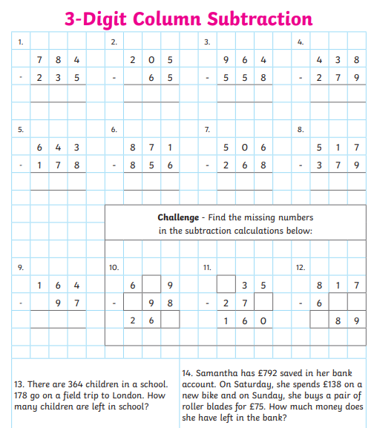
Money Matters – Party Planning
3* task
You have been given £50 and 15 children are coming to the party.

Big Crisps – £1.50 each
Blackcurrant Juice – 58p each
Orange Juice – 32p each
Huge bag of sweets - £5
Cupcakes – 85p each
Sausage Rolls – £2.50 for 10
Mini Cheeses – 40p for 5
Hot Chocolate – £1 each
Balloons - £10

2* task
You have been given £35 and 10 children are coming to the party.

Crisps – 55p each
Blackcurrant Juice – 52p each
Orange Juice – 48p each
Huge bag of sweets - £2
Cupcakes – 40p each
Sausage Rolls – £2.50 for 10
Mini Cheeses – 45p each
Hot Chocolate – 15p each
Balloons - £4

1* task
You have been given £20 and 10 children are coming to the party.

Crisps – 20p each
Blackcurrant Juice – 50p each
Orange Juice – 40p each
Big bag of sweets - £1
Cupcakes – 30p each
Sausage Rolls – £1.50 for 10
Mini Cheeses – 20p each
Hot Chocolate – 10p each
Balloons - £3

