Reading  Read daily for 30 mins  Skim the opening chapter of a book in order to generate questions and make appropriate predictions about what is going to happen. Use the sheet provided to note them down. | Numeracy and Mathematics – Cooking  Find a favourite recipe. Imagine you are preparing this for guests and double the quantities of all ingredients. Or maybe you are going to use it for a party – you might need to triple (x3) or quadruple (x4) the quantities. Can you manage this?  If there is a chance to help in the kitchen, can you weigh out the ingredients for a cooking or baking recipe? | Health and Wellbeing  What is the difference between your best friend, a friend, a cousin and your next-door neighbour? Write down three qualities that each person needs. What do you notice? What qualities are similar? Do any of the people share the same qualities?
Literacy and English  Story explorer – think about a story you have read that has an interesting setting. Make a list of all the places and features of this setting. Draw a map that shows all these features and how they are connected. Use the story explorer sheet to help you. | Numeracy and Mathematics - Dicey Subtraction  Roll three dice to create a three-digit number. Repeat to create another three-digit number. Subtract the smaller number from the bigger number. How did you do this? Can you do this without using the vertical, written method? Roll and repeat… | STEM  Act as Eco Rep for your family. Weigh your kitchen bin bag before it goes outside with the aim of recycling more through the week. Weigh your bin bag at the end of the week and see if you have made a change.
Literacy and English  Visitor’s Guide – design a leaflet or web page about a story setting you know well that tells people all about the story setting. The town in the Creakers, Hogwarts School. What would you expect to see and do when you visit? Use the guide sheet to help you! | Maths and Numeracy - Day Trip  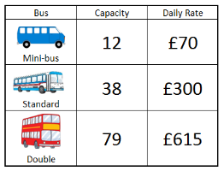  What is the cheapest way to book buses for a school trip for:  -One class (32 pupils)  - A year group (92 pupils)? | Expressive Arts  Take a tour of The Natural History Museum in London: https://artsandculture.google.com/partner/natural-history-museum  Did you have a favourite exhibit? If you feel inspired you can recreate a famous work or in a particular style
Fact or Opinion  It is important that we can recognise the difference between Fact and the opinions of others. Look at the sheet provided and see if you can work out what is fact and what is opinion. Underline the facts and circle the opinions. Check your answers using the answer sheet. | Numeracy and Mathematics – Displaying Data  In this activity, you will look at the different ways to display data. The type of graph selected and the way it is used to display data can sometimes make data misleading. Find the activity later in the pack. | Social Studies  Imagine that the closest park to your home was due to be changed into a windfarm. How would you feel? Write a balanced argument taking in the pros and cons and make sure to research how windfarms can affect people and animals that live near to them.
Listening and Talking  Create an Advert – Look at the adverts around you and on the TV. Note words and phrases which are used to persuade or influence you. Rehearse your own advert for an object of your choosing. You could even record your advert. | Puzzle - Missing Numbers  Can you fill in the missing numbers?  CLUE: Look at the middle column: ? X 8 x ? = 80. To make 80 the 2 missing numbers must multiply to make 10 (as we know 8 x 10 = 80). What could these numbers be?  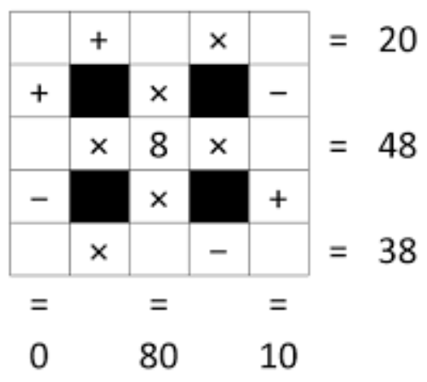 | Modern Foreign Languages  Turn your house into a bilingual dictionary! Use an online tool to translate the terms for things around your house. Use pieces of paper and tape (or sticky notes) to help teach yourself the new vocabulary.

Notes from Reading

What I think the book is about

What I think will happen in the book.
Questions I have about the book.

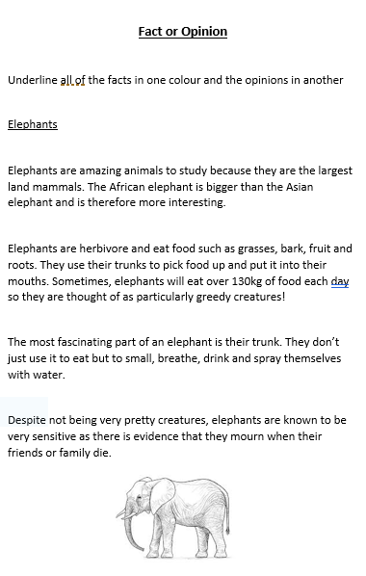

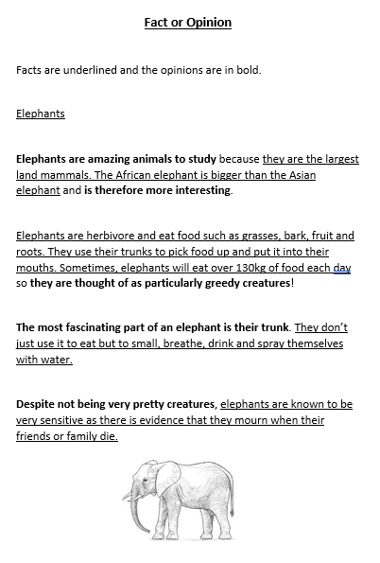
Answers

Story Explorer
Every story deserves a good map! Maps help us explore and when it comes to a good story we don’t want to miss anything. Think about the maps you remember from children’s books - The Hobbit, Lord of the Rings, Narnia, The Marauder’s Map in Harry Potter or The Isle of Berk in How to Train Your Dragon. Maps can be really creative and show more than just locations and geographical features - they can bring all the elements of the story to life and show us what it might be like to explore them! The map could be of a whole world or just a small cityscape, depending on the setting. Choose a book you have read and enjoyed to use a focus for your map. If you like sharing stories with younger children, try creating a map of a well-known fairy tale such as Jack and the Beanstalk or Little Red Riding Hood.
Your map should include….
- key landmarks and physical features in the setting e.g. the school, the swamp, the dark tower,
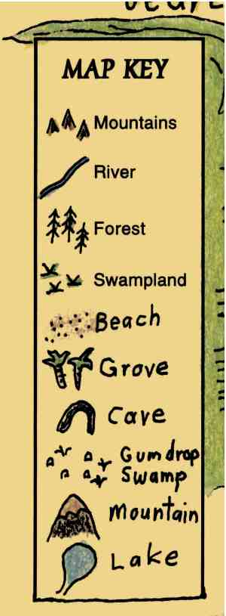
- a map key that helps the reader identify specific places e.g.
- locations of characters

Make a list of all the things you would like to include on your map below …..

Now sketch out and label your map on a blank sheet of paper or use the grid sheet provided.
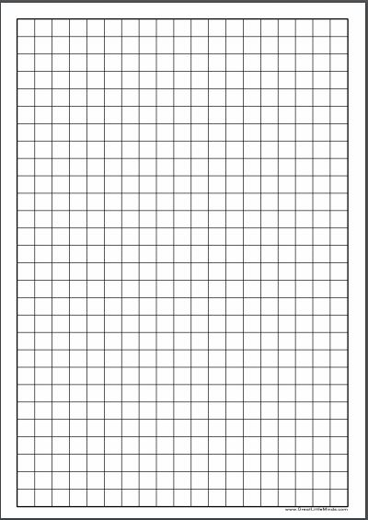
Visitor Guide
Stories are full of exciting places to go, things to do and people to meet (or maybe magical creatures!) or see. Think of a story setting from a story/book you know well. What are the things that make the setting exciting to explore?
You are going to design and write a Visitors Guide to your chosen setting. It can be a hand written leaflet or a website page (completed on SWAY, Powerpoint or Word).
When composing your Visitor Guide, include information on the following, using these subheadings. You can also add you own sub headings if you wish!
• Location - What kind of atmosphere does the place have? Scary, funny, exciting? Is the setting a ‘real’ place or fantasy, or a combination of both? Or is the setting historical?
• Climate - Is it a hot or cold place? Do visitors need to wear special clothes? They might need a costume! What will the weather be like? Maybe the story is set in space!
• Transport - How will visitors get there? If it’s a different place in time, they might need a time machine. If the story is set in space, they might need a rocket. Or maybe they’ll travel by horse and cart! Is there a special way to explore the world they’re visiting? Maybe they’ll have to travel by umbrella!
• Attractions - Are there different attractions that could be visited? For example, if you went to Hogwarts you might like to visit Hogsmeade and the Shrieking Shack. Or if you went to Dream Country you might want to see the dream jars. Is there anywhere that should be avoided if it’s dangerous?
• Things to do - What can they do while they’re there? Ride a dragon with Horrendous Hiccup or go on a motorbike with Gangsta Granny? Or maybe race through the jungle with Mowgli and Baloo the Bear?
• Food - What food can they expect to eat when they get there? Are there places to eat? Will they be able to eat the food or is it dangerous? Maybe they could try Willy Wonka’s everlasting gobstoppers or have a picnic with The Famous Five?
• People - Who might they see when they are there? Maybe they’ll meet some hobbits, or Tom Gates or Mabel Jones! Think about the characters in the book and think about what kinds of people or creatures live in the story world you are focusing on.

Once you have completed your Visitors Guide, share it with a family member and ask them for their feedback. Does your leaflet make your story setting sound exciting to visit? Would they like to go? Which part do they think sounds the most interesting?

© National Literacy Trust 2018 Story Explorers © National Literacy Trust 2018 Story Explorers

Numeracy and Mathematics – Displaying Data
In this activity, you will look at the different ways to display data. The type of graph selected and the way it is used to display data can sometimes make a data misleading. This YouTube video explains how to spot a misleading graph.
After watching the video clip, have a look at the results below from a class survey. The teacher sent out a survey to a class asking them about their favourite school activities. The results from this survey have been presented in two different ways. One is displayed as a pie chart, and the other as a bar graph. Talk to an adult about how the data is displayed in each of the examples below.
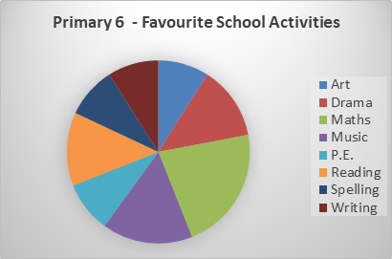
Do you think this pie chart displays the survey results clearly? Are you able to compare the results to work out the most and least favourite activity? What would make this pie chart easier to read?
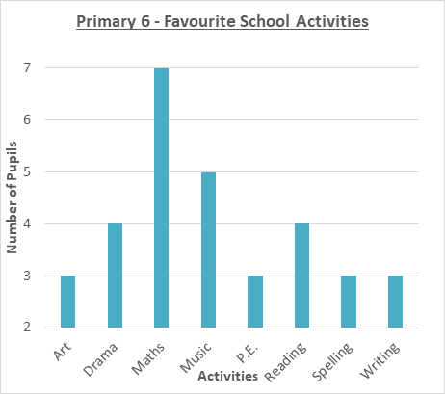
Are there any changes that you would make to improve the pie chart and graph? Discuss your suggestions with an adult to see if they agree.
Do you think this bar graph displays the survey results accurately? Is this a fair scale to have used? What happens to the results when you use a different scale?
Create your own display of the survey results to display the data clearly and accurately. Share your work with someone at home and ask for their thoughts about whether the data is displayed clearly and accurately.

