Literacy and English  Bubble letters - Choose 8 wow words from your favourite book. These are your spelling words. Now write your spelling words in bubble letters. After you write your words in bubble letters, colour your words with a crayon or colored pencil. | Numeracy and Mathematics  Legs! - Count the number of legs of each of the things below in your home and record each as a number sentence:  - legs of tables in my home, e.g. 3 × 4 = 12 (3 tables with 4 legs = 12 legs)  - legs of people in my home  - legs of cats, dogs or other 4-legged animals in your home. | Health and Wellbeing  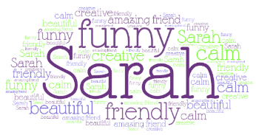  Compliments are good – Draw or go to www.wordart.com and create a word art picture filled with compliments for someone that means a lot to you!
Literacy and English  Reading – Read a few pages/chapters of your book you are reading. Now write a letter to someone telling them about the book and remember to include your own opinion. Did you enjoy the book? Who is your favourite character and why? | Numeracy and Mathematics  How many? Collect between 10 and 30 small items at home to sort into equal groups. For each size of group, note the total number of items (e.g. 22), the group size (e.g. 3, 4, 5 or 6), the number of groups that can be made and the number left over, e.g. ‘22 is 7 groups of 3 with 1 left over’. Do this several times with different amounts each time. | STEM  Invention: Invent and draw a robot to collect food from a local shop for someone who is staying at home. Think about how the robot travels and how it is going to pick up and carry food. Remember an invention has to be something new or something better than we already have. You could build a model of your invention.
Literacy and English  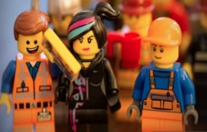  Story writing – You wake up to find that you are living in a Lego world. Write a short story and remember to include how you were feeling, what you did and how you escaped the Lego world. Did you decide to stay? Remember to check for punctuation! | Numeracy and Mathematics  Top Marks - Visit https://www.topmarks.co.uk/maths-games/hit-the-button  Go to ‘Number Bonds’. Here you may choose ‘Make 100 (tens)’, or ‘Make 100’ which is slightly more challenging. Why not try some of the other games too? | Expressive Arts  Inspiring artists – Wassily Kandinsky is a famous artist. He liked to paint circles one inside the other, into squares and then colour them. Draw/Paint/colour your own version of Kandinsky circles. Can you name some primary colours?  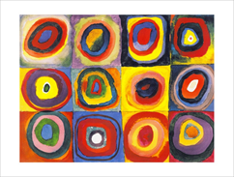
Literacy and English  Acrostic Poem - Choose a word to spell. Write an acrostic poem for that word.  You must also ILLUSTRATE your poem.  *Example: FLY  Fun in the sky.  Laps around clouds.  Yes! I’m free! | Numeracy and Mathematics  Tile shapes (exploring how different shapes fit together) – Walk around your home to find parts of it that show tiling patterns (e.g. roof slates, bathroom floors, etc.). Now draw and label the shapes you spot.  Be a designer - Can you create a pattern of tiles for your bathroom on squared paper? What shapes fit well together?  You can print squared paper from here | Social Studies  Castles vs Houses - Compare life living in a medieval castle to life in your own home. Look in books and online to research what life was like in a castle. Draw pictures or write a short paragraph to show the comparison between the two.
Literacy and English  Reading Task – Choose a book to read. Now write about the main character in the story. Choose 5 – 10 words to describe his or her behaviour. Give an example for each one. E.g. Sally is foolish when she goes to the mill by herself. | Problem Solving  Pyramid number blocks - In the pyramids the two numbers below add to make the number above. Complete these two pyramids. Now create your own!  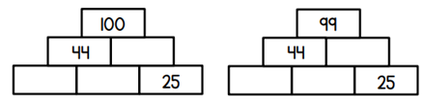 | Health and Wellbeing  Magic Exercises - Discuss the importance of exercise and a healthy body. Think of some exercises to do.  Put the exercises together to make a simple routine. See if you can repeat them several times

