Literacy and English - Reading  Read the first paragraph of a book. Can you draw a picture of the setting and characters? What did you learn from this paragraph? What information did you get? What questions would you ask the characters? | Numeracy and Mathematics – Estimator  Draw a line. Put 0 at the end on the left and 100 at the end on the right. Think of a number and estimate where it should go on the line. Do this for 5 more numbers. Are some numbers harder than others? Did it get harder as you added more numbers to the line? | Health and Wellbeing  1-Week Tidy Bedroom Challenge! Challenge yourself to keep your room tidy and help your family out. See what a difference not having clutter feels like - can you encourage other family members to take up the challenge alongside you?!
  
Literacy and English - Vocabulary and Spelling  In written tasks this week pay special attention to your spelling. Use a dictionary or word bank to help with tricky words. Note down any words you would like to learn and find a way to remember the spelling of them. | Numeracy and Mathematics – Times Table Chain  Draw a long rectangle with 10 boxes. Pick a number card (between 1-10), e.g. 3, and write the third number in the 5 times table in the third box. Keep going until you have all the numbers in the 5 times table in order. | STEM  Did you manage to complete the challenge above? What would have made it easier? Design a bedroom-tidying invention and make sure you draw out your plans, taking care to label the important features.
  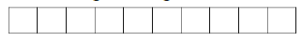
Literacy and English – Speech Marks  https://www.bbc.co.uk/bitesize/topics/zr6bxyc/articles/zhqh92p  Go to this link to watch a short video about how to use speech marks. There is a quiz you can take too. Try writing some speech of your own. Look at the book you are reading. Can you find any speech? | Numeracy and Mathematics – Subtraction  Roll 2 dice to create a 2 digit number. Roll 1 dice to create a 1 digit number. Take away the small number from the big number.  How did you work it out?  …Use cotton buds or an empty number  line to help if you like. | Expressive Arts  Design some clothes for your favourite toy or character in a book. What kind of protection or special features will your clothes need? Try sketching a design first before sewing if you have the materials.
Writing - Instructions  Help to inform the public and keep them safe. Write instructions for washing your hands properly. Use the sheet provided. Maybe you could make your instructions into a poster for public areas in your school or for in your home! | Numeracy and Mathematics – Shopping  Tom and Ann are going shopping. Look at the activity later in the pack to help them make good choices. | Social Studies  Family Oil-Spill Experiment. Ask an adult to help you collect the materials needed and investigate the problems that an oil spill can create in our fragile environment. Substitute graduated cylinder for measuring jug, plastic spoon for tea spoon and absorbing cloth for paper towel or cotton wool ball if needed. Dawn is dish soap.  https://youtu.be/xi-HuV4Yi5A
Talking and Listening  Listen to a news report and come up with questions you would like to ask. Discuss your questions with an adult or another member of your family. | Puzzle - Card Game  Use a set of playing cards, take out the face cards. Turn over 2 cards and add the numbers together. If you answer correctly, you keep the cards. How many cards they can collect in 2 minutes? You can also play the same game and multiply the two numbers instead of adding them. If you don’t have playing cards, try making 2 sets of number cards with the numbers 1 to 10. | Health and Wellbeing  Start a nature diary, make a note of what you see out of your window/in your garden, every day. Are there any repeat visitors? Can you think of ways to attract more nature for you to observe?
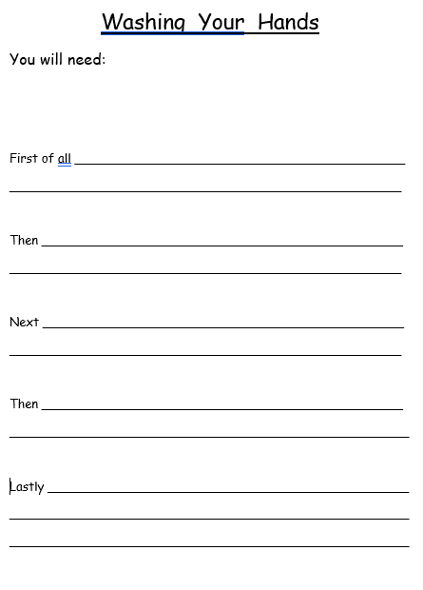
Numeracy and Mathematics - Shopping
Look at the price list below. It shows the cost of some of these items on sale in a shop. They are available in multi-packs. Look at this list and work out the answers to the questions. Explain how you got your answers and what method you used.
Tom buys a multipack of twelve apples and a multipack of six cartons of juice. He gives the shop assistant £5. What change will he receive? What change would he receive if he bought the same items, but gave the shop assistant £10?
The shop assistant gives Ann £1.50 change from £10. Can you work out what she bought? List the possible options.

Multipack | Price
Six cartons of juice | £1.50
Six apples | £1.00
Six packets of crisps | £2.00
Six fun size chocolate bars. | £2.50

Challenge: Look at the price list below. Imagine if Tom and Ann bought exactly the same items as before and in the same quantity. However, this time they bought single items instead of multi packs. Answer the original questions again and compare the results. Work out the difference in cost for each item and explain how you have done this.
Single Item | Price
Carton of juice | 30p
Apple | 25p
Packet of crisps | 45p
Fun size chocolate bar | 60p
