Literacy and English  Letter formation - Practise making patterns and the letters you know in sand, rice, shaving foam, paper or use a stick to practise in the mud. Can you write your first and last name? | Maths and Numeracy  Forward count - Count out loud as far as you can go.  Start at 3 and stop at 6  Start at 5 and stop at 9  Start at 8 and stop at 12  Start at 2 and stop at 7  Can you try any more? | Health and Well Being  Outdoor Learning - Set up an obstacle course in your house or outside and see how long it takes you to complete it. Can you do it quicker each time?
Literacy and English  Reading - Choose a favourite story. First, ask a grown-up to read it to you. Next, you re-tell the story in your own words. Draw a picture of your favourite part of the story and talk about why you liked that part.  Can you think of a different ending to the story? | Maths and Numeracy  Backward count – Count back from 5, 10, 15 or 20  Start at 5 count back to 2  Start at 7 count back to 3  Start at 12 count back to 8  Start at 10 count back to 4  Can you try any more? | STEM  Science - Make a boat out of this paper and see if it will float in your sink. Try and see if it could carry an object like a lid or a biscuit. Can it carry a heavier object? What happens when it is too heavy and why?
Literacy and English  Comprehension - Watch the Paddington film trailer - here is the link https://www.youtube.com/watch?v=7bZFr2IA0Bo  Then discuss the trailer with an adult.  What are the names of all the characters?  How did Paddington get his name?  Do you think Paddington is a friendly bear? Why?  Would you like to see the film and why? | Maths and Numeracy  Counting objects – find things around the house to count out loud. How many cushions? How many lights? How many cups? How many shoes? How many chairs? How many toys? | Expressive Arts  Design a new jacket for Paddington.  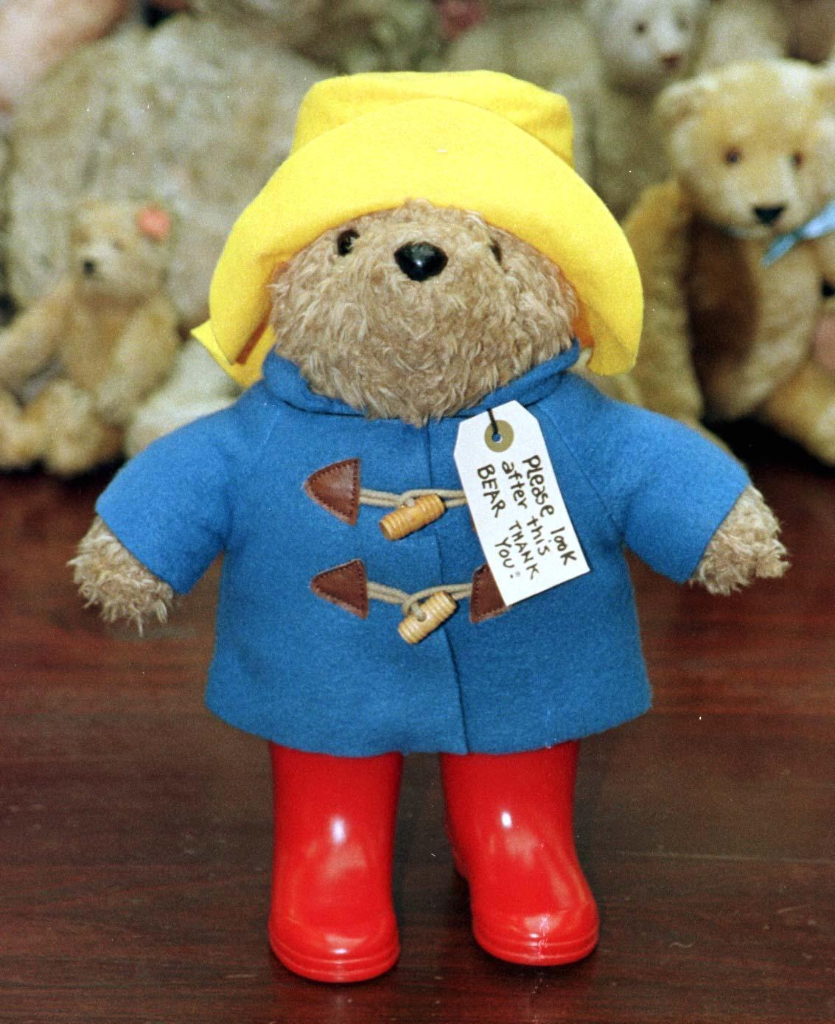
Literacy and English  Rhyming Words –which words rhyme with -  cat, net, tin, fan, cup, rot, bag, lick, tea, my  Can you say this nursery rhyme?  Hey Diddle Diddle  The Cat and the fiddle  The cow jumped over the moon  The little dog laughed to see such fun  And the dish ran away with the spoon.  Which words rhyme? | Maths and Numeracy  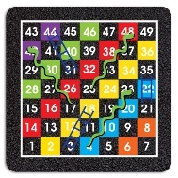  1:1 Correspondence - Play a game of snakes and ladders using the board below. | Social Studies  People Who Help Us - Make a thank you card for your teacher who will be missing you while you are at home. Think about what they might like to see on the card. Can you write your first and last name on it?
Literacy and English  Talk about your favourite toy for 1 minute. What is its name? Why do you like it? Where did you get it from? Where do you keep it? What does it look like? | Problem Solving  Finish the patterns in the sheet below.  Can you make up some patterns of your own? | Health and Well Being  Go on a walk with a grown-up and on your return, draw a map of where you have been.
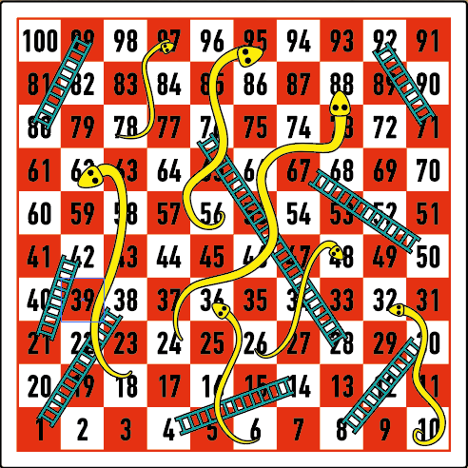
Finish the Pattern
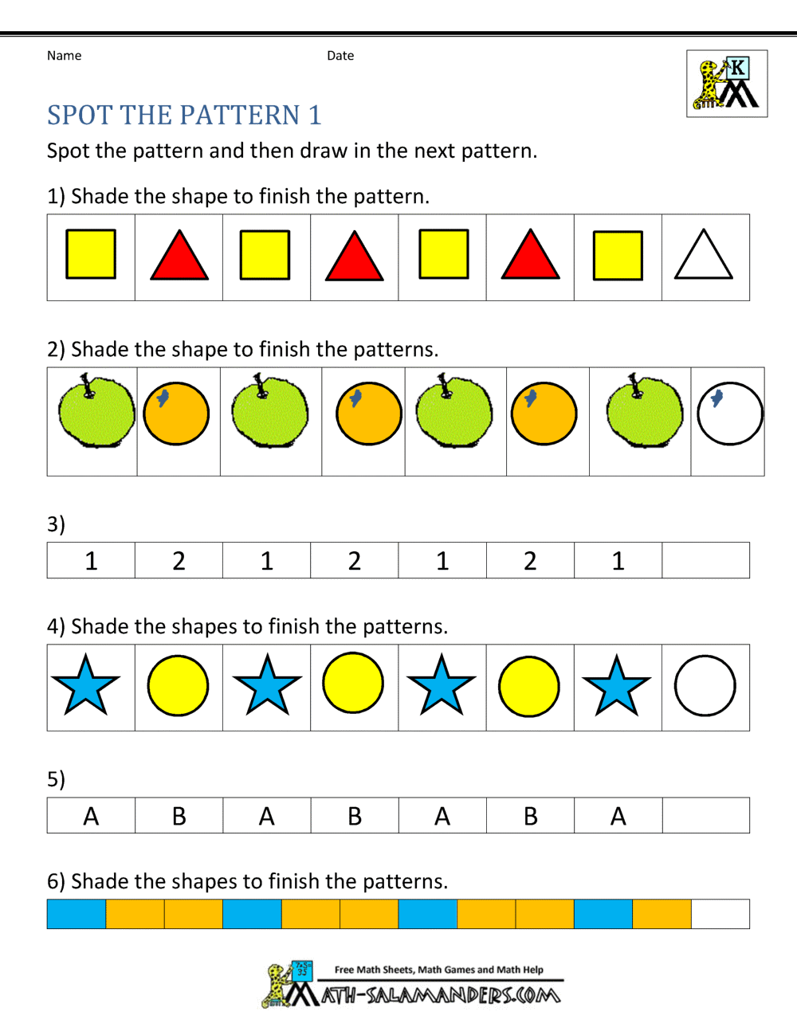

Self-reflection Plenary
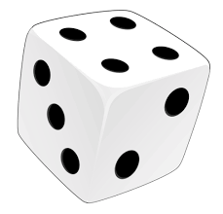
At the end of a day of learning you might like to choose a row (A, B or C) and roll a die to select some self-reflection questions. You can Look at them by yourself or, even better, discuss them with someone else.
 | 1 | 2 | 3 | 4 | 5 | 6
A | Were there any tasks today that I found too easy? Why? Could I have added my own challenge? | Were there any tasks today that I found too difficult? What made it difficult? Did I give up straight away or keep trying? | Did I estimate correctly how long each task would take? If not did I under estimate or over estimate? | Did I start with the easiest bits of the task or the hardest? Did I work through tasks in a specific order? | Did I try going back to a tricky task later and reading it again? Did it make a difference? | Did any of yesterday’s tasks make more sense today now that my brain has had time away from it?
B | Which parts of today’s tasks used knowledge I felt confident about remembering? | Which tasks had new learning in them? What did I learn? | Thinking of one of my tasks. Did I understand the concept that I was working on? | Did I find it easy to stay on task today? What helped/hindered this? Is it different depending on the task? | Can I think of ways to improve my motivation for tomorrow? | Do I need to practise anything to make tomorrow’s learning easier?
C | Did I have everything I needed to complete the tasks? Did I use anything to help me? | Did I get stuck? How did I get past that? Did I give up or try something else? What did I try? | What made my learning stick today? What did I do that helped me understand a particular task? | How can I make sure I remember what I learned? What have I done in the past that has worked? | How long do I think I will remember what I learned? How could I check next week, next month? | Am I worried about anything after today’s work? What can do if I am worried?

