Literacy and English  Reading for Pleasure  Pick a favourite book to read with an adult. Can you use the pictures to work out what is happening before you start reading? When you finish, draw a new cover for the book. | Numeracy and Mathematics  Backwards Count  Time to exercise and count! Come up with an action (e.g. star jumps, running on the spot, etc) and then count backwards from 20 as you do them. | Health and Wellbeing  Healthy Eating  With an adult, make a healthy lunch/snack. What kind of foods could you include? What kind of foods shouldn’t you include?
Literacy and English  Comprehension  Watch the short film “Pip” - https://www.youtube.com/watch?v=07d2dXHYb94  Talk about these questions with an adult:  - What do you think the film is about? Why?  - What did Pip want to be?  - How do you think Pip felt at the start of the film? Why?  - Did you like the film? What was your favourite part? | Numeracy and Mathematics  Counting  Play a game of beat that! Roll 2 dice (or more for an extra challenge) and count how many dots you have in total. Taking turns with an adult, see who can get the highest number of dots.  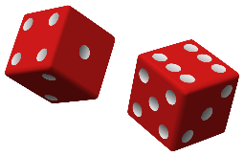 | STEM  Magic Beans  Grow a seed in a bag! Wrap a bean in a wet tissue, put it in a zip lock bag and stick it to a window. Wait for about 5 days and then check to see if the bean has sprouted. While you wait, draw and label a picture of what you think your plant will look like when it has grown.
Literacy and English  Writing  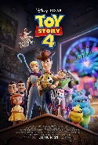  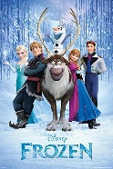  Make a poster for “Pip” or for your favourite film. Make sure to include a detailed picture, the title, and lots of colour! | Numeracy and Mathematics  Numeral Sequences  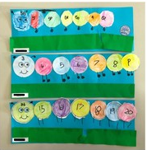  Use the numbers 1-10 to make a number caterpillar collage like the ones in the picture. For an extra challenge you could go all the way to 20 or beyond. | Expressive Arts  Art  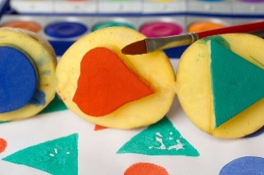  Make a painting using potato printing! You can keep it simple or you can ask an adult to help carve designs into the potatoes. What kind of pictures can you make?
Literacy and English  Phonics  Go on a sound hunt around your house! Can you find different things that start with the letters you know? | Numeracy and Mathematics  Measuring  Make some homemade balance scales using the instructions below. What’s that heaviest thing you can weigh? What about the lightest? | Social Studies  Tree ID  Go on a walk or look out of the windows at home. Using the sheet below, see how many different trees you can find. If you can’t make out the leaves, try drawing the shapes of the trees you can see.
Literacy and English  Reading  Play a game of snakes and ladders. With an adult, fill in the template below with short words (or sounds) and then get reading! | Problem Solving  How many ways can you make 10?  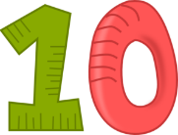 | Health and Wellbeing  P.E.  Pick a routine from the Cosmic Kids YouTube channel and enjoy some yoga and a story!  https://www.youtube.com/user/CosmicKidsYoga

