Literacy and English  Rainbow Write – Choose 6 or 8 words from a reading book to practise your spelling. First write each word in pencil. Then trace over each word three times. Each time you trace, you must use a DIFFERENT colour crayon. Trace neatly and you will see a rainbow! | Numeracy and Mathematics  BIG Adding - Roll 2 dice to create a 2-digit number. Roll again to create another 2-digit number. Add them together. How did you work it out? …Use cotton buds or building blocks to help if you like. | Health and Wellbeing  Make a Pinwheel – Have fun designing and making a pinwheel. See instructions and video here.  https://myworldtheirway.com/2020/04/how-to-make-a-pinwheel-without-pins/  Then practise your breathing by inhaling and exhaling to make it spin. Turn on some calm music to help you concentrate.
Literacy and English  Read and Retell – Read a book and then retell it in your own words to a family member. | Numeracy and Mathematics  Adding Friends - Roll 2 dice to create a 2-digit number. Roll 2 dice again to create another number. Create a Missing number sum using those numbers…Remember to put the highest number after the = sign. E.g. 34 + ___ = 57  What strategies did you use to find the missing number? | STEM  Invention: Invent and draw a robot that can  do a job in your community. Think about how the robot will help. How will it move? What special features will it have? Remember an  invention has to be something new or  something better than we already have. You  could build a model of your invention.
Literacy and English  Describing words – Think of as many describing words as you can using your five senses. Touch, taste, smell, sound and look. | Numeracy and Mathematics  Adding to 100 - Write a number sentence to show how much longer each tortoise must live to be 100 years old.  Example:  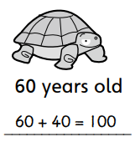  - 80 years old  - 70 years old  - 55 years old  - 90 years old  - 10 years old  - 35 years old  - 5 years old | Expressive Arts  Inspiring artists – Wassily Kandinsky is a famous artist. He liked to paint circles one inside the other, into squares and then colour them. Draw/Paint/colour your own version of Kandinsky circles  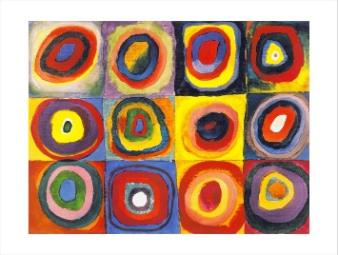
Literacy and English  Writing Instructions - Help to inform the public and keep them safe. Write instructions for washing your hands properly. Use the sheet provided. Maybe you could make your instructions into a poster for public areas in your school or for in your home! | Numeracy and Mathematics  Using coins - Ask your child to choose an item from home with a price shown on the item (e.g. from a pizza menu, food packaging or newspaper, etc.). Ask your child to record the coins or notes that could be used to pay exactly for this item. Can they make up a different combination for the same total? | Social Studies  Scottish Farming - Create a poster to show the different foods that grow on a farm.
Literacy and English  Characters - Draw a character from a book you have read, describe them by labelling them with good adjectives (describing words). | Problem Solving  Questions to solve -  - On St. Patrick’s Day, Seán ate 15 sweets. Later that day he ate 17 more sweets. How many did he eat altogether?  - 14 birds were sitting in a tree. 21 more birds flew up to the tree. How many birds were there altogether in the tree?  - Beth has 74 crayons. She gives 25 of them away to Ciara. How many crayons does Beth have left? | Health and Wellbeing  Magic Exercises - Discuss the importance of exercise and a healthy body. Think of some exercises to do.  Put the exercises together to make a simple routine. See if you can repeat them several times

Describing Words

Touch Taste Smell Sound Look

