dwLiteracy and English - Reading  Read a book from home or online and retell the story to someone else. Make sure you include enough detail to make the story clear. Did you remember all the main points? | Numeracy and Mathematics – Dice Addition  Roll two dice (if you haven’t got dice then write each number on a piece of paper and turn two over). How many dots are there altogether?  Challenge: How long does it take you to do this 3 times, or 5 times? Can you beat your best time? | Health and Wellbeing  1-Week Tidy Bedroom Challenge! Challenge yourself to keep your room tidy and help your family out. See what a difference not having clutter feels like - can you encourage other family members to take up the challenge alongside you?!
Literacy and English - Vocabulary and Spelling  Use a dictionary or thesaurus (online version is fine).  Find 6 interesting words which you may not have used before. Find out what they mean and use them in sentences to show you understand them. Look for other opportunities to use these words. | Numeracy and Mathematics – What Comes After? | STEM  Did you manage to complete the challenge above? What would have made it easier? Design a bedroom-tidying invention and make sure you draw out your plans, taking care to label the important features.
  Choose a number between 1 and 100. What is the number after your number? e.g. “What is the number after 87?”.
  Challenge: Can you say the number 2 more than your number e.g. “What is 2 more than 39?”.
Literacy and English - Fact or Opinion  It is important to recognise what is fact (true) and opinion (one person’s idea of what is true). The sheet provided asks you to decide if each statement is fact or opinion. There is an additional sheet if you would like further challenge. | Numeracy and Mathematics – Counting Out Loud | Expressive Arts  Design some clothes for your favourite toy or character in a book. What kind of protection or special features will your clothes need? Could you sew together a costume for them?
  Choose a starting number between 1 and 100. Count forwards from that number.
  Challenge: Can you count forwards from a number larger than 100? Can you count forwards with someone, each taking a turn to say a number?
Literacy and English - Poster  Choose an object from your house. It could be a tin of beans, a mop or your favourite toy. Make a poster to advertise your object. Include facts and opinions about it, i.e. for a beans fact you could say ‘full of protein’ and for an opinion you could say ‘best on the market’. Blank sheet provided. | Numeracy and Mathematics – Symmetry Hunt | Social Studies  Family Oil-Spill Experiment. Ask an adult to help you collect the materials needed and investigate the problems that an oil spill can create in our fragile environment. Substitute graduated cylinder for measuring jug, plastic spoon for tea spoon and absorbing cloth for paper towel or cotton wool ball if needed. Dawn is dish soap.  https://youtu.be/xi-HuV4Yi5A
  Find items in your home which have symmetry, e.g. a television or your sofa?
  Challenge: Can you find 3 things in each room? Can you find an item that you can hold in your hand, an item which is bigger than you?
Talking and Listening  Gather information about something which interests you e.g. find information in a book, on the internet or watch an episode of a nature programme. Take notes – record the main points plan how you would share this information with others. | Problem Solving  Rosa the shark was hungry. Really hungry. On Monday she ate 16 jellyfish and on Tuesday she ate twice as many. How many jellyfish had she eaten by Wednesday morning? | Health and Wellbeing  Start a nature diary, make a note of what you see out of your window/in your garden, every day. Are there any repeat visitors?
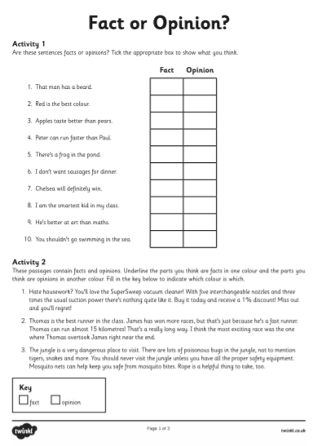
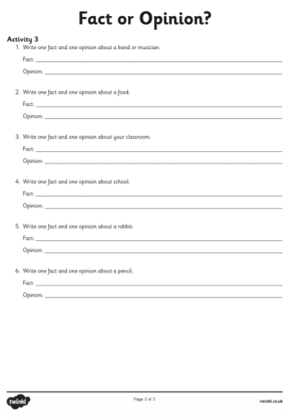

sheet for poster

Use the back of this sheet to plan what you will say.
How long will my talk last?

Who will I ask to hear my talk?

When is the best time for it to take place?

How can I get them interested in my subject?

How will I keep them interested during the talk?

Talking and Listening
Make your notes here.

